

Data-driven marketing practices

Australian industry participants survey results

DECEMBER 2016

Canberra

Red Building   
Benjamin Offices  
Chan Street   
Belconnen ACT

PO Box 78  
Belconnen ACT 2616

T +61 2 6219 5555  
F +61 2 6219 5353

Melbourne

Level 32   
Melbourne Central Tower  
360 Elizabeth Street   
Melbourne VIC

PO Box 13112  
Law Courts   
Melbourne VIC 8010

T +61 3 9963 6800  
F +61 3 9963 6899

Sydney

Level 5   
The Bay Centre  
65 Pirrama Road   
Pyrmont NSW

PO Box Q500  
Queen Victoria Building   
NSW 1230

T +61 2 9334 7700 or 1800 226 667  
F +61 2 9334 7799

Copyright notice

[Creative Commons logo](http://i.creativecommons.org/l/by/3.0/88x31.png)

<http://creativecommons.org/licenses/by/3.0/au/>

With the exception of coats of arms, logos, emblems, images, other third-party material or devices protected by a trademark, this content is licensed under the Creative Commons Australia Attribution 3.0 Licence.

We request attribution as: © Commonwealth of Australia (Australian Communications and Media Authority) 2016.

All other rights are reserved.

The Australian Communications and Media Authority has undertaken reasonable enquiries to identify material owned by third parties and secure permission for its reproduction. Permission may need to be obtained from third parties to re-use their material.

Written enquiries may be sent to:

Manager, Editorial and Design  
PO Box 13112  
Law Courts  
Melbourne VIC 8010  
Tel: 03 9963 6968  
Email: [candinfo@acma.gov.au](mailto:candinfo@acma.gov.au)

Background 1

About this research 1

Methodology 1

research**acma** 2

Survey results 3

About the business 3

Experience of respondents 6

Use of marketing strategies 7

Customer data management 8

Externally-sourced data 13

Marketing channels 17

Marketing budgets 22

Use of marketing channels 26

Use of real-time data 28

Changes in technology 30

Overview

## Background

The Australian Communications and Media Authority (the ACMA) is responsible for oversight of the *Do Not Call Register Act 2006*, the Telemarketing and Research Industry Standard 2007, the Fax Marketing Industry Standard 2011 and the *Spam Act 2003*, which set out the rules for unsolicited communications—telemarketing calls, fax marketing calls and commercial electronic messages (spam).

Data-driven marketing and advertising includes any marketing communication that uses insights from data, including personal information to determine:

* who to target
* when to engage

what to include in the offer.[1]

Direct marketing involves the business of selling products directly to the public, for example, by mail order or by telephone selling, rather than through retailers.

Knowledge of how spam, telemarketing and fax marketing are used, and how they differ from broader data-driven marketing practices when marketing to Australian consumers, provides intelligence and contextual information for policy and decision makers.

## About this research

In the first half of 2016, the ACMA commissioned the Association for Data-driven Marketing and Advertising (ADMA) to conduct a survey among its members to better understand current data-driven marketing practices and trends.

The research needs identified included:

* an analysis of data-driven marketing activity in Australia, including where possible information about the size and structure of the market
* explanations of the marketing methods and channels
* an explanation on how marketing strategies are developed

an analysis of past and predicted trends in marketing.

This paper reports on the survey results.

## Methodology

ADMA conducted an online survey from 8 July to 20 August 2016. An invitation to participate in the survey was sent on 8 July 2016 to a sample industry section of 700 members of ADMA.

In order to complete the research, ADMA publicised a marketing tools and trends survey across multiple channels, including email databases and social media, and surveyed 208 respondents.

research**acma**

Our research program—research**acma—**underpins our work and decisions as an evidence-informed regulator. It contributes to our strategic policy development, regulatory reviews and investigations, and helps us to make media and communications work for all Australians.

research**acma** has five broad areas of interest:

* market developments
* media content and culture
* social and economic participation
* citizen and consumer safeguards

regulatory best practice and development.

This research contributes to the ACMA’s social and economic participation research theme, which is directed to identifying regulatory settings and interventions that assist businesses and citizens participating in the offline and online environment.

# Survey results

The results of the survey are provided per question and include a table and a chart.

## About the business

1. Business type of survey respondents

|  |  |  |
| --- | --- | --- |
| Business type | % | *n* |
| Business-to-business (B2B) | 31 | *64* |
| Business-to-consumer (B2C) | 30 | *62* |
| Advertising/Marketing agency | 16 | *34* |
| Not-for-profit | 9 | *19* |
| Other | 14 | *29* |

Question: Q1 ‘Your business is a?:’

Source: ADMA industry survey 2016 (n=208).

Business-to-business refers to a situation where one business makes a commercial transaction with another.

Business-to-consumer refers to a situation where one business makes a commercial transaction with a consumer.

1. Business type of survey respondents—by %

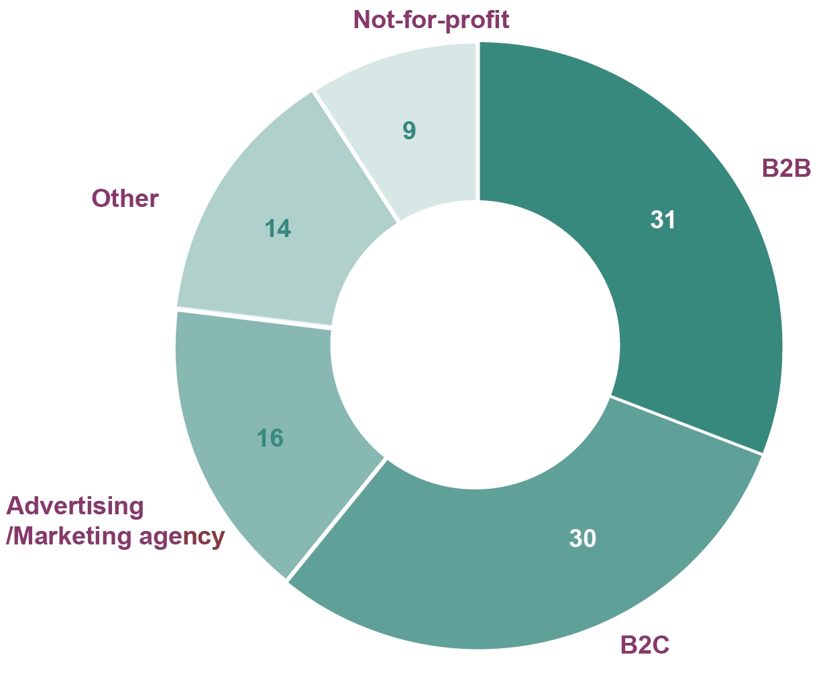

Source: ADMA industry survey 2016 (n=208).

1. Business size of survey respondents

|  |  |  |
| --- | --- | --- |
| Business size | % | *n* |
| Large—over 200 employees | 55 | *115* |
| Medium—between 20 and 200 employees | 24 | *49* |
| Small—up to 20 employees | 16 | *33* |
| Micro—sole proprietor/partnership with no employees | 5 | *11* |

Question: Q2 ‘Your business size is?:’

Source: ADMA industry survey 2016 (n=208).

1. Business size of survey respondents—by %

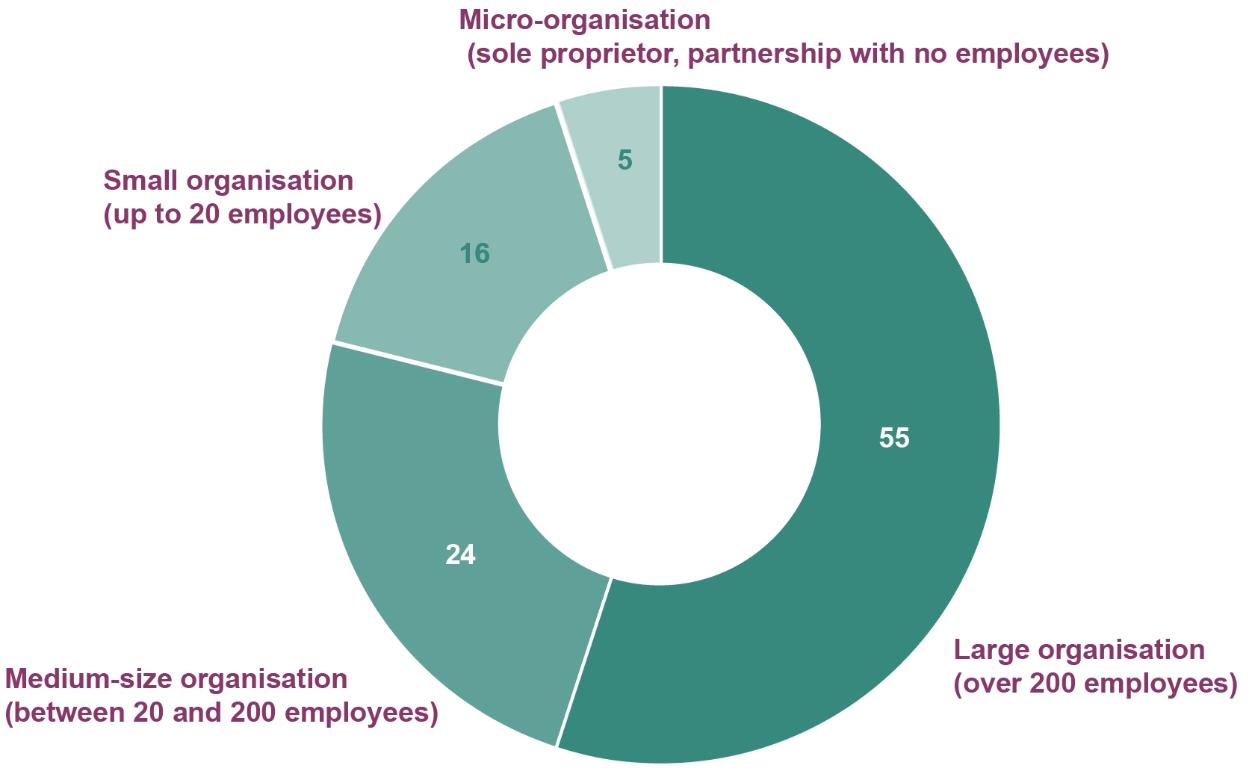

Source: ADMA industry survey 2016 (n=208).

1. Industry sector of survey respondents

|  |  |  |
| --- | --- | --- |
| Industry sector | % | *n* |
| Financial services | 16 | *34* |
| Business-to-business services (B2B) | 10 | *21* |
| Technology | 8 | *16* |
| Telecommunications | 7 | *14* |
| Travel and hospitality | 6 | *12* |
| Consumer goods | 5 | *11* |
| Retail (predominantly catalogue and/or e-commerce) | 5 | *11* |
| Not-for-profit/charities | 5 | *11* |
| Entertainment, media and/or publishing | 5 | *10* |
| Automotive | 5 | *10* |
| Retail (predominantly ‘brick and mortar’ stores) | 4 | *8* |
| Utilities | 3 | *6* |
| Insurance | 3 | *6* |
| Government | 3 | *6* |
| Manufacturing | 2 | *4* |
| Healthcare and/or pharmaceuticals | 1 | *3* |
| Construction | 1 | *2* |
| Other | 11 | *23* |

Question: Q3 ‘What industry sector are you in (or, for agencies, main sectors do you service)?’ Unique response possible. Agriculture sector=0.

Source: ADMA industry survey 2016 (n=208).

1. Life-cycle position of survey respondents

|  |  |  |
| --- | --- | --- |
| Life cycle position | % | *n* |
| Established (business is routine) | 31 | *65* |
| Expansion (new markets and/or distribution channels) | 25 | *51* |
| Growth (profits are improving) | 19 | *40* |
| Mature (stable sales but lessening profits) | 19 | *39* |
| Start-up (trading as begun but margins are tight) | 6 | *13* |
| Seed (have yet to start trading) | - | *0* |
| Exit (sale of business or exit from failing market) | - | *0* |

Question: Q4 ‘Which life-cycle category best describes your business?’

Source: ADMA industry survey 2016 (n=208).

1. Lifecycle position of survey respondents—by %

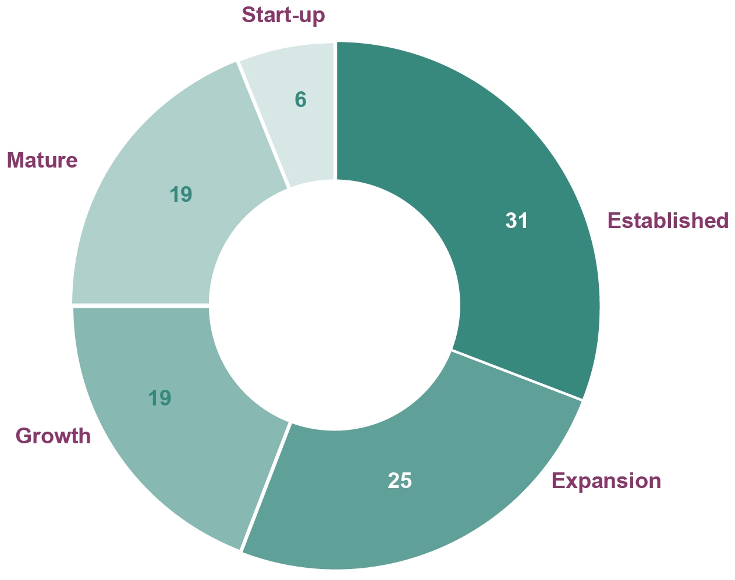

Source: ADMA industry survey 2016 (n=208).

## Experience of respondents

1. Years of marketing/advertising experience of survey respondents

|  |  |  |
| --- | --- | --- |
| Experience | % | *n* |
| Less than a year | 2 | *4* |
| 1–5 years | 23 | *48* |
| 6–10 years | 23 | *48* |
| 11–15 years | 20 | *41* |
| 16–25 years | 25 | *53* |
| 26 years and over | 7 | *14* |

Question: Q5 ‘How many years of experience do you personally have in marketing/advertising? Please consider your current and past professional roles that may apply’.

Note: Years of personal experience in marketing/advertising considering current role and past roles that apply.

Source: ADMA industry survey 2016 (n=208).

1. Years of marketing/advertising experience of survey respondents—by %

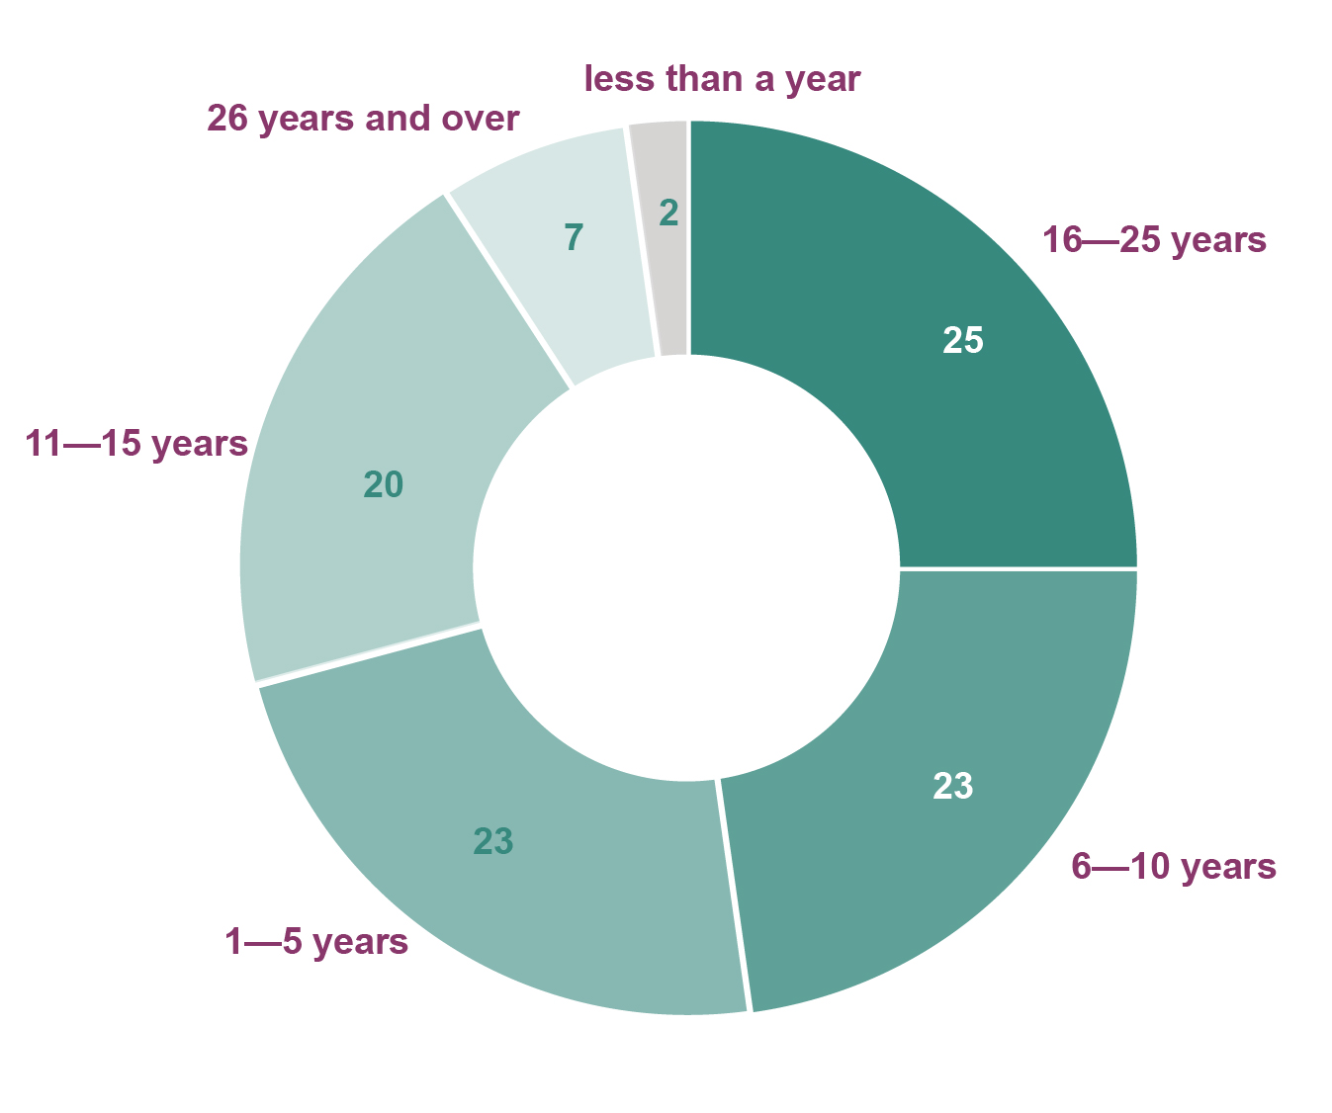

Source: ADMA industry survey 2016 (n=208).

## Use of marketing strategies

1. Main marketing strategies used to acquire customers

|  |  |  |
| --- | --- | --- |
| Marketing strategy | % | *n* |
| Customer journey approach with multiple customer touch points for acquisition | 34 | *70* |
| Nurture approach building a connection with customers over time | 20 | *42* |
| Always a standalone or one-off acquisition campaign running | 11 | *22* |
| Sporadic one-off campaigns | 10 | *20* |
| Networking | 9 | *19* |
| Customer centric strategy, customer value determines communication approach | 7 | *15* |
| Sales and enquiry data* | 3 | *7* |
| Customer referrals* | 3 | *6* |
| Customer details from external sources (purchase, swap databases) | 1 | *3* |
| Other | 2 | *4* |

Question: Q6 ‘What marketing strategies do you mainly use to acquire customers?’

*The categories sales and enquiry data, and customer referrals have been combined in the chart.

Note: Examples provided for one off-acquisition campaign are online newsletter sign-up; continuous advertising. Examples provided for sporadic one-off campaign are trade-shows, one-off advertisement, mail-out, competition.

Source: ADMA industry survey 2016 (n=208).

1. Use of direct marketing or data-driven marketing strategies

|  |  |  |
| --- | --- | --- |
|  | % | *n* |
| Yes | 84 | *174* |
| No | 16 | *34* |

Question: Q8 ‘Do you use direct marketing/data driven marketing strategies?’

Note: The question refers to direct marketing as using a standard database alone for marketing to consumers via email, telemarketing etc. Data-driven marketing refers to marketing following the enhancement of such databases by interpreting and analysing data therein.

Source: ADMA industry survey 2016 (n=208).

1. Use of direct marketing or data-driven marketing strategies—by %

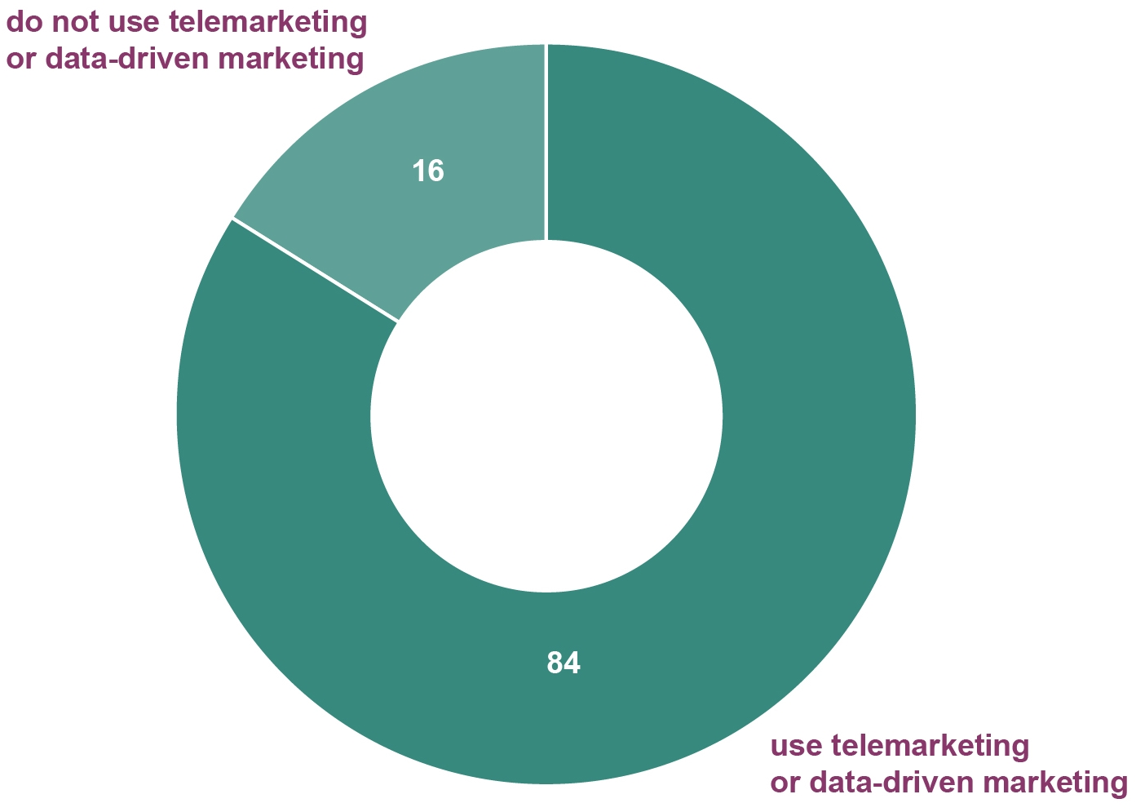

Source: ADMA industry survey 2016 (n=208).

## Customer data management

1. How customer data is managed

|  |  |  |
| --- | --- | --- |
| Type of database | % | *n* |
| Single central database of all customers for marketing and sales | 49 | *84* |
| Separate (non-integrated) databases of all customers for marketing and sales | 33 | *57* |
| One main customer database internally, multiple databases for separate channels held by agencies | 13 | *23* |
| All customer data held in multiple databases at agencies or third parties | 5 | *8* |

Question: Q9 ‘How do you manage your customer data?’

Source: ADMA industry survey 2016 (n=172).

1. How customer data is managed—by %

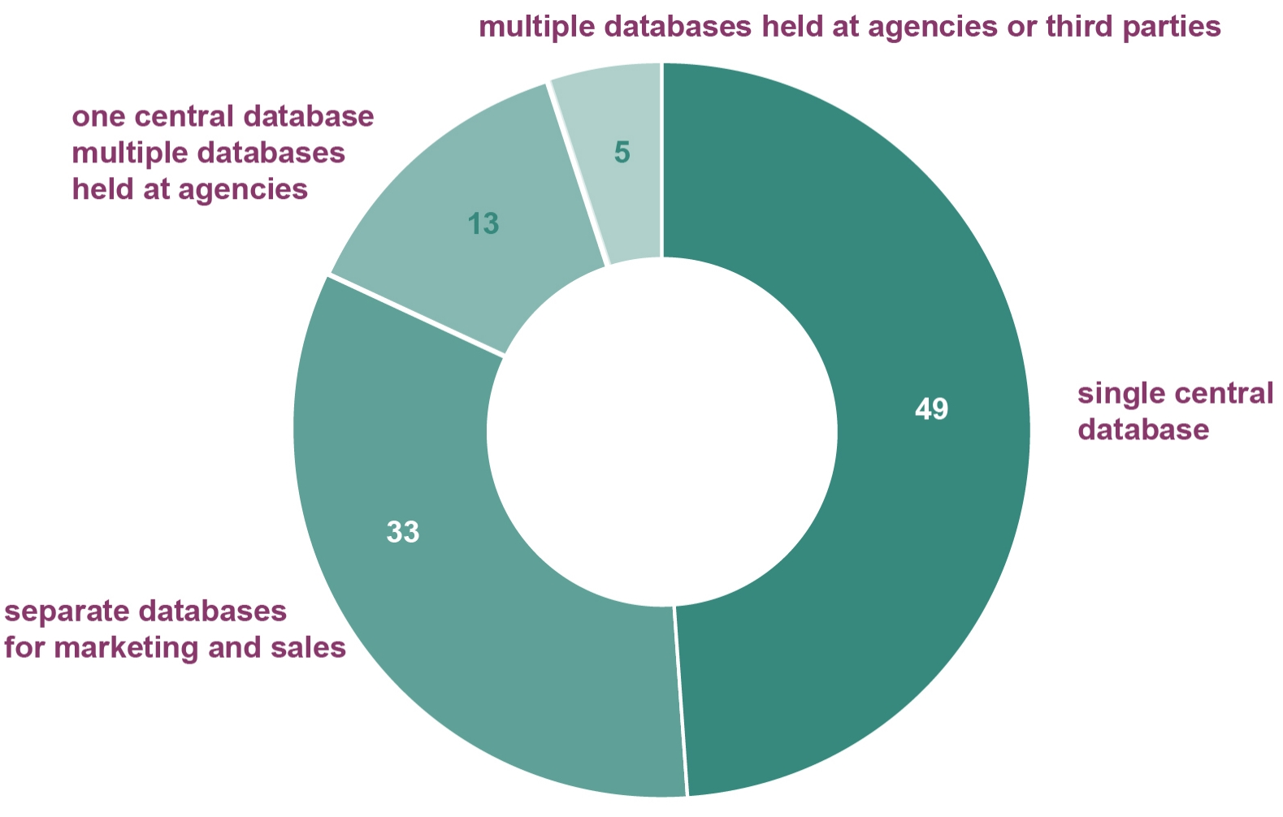

Source: ADMA industry survey 2016 (n=172).

1. Intention to merge multiple customer databases

|  |  |  |
| --- | --- | --- |
|  | % | *n* |
| Definitely | 35 | *22* |
| Maybe | 32 | *20* |
| Undecided | 24 | *15* |
| Definitely not | 6 | *4* |
| Maybe not | 2 | *1* |

Question: Q10 ‘Do you intend to merge these multiple databases into one database?’

Source: ADMA industry survey 2016 (n=62).

1. Intention to merge multiple customer databases—by %

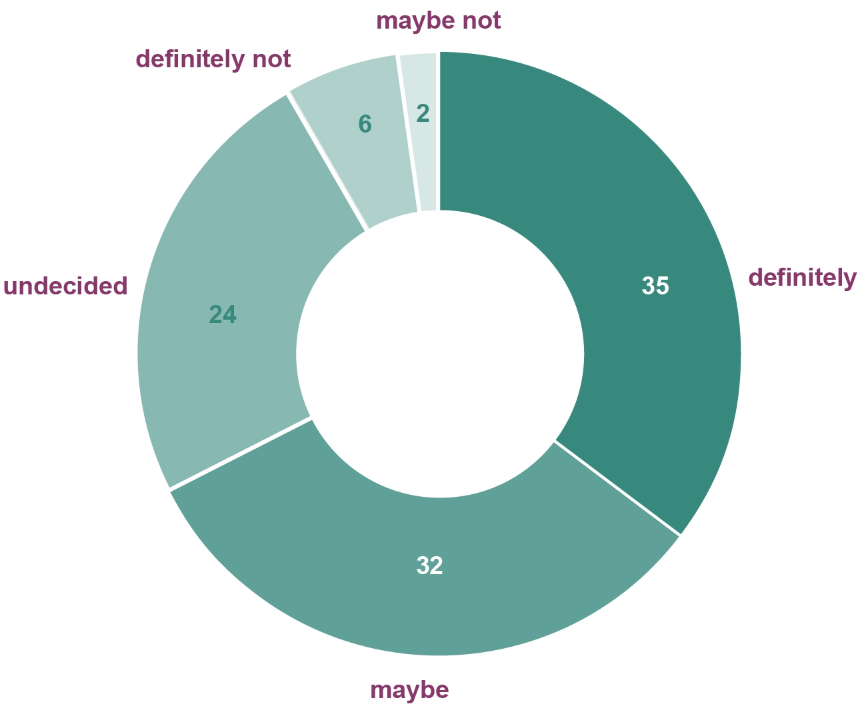

Source: ADMA industry survey 2016 (n=62).

1. Where customer contact details are sourced

|  |  |  |
| --- | --- | --- |
|  | average % reported by respondents | *n* |
| Internally (from sales information, records, website) | 80 | *123* |
| Externally (from agencies, brokers, public databases, publications) | 23 | *106* |

Question: Q11 ‘In your marketing communications, what percent of customer contact details is sourced: Please provide as a percentage, the total must add up to 100%.’

Note: Percentage relates to the average percentage reported by respondents to the two categories.

Source: ADMA industry survey 2016 (n=123).

1. Where customer contact details are sourced—by %

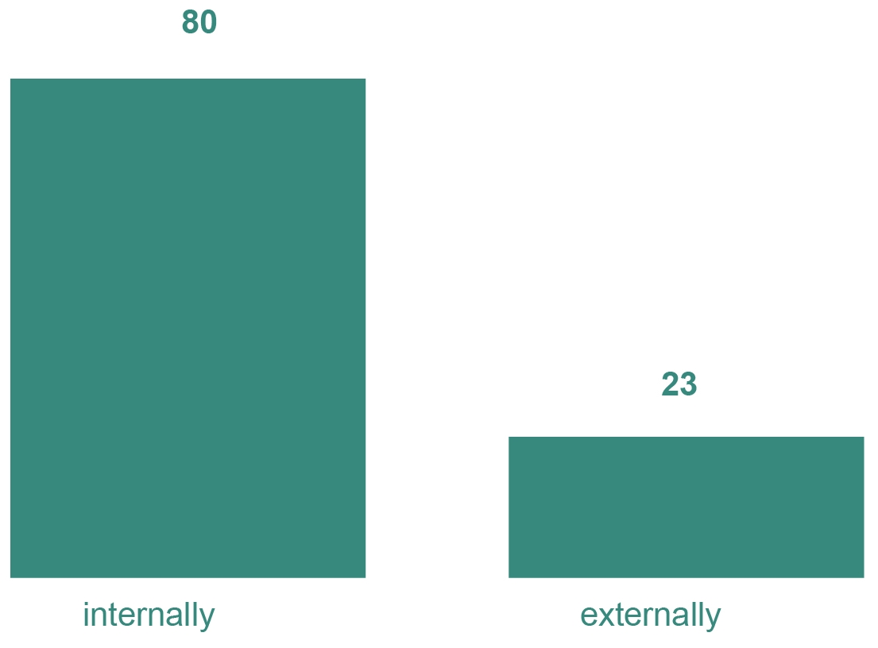

Source: ADMA industry survey 2016 (n=123).

1. Sources of internally-compiled customer contact data

|  |  |  |
| --- | --- | --- |
| Source | Average % reported by respondents | *n* |
| Inbound email/website contact form | 40 | *110* |
| Customer records (e.g. warrantees or as part of provision of goods or services) | 35 | *100* |
| Inbound telephone inquiries | 20 | *88* |
| Social media | 12 | *103* |
| Surveys | 8 | *88* |
| Competition entries | 7 | *85* |

Question: Q12 ‘As a percentage, of your internally compiled data, how much comes from. Note the total must add up to 100%.’

Note: Percentage relates to the average percentage reported by respondents.

Source: ADMA industry survey 2016 (n=123).

1. Sources of internally-compiled customer data—by %

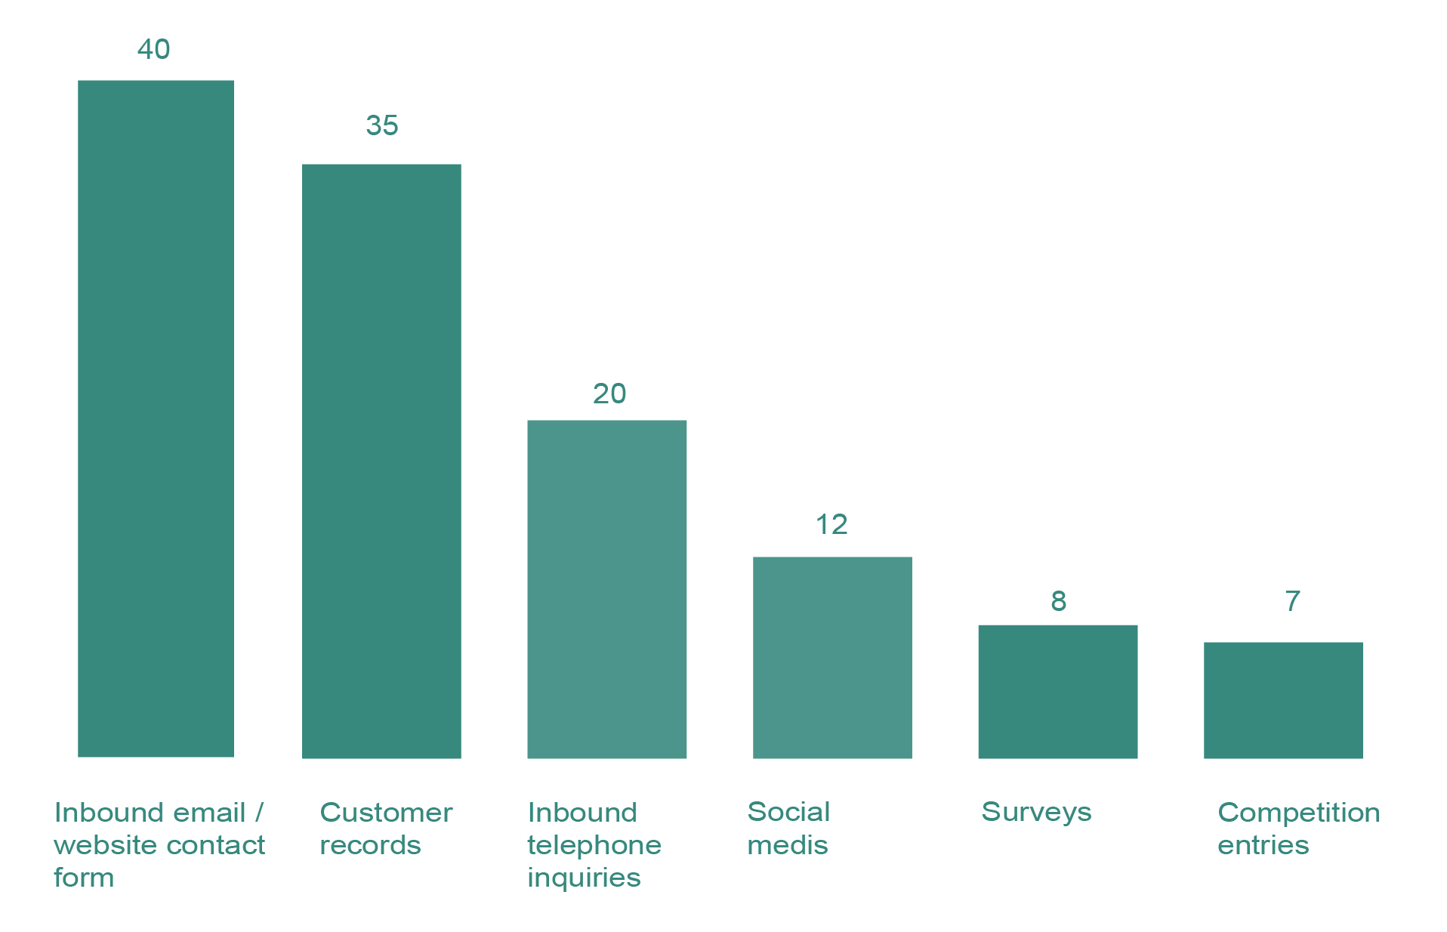

Source: ADMA industry survey 2016 (n=123).

1. Customer consent when collating data for email marketing

|  |  |  |
| --- | --- | --- |
|  | % | *n* |
| Ask your customers for express consent to contact them for marketing purposes | 65 | *80* |
| Use consumer provision of contact details as consent to be contacted for marketing purposes | 35 | *43* |

Question: Q13 ‘When collating data internally for email marketing, do you?:’

Source: ADMA industry survey 2016 (n=123).

1. Customer consent when collating data for email marketing—by %

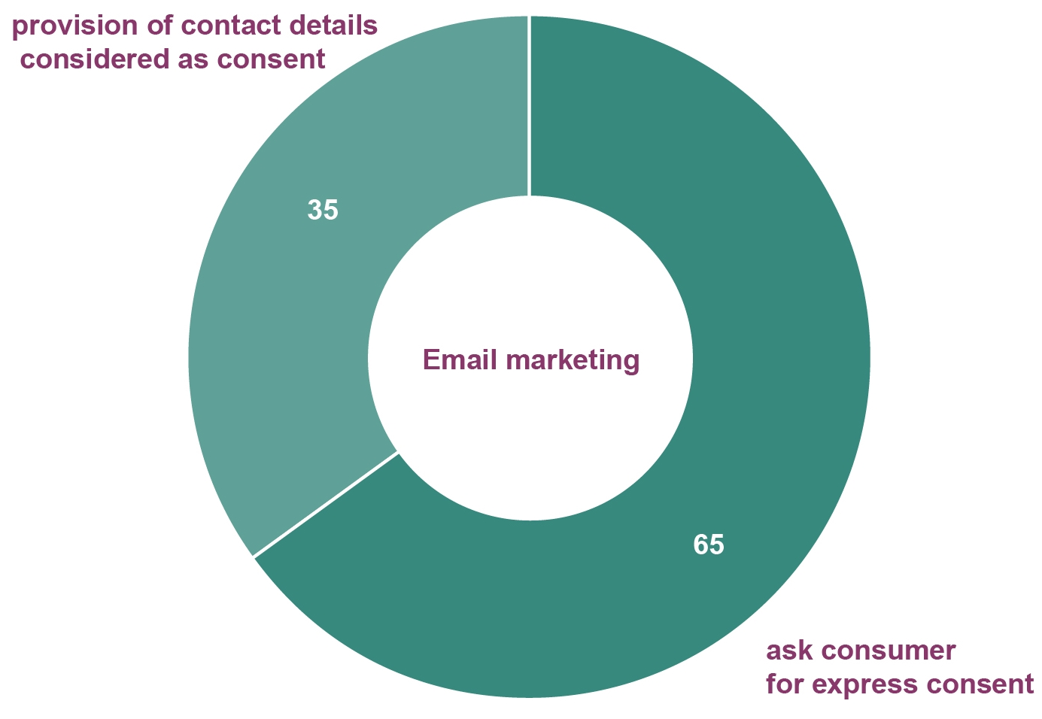

Source: ADMA industry survey 2016 (n=123).

1. Customer consent when collating data for telemarketing

|  |  |  |
| --- | --- | --- |
|  | % | *n* |
| Ask your customers for express consent to contact them for marketing purposes | 59 | *73* |
| Use consumer provision of contact details as consent to be contacted for marketing purposes | 41 | *50* |

Question: Q14 ‘When collating data internally for telemarketing, do you:’

’Source: ADMA industry survey 2016 (n=123).

1. Customer consent when collating data for telemarketing—by %

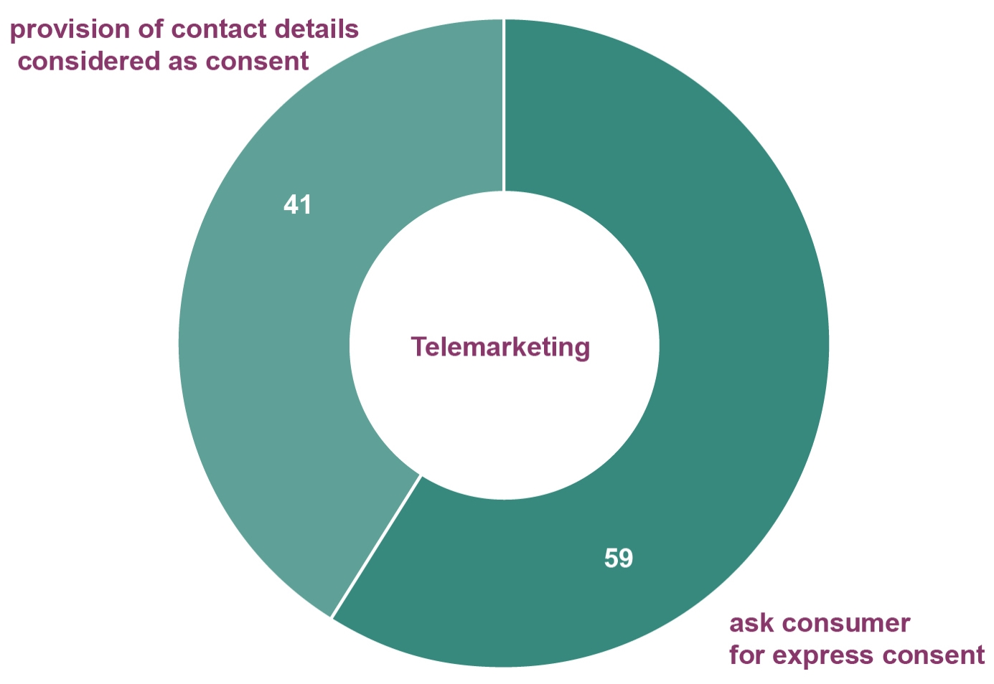

Source: ADMA industry survey 2016 (n=123).

1. Customer consent when collating data for SMS marketing

|  |  |  |
| --- | --- | --- |
|  | % | *n* |
| Ask your customers for express consent to contact them for marketing purposes | 68 | *81* |
| Use consumer provision of contact details as consent to be contacted for marketing purposes | 32 | *38* |

Question: Q15 ‘When collating data internally for SMS marketing, do you?’

Source: ADMA industry survey 2016 (n=119).

1. SMS marketing and customer consent to be contacted—by %

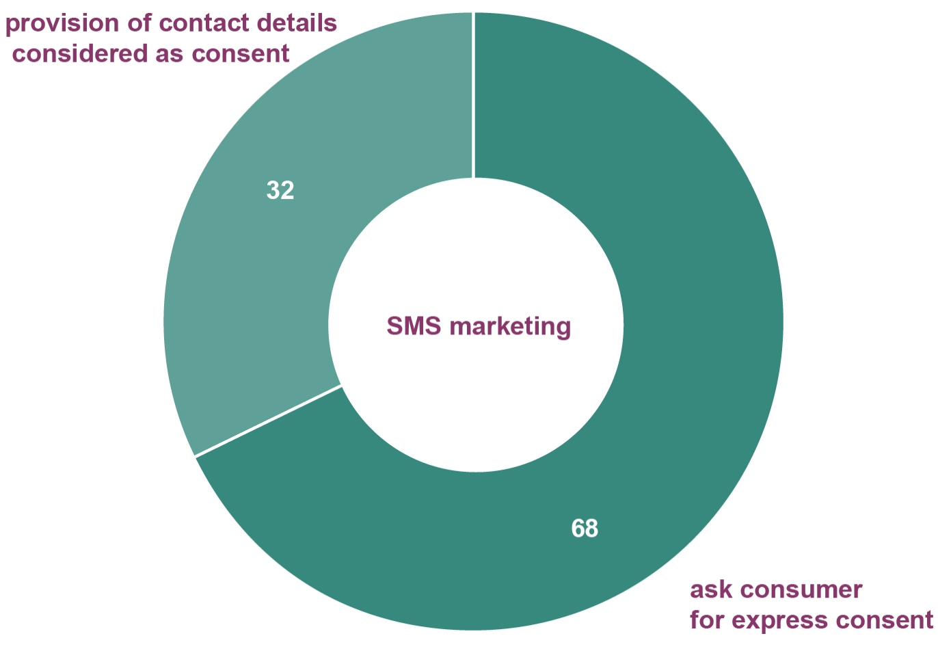

Source: ADMA industry survey 2016 (n=119).

## Externally-sourced data

1. Acquisition of externally-sourced customer contact details

|  |  |  |
| --- | --- | --- |
| Source | % | *n* |
| Acquired from an external party (purchased from a list broker) | 52 | *50* |
| Acquired from public data (e.g. social media, telephone book) | 40 | *39* |
| Acquired from a partnership with external party (e.g. a competition run on behalf of multiple parties) | 37 | *36* |
| Acquired from a survey | 29 | *28* |
| Acquired from a partnership with external party (a swap of lists) | 15 | *15* |

Question: Q16 ‘For externally-sourced data, where you sourced customer contact details? (Tick all that apply)’ (Multiple response).

Source: ADMA industry survey 2016 (n=97).

1. Acquisition of externally-sourced customer contact details —by %

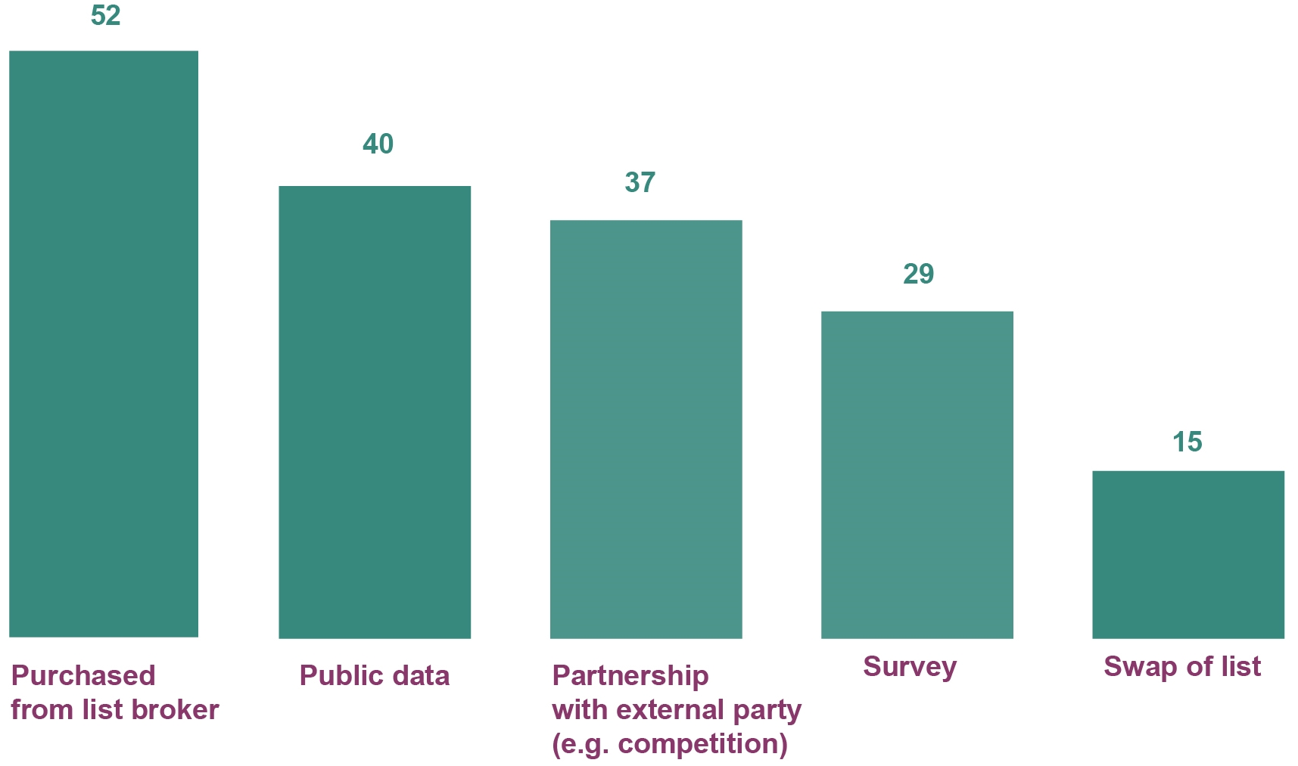

Source: ADMA industry survey 2016 (n=97).

1. Main benefits of using external data

|  |  |  |
| --- | --- | --- |
| Benefit | % | *n* |
| Large number available | 42 | *34* |
| Ability to enhance existing customer information | 37 | *30* |
| Quicker than sourcing internally | 31 | *25* |
| Low cost | 21 | *17* |
| Guaranteed information | 15 | *12* |
| High quality | 7 | *6* |
| Other | 14 | *11* |

Question: Q17 ‘What are the main benefits of using external data? (Tick all that apply).’ (Multiple response)

Source: ADMA industry survey 2016 (n=81).

1. Main benefits of using external data —by %

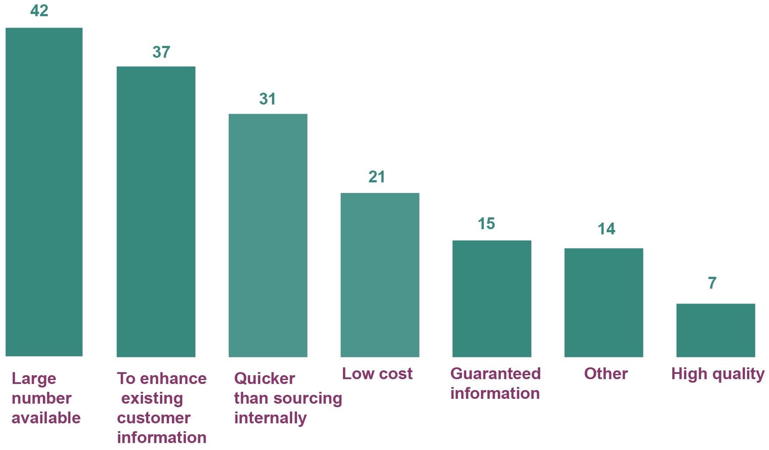

Source: ADMA industry survey 2016 (n=81).

1. Location of external data provider

|  |  |  |
| --- | --- | --- |
|  | % | *n* |
| Australia | 72 | *64* |
| Offshore | 9 | *8* |
| Don’t know | 18 | *16* |

Question: Q18 ‘Is your external data provider based in Australia or offshore?’ (Multiple response)

Percentage based on the total number of responses (n=88).

Source: ADMA industry survey 2016 (n=82).

1. Location of external data provider—by %

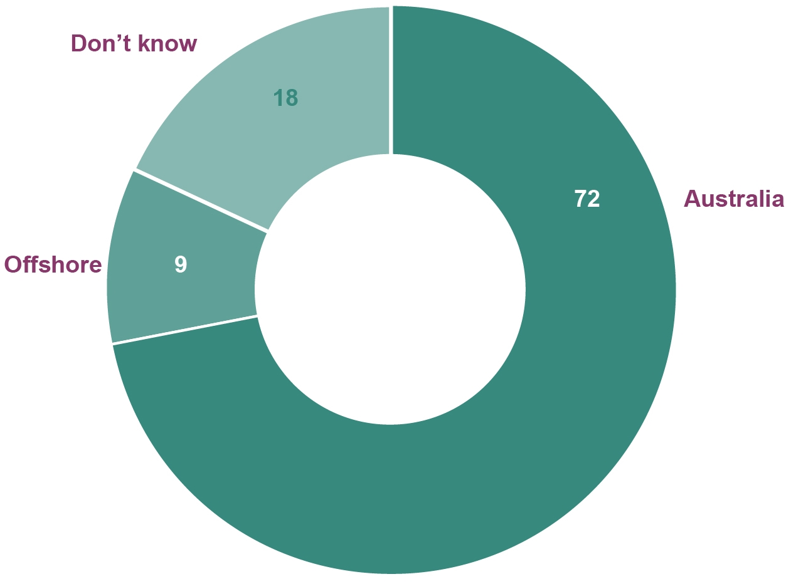

Percentage based on the total number of responses (n=88).

Source: ADMA industry survey 2016 (n=82).

1. Influence of the location of the external data-provider in the choice of provider

|  |  |  |
| --- | --- | --- |
|  | Average % reported by respondents | *n* |
| Yes | 59 | *48* |
| No | 42 | *34* |

Question: Q19 ‘Did the location of your external data-provider influence your decision?’

Source: ADMA industry survey 2016 (n=82).

*Note: Percentage relates to the average percentage reported by respondents.*

1. Influence of the location of the external data-provider in the choice of provider—by %

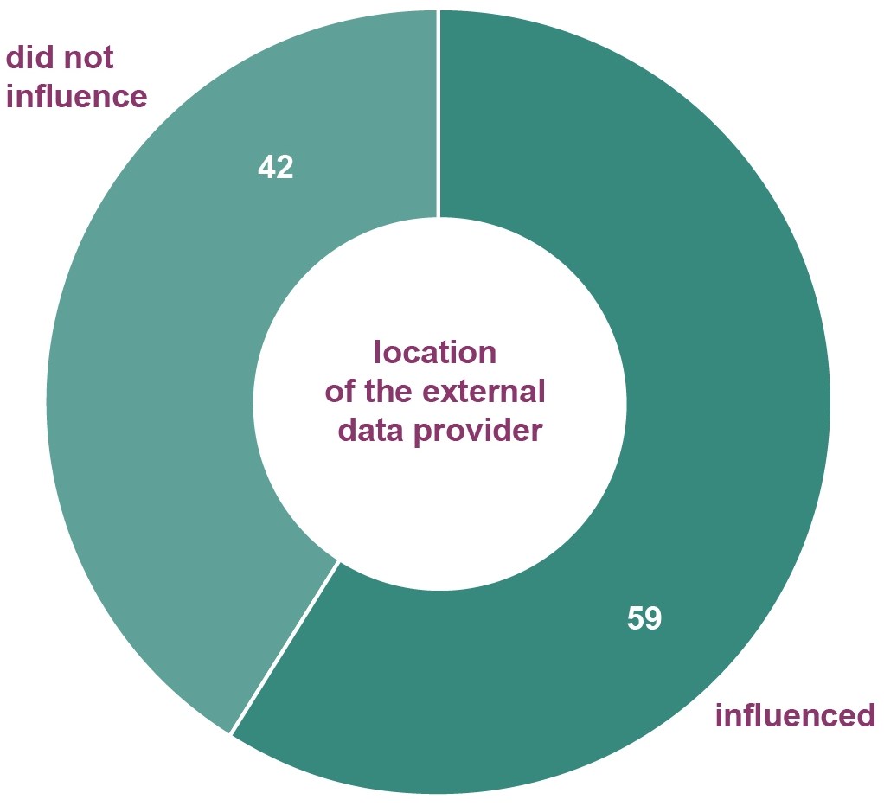

Source: ADMA industry survey 2016 (n=82).

1. Inclusion of information regarding consent in externally-sourced contact details’ lists

|  |  |  |
| --- | --- | --- |
|  | % | *n* |
| Yes | 63 | *59* |
| No | 37 | *35* |

Question: Q20 ‘In sourcing contact details from an external source, do these lists contain specific details on how communication consent was given (e.g. ticking a box on a form, clicking ‘accept’ on a website, confirming during a phone call)’.

Source: ADMA industry survey 2016 (n=94).

1. Inclusion of information regarding consent in externally-sourced contact details’ lists by %

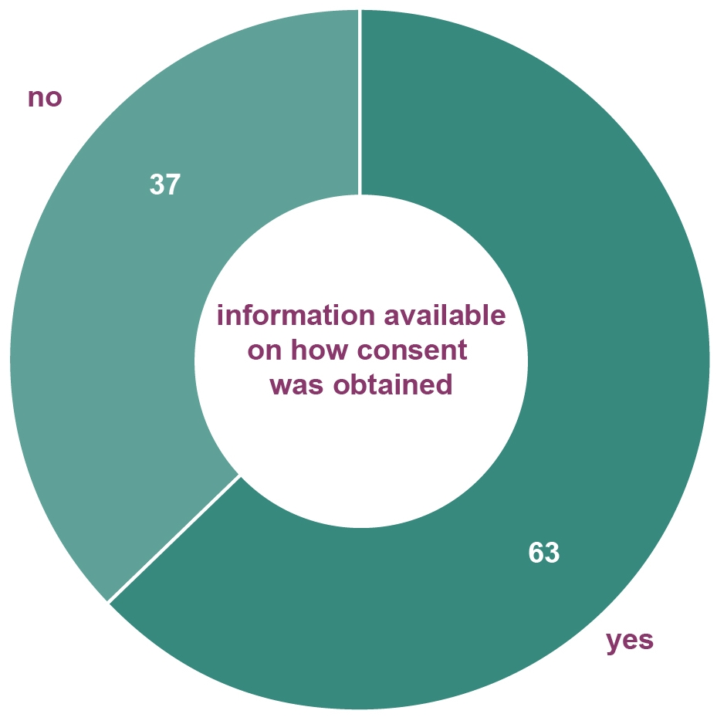

Source: ADMA industry survey 2016 (n=94).

## Marketing channels

1. Preferred direct/data-driven marketing channels

|  |  |  |
| --- | --- | --- |
| Channel | Weighted average | *n* |
| Email | 4.5 | *66* |
| Website display advertising | 3.3 | *63* |
| Social media (e.g. Facebook, Twitter, Instagram) | 3.2 | *62* |
| Postal mail | 2.5 | *55* |
| Text/SMS mobile messaging | 2.2 | *50* |
| Telemarketing | 1.8 | *49* |
| Fax | 0.4 | *32* |

Question: Q21 ’What are your preferred direct/data driven marketing channels? (Number from 1 for your least preferred to 6 for your most preferred’).

Note for the analysis the scale used was reversed compared to the one used in the questionnaire.

Source: ADMA industry survey 2016 (n=67).

1. Preferred direct/data-driven marketing channels

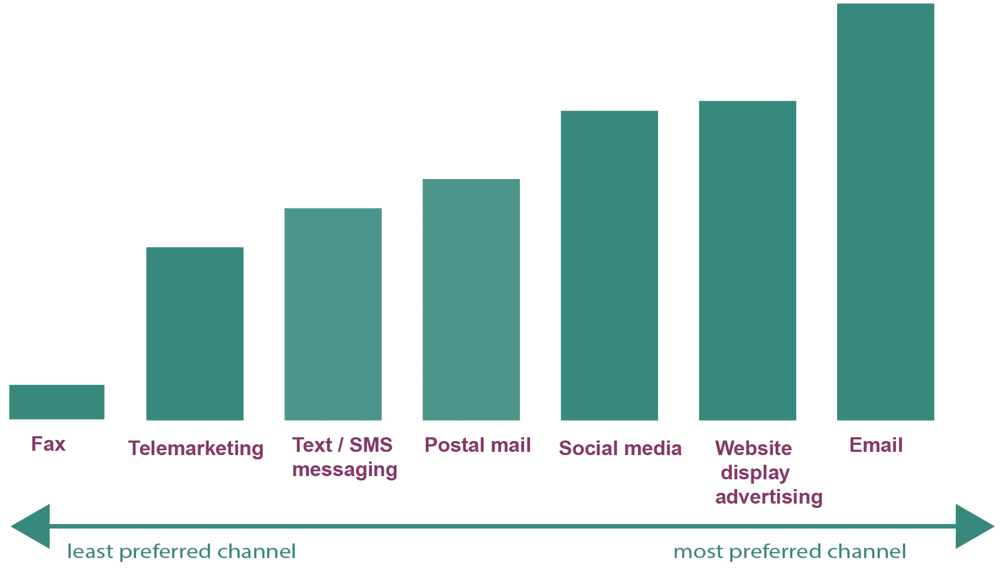

Source: ADMA industry survey 2016 (n=67).

1. Frequency of use of marketing channels

|  |  |  |  |  |  |  |  |  |  |
| --- | --- | --- | --- | --- | --- | --- | --- | --- | --- |
| Channel  *(No. of respondents)* | Hourly | Daily | Weekly | Monthly | Every 4–8 weeks | Every 6 months | Yearly | Never | *Total*  *n* |
| Social media | 10 | 27 | 18 | 2 | 3 | 2 | 2 | 0 | *64* |
| Email | 6 | 18 | 15 | 18 | 3 | 4 | 2 | 0 | *66* |
| Website display advertising | 9 | 19 | 14 | 10 | 3 | 3 | 3 | 1 | *62* |
| Postal mail | 0 | 7 | 9 | 9 | 7 | 14 | 4 | 8 | *58* |
| Text/SMS mobile messaging | 2 | 8 | 3 | 9 | 5 | 10 | 3 | 14 | *54* |
| Telemarketing | 2 | 9 | 8 | 4 | 5 | 4 | 4 | 16 | *52* |
| Fax | 0 | 3 | 0 | 1 | 0 | 0 | 2 | 36 | *42* |

Question: Q22 ‘For each channel indicated, how often do you use this channel?’

Source: ADMA industry survey 2016 (n=67).

1. Frequency of use of marketing channels

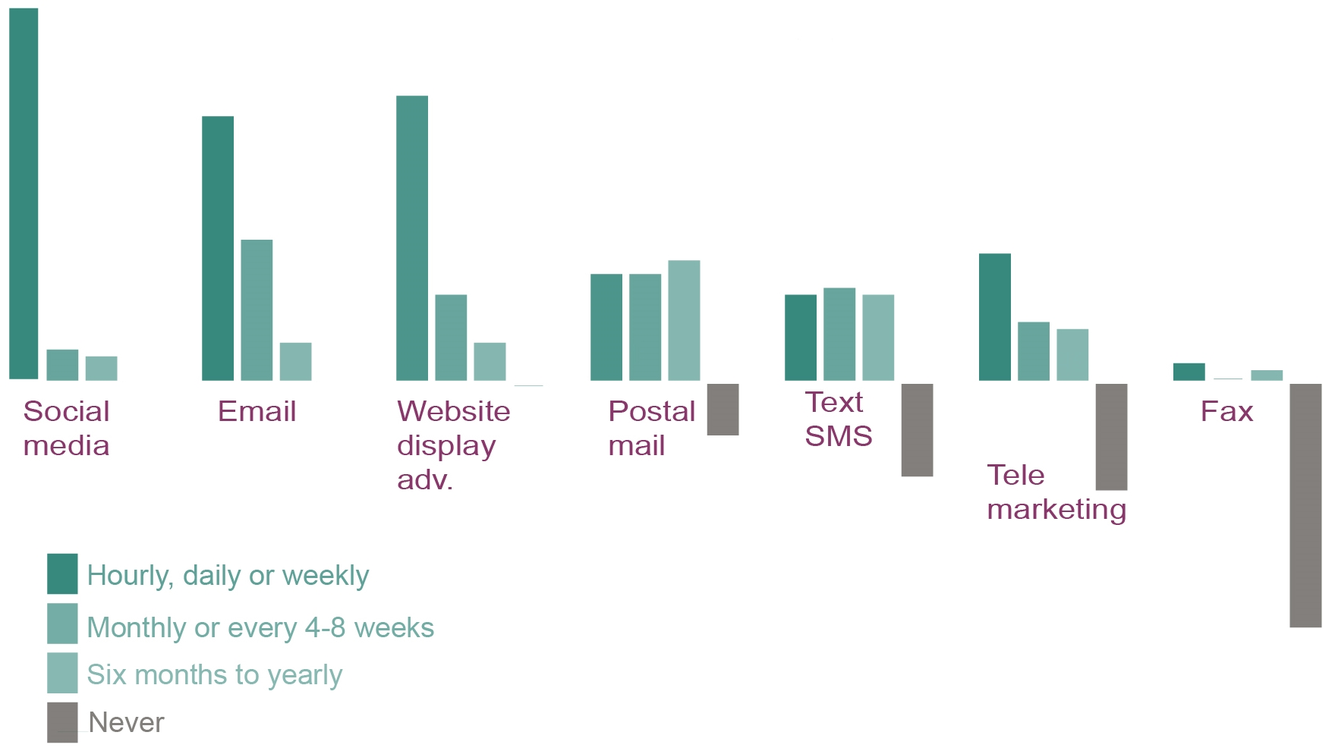

Source: ADMA industry survey 2016 (n=67).

1. Reasons for channel use and main benefits

|  |  |  |  |  |  |  |  |  |
| --- | --- | --- | --- | --- | --- | --- | --- | --- |
| Benefits  *(No. of respondents)* | | Email  *(65)* | Web display ad  *(61)* | Social  media  *(63)* | Postal  mail  *(46)* | Text /SMS  *(37)* | Tele-  marketing  *(36)* | Fax  *(13)* |
| Low cost | | 49 | 21 | 29 | 4 | 18 | 6 | 3 |
| Highly specified targeting of audience | | 36 | 23 | 29 | 12 | 14 | 12 | 1 |
| One-to-one communication | | 38 | 4 | 16 | 21 | 19 | 21 | 1 |
| Ease of use | 34 | | 27 | 27 | 9 | 15 | 4 | 2 |
| Easy to track | | 48 | 29 | 26 | 5 | 7 | 9 | 0 |
| Captive audience | | 17 | 11 | 17 | 12 | 10 | 6 | 1 |
| High return on investment | | 25 | 14 | 19 | 8 | 8 | 2 | 2 |
| Instant response | | 12 | 8 | 16 | 1 | 9 | 16 | 0 |
| Ability to send a lot of information | | 20 | 6 | 6 | 18 | 1 | 2 | 0 |
| Location targeting | | 5 | 4 | 7 | 6 | 0 | 0 | 0 |
| Restriction on information size | | 1 | 3 | 2 | 1 | 0 | 0 | 0 |
| Other | | 1 | 1 | 1 | 1 | 1 | 2 | 5 |

Question: Q23 ‘Why use this channel, what are the main benefits: Please tick all that apply?.’

Source: ADMA industrysurvey 2016 (n=67).

1. Reasons for channel use and main benefits

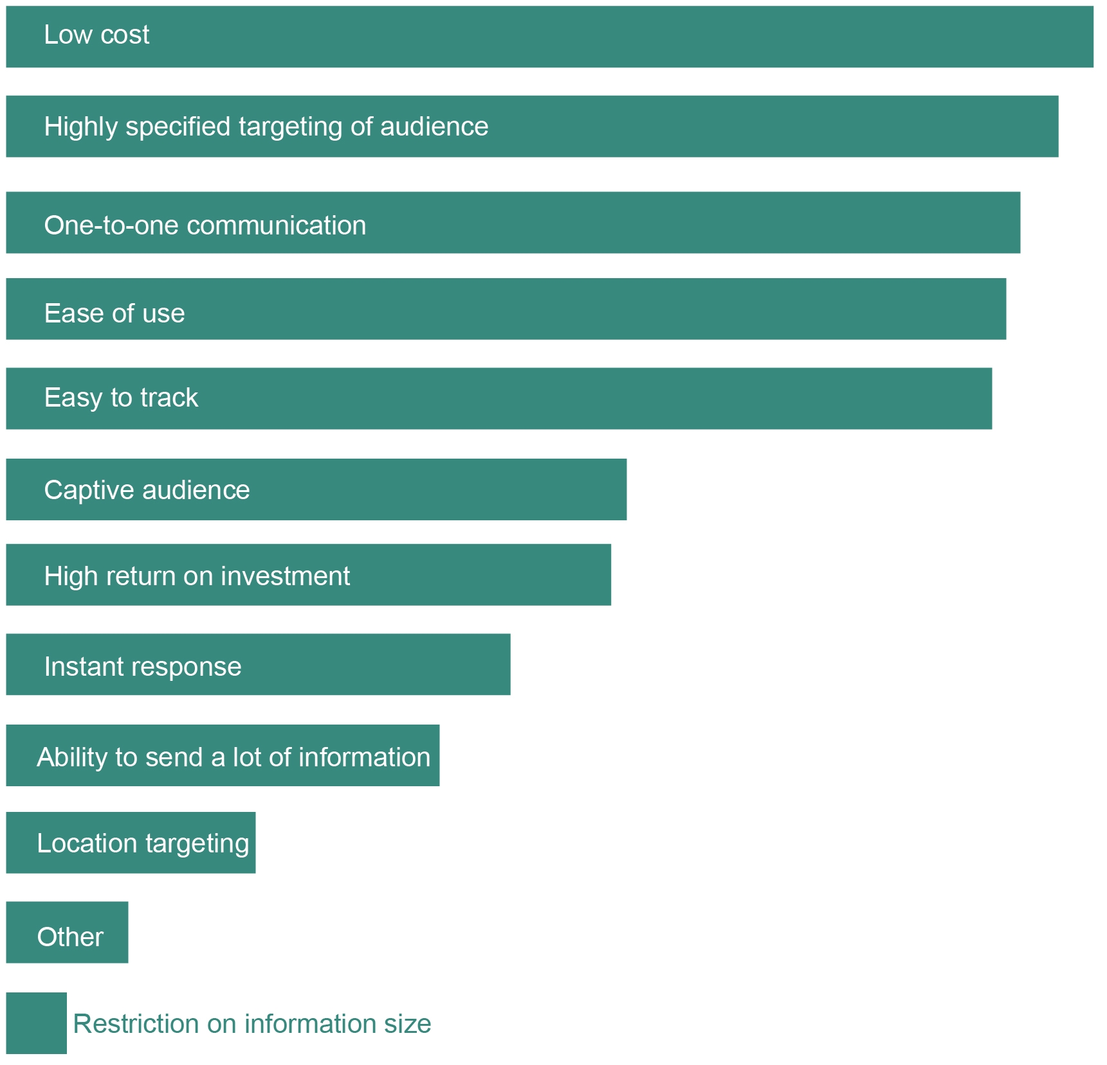

Source: ADMA industry survey 2016 (n=67).

1. Main drawbacks of marketing channels

|  |  |  |  |  |  |  |  |  |  |
| --- | --- | --- | --- | --- | --- | --- | --- | --- | --- |
| Drawbacks  *(No. of respondents)* | Email  *(61)* | | Web display ad  *(51)* | Social  media  *(47)* | Postal  mail  *(50)* | Text / SMS  *(39)* | Tele-  marketing  *(41)* | | Fax  *(22)* |
| Customers actively avoid communication via this channel | 21 | | 14 | 7 | 8 | 9 | 21 | 8 | |
| High cost | 2 | | 15 | 3 | 33 | 5 | 21 | 7 | |
| Can’t track what happens after it is sent | 6 | | 7 | 10 | 24 | 12 | 2 | 8 | |
| Message restrictions | 11 | | 13 | 10 | 0 | 21 | 5 | 3 | |
| Takes time to set up | 23 | | 10 | 6 | 16 | 1 | 3 | 2 | |
| Regulation and compliance issues | 20 | | 5 | 5 | 7 | 8 | 13 | 0 | |
| No delivery guarantee | | 13 | 9 | 10 | 14 | 6 | 0 | 3 | |
| Staff with the right channel skills are hard to find | 7 | | 10 | 12 | 2 | 2 | 10 | 1 | |
| Getting relevant data is difficult | 13 | | 4 | 6 | 4 | 4 | 3 | 3 | |

Question: Q24 ‘What are the main drawbacks of this channel (Please tick all that apply)?’

Source: ADMA industry survey 2016 (n=67).

1. Main drawbacks of marketing channels

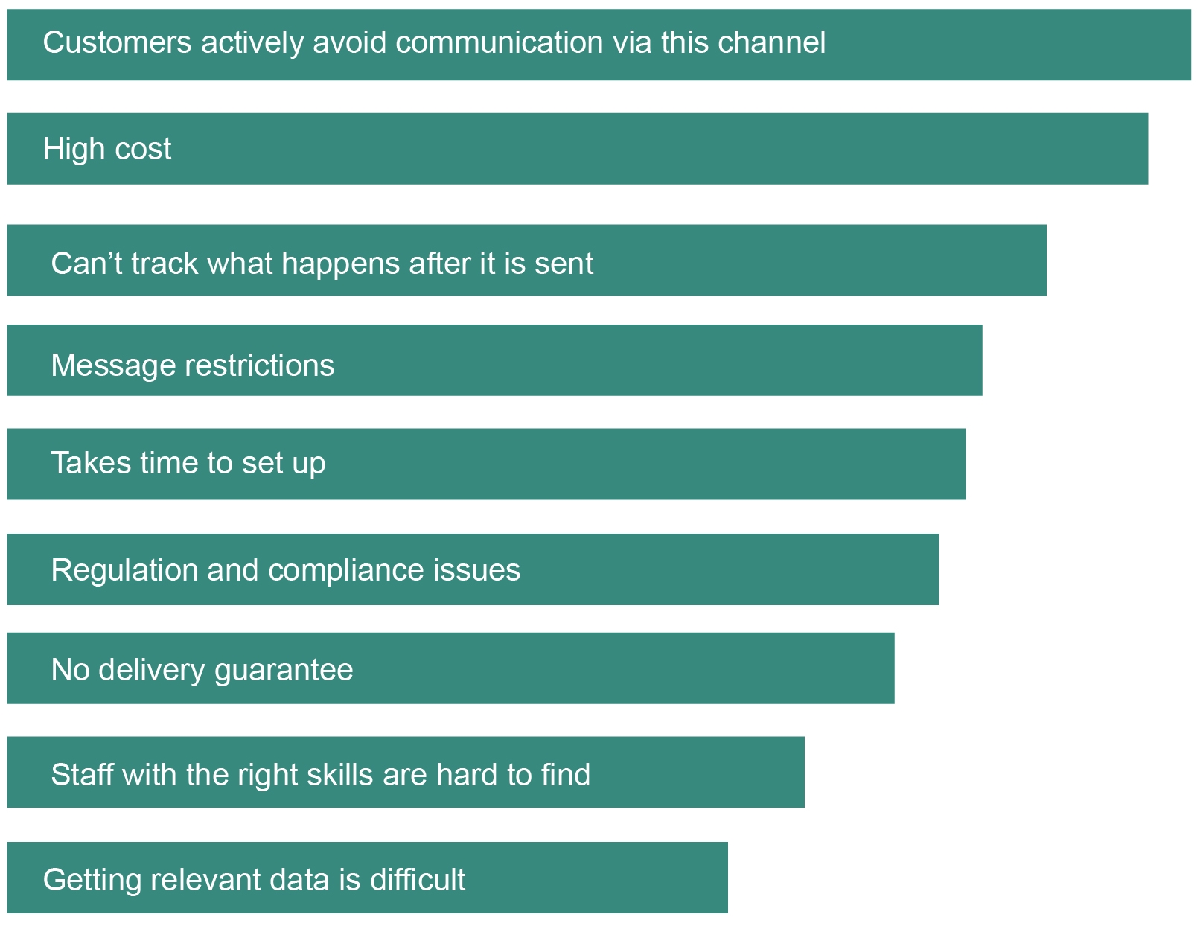

Source: ADMA industry survey 2016 (n=67).

## Marketing budgets

1. Annual marketing budget

|  |  |  |
| --- | --- | --- |
| Annual marketing budget | % | *n* |
| $0–100K | 19 | *13* |
| $100K–250K | 9 | *6* |
| $250K–500K | 4 | *3* |
| $500K–750K | 6 | *4* |
| $750K–1M | 6 | *4* |
| $1M–2M | 10 | *7* |
| $2M–5M | 9 | *6* |
| $5M+ | 15 | *10* |
| Prefer not to say | 21 | *14* |

Question Q25: ‘Approximately, what is your annual marketing budget?’

Source: ADMA industry survey 2016 (n=67).

1. Annual marketing budget—by %

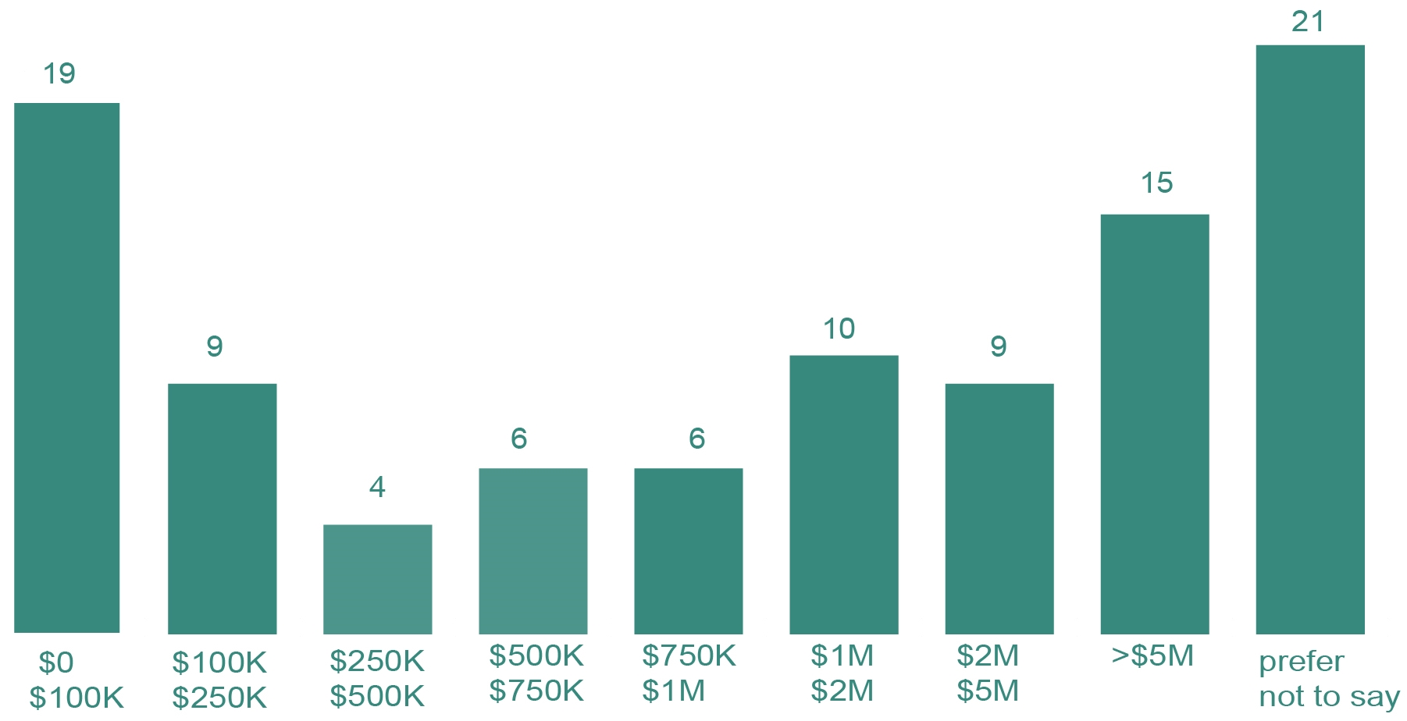

Source: ADMA industry survey 2016 (n=67).

1. Marketing budget spend per channel

|  |  |  |
| --- | --- | --- |
| Type of expenditure | Average % reported by respondents | *n* |
| Direct/data-driven marketing channels | 57 | *67* |
| Mass marketing channels | 40 | *58* |
| Other | 26 | *19* |

Question: Q26 ‘What percentage of your marketing budget is spent on: (must add up to 100%)

Source: ADMA industry survey 2016 (n=67).

Note: Percentage relates to the average percentage reported by respondents.

1. Marketing budget spend per channel—by %

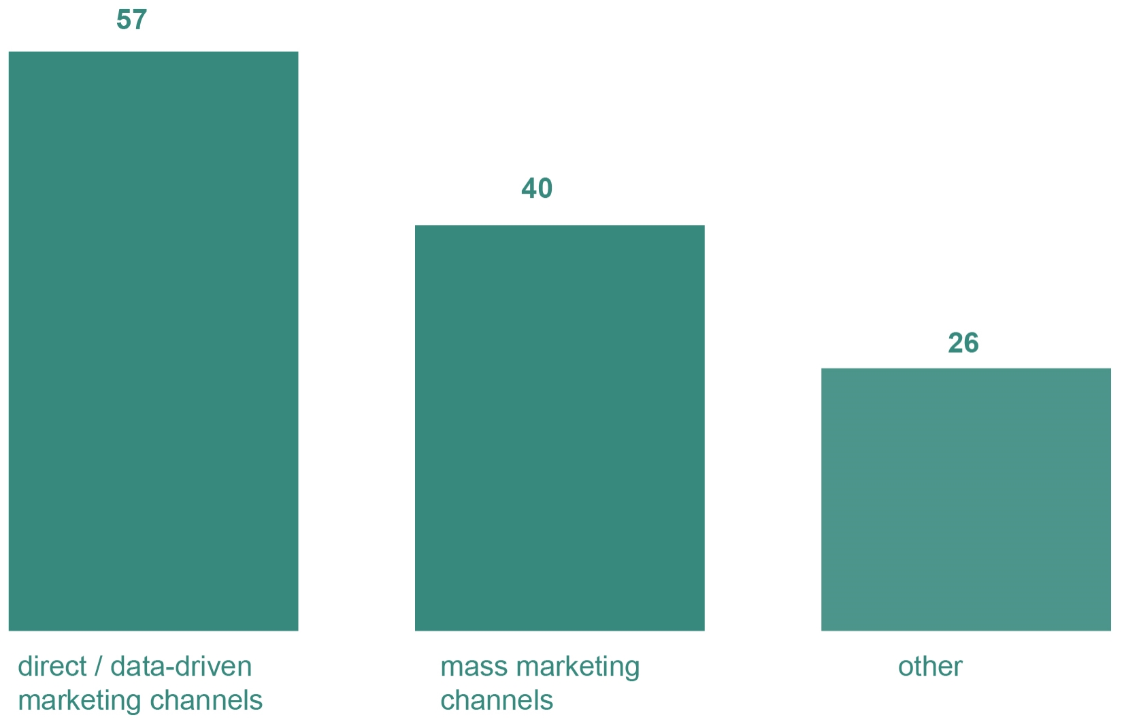

Source: ADMA industry survey 2016 (n=67).

1. Marketing budget spent on new customers’ acquisition vs. existing customers

|  |  |  |
| --- | --- | --- |
| Type of expenditure | Average % reported by respondents | *n* |
| Acquisition of new customers | 62 | *64* |
| Marketing to existing customers | 39 | *62* |

Question: Q27 ‘What percentage of your marketing budget is spent on’ (must add up to 100%)

Source: ADMA industry survey 2016 (n=64).

Note: Percentage relates to the average percentage reported by respondents.

1. Marketing budget spent on new customers’ acquisition vs. existing customers—by %

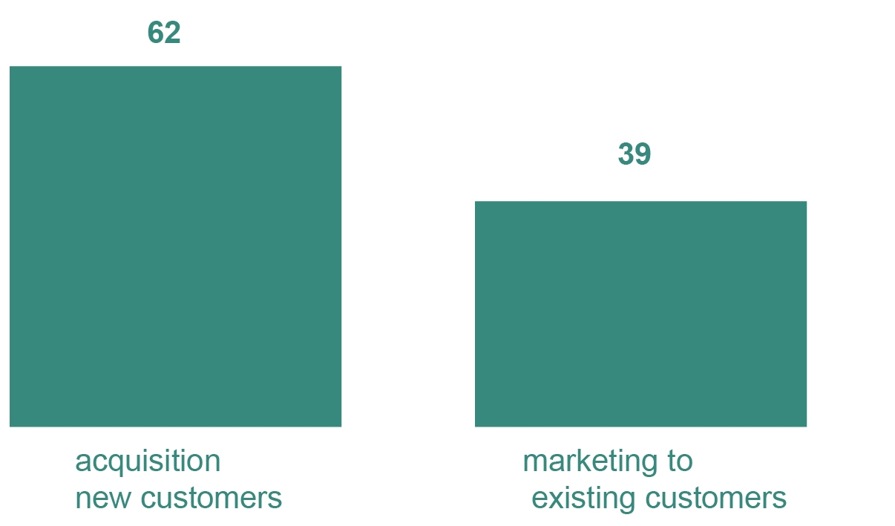

Source: ADMA industry survey 2016 (n=64).

1. Acquisition budget spend

|  |  |  |
| --- | --- | --- |
| Type of expenditure | Average % reported by respondents | *n* |
| Lead generation (e.g. telemarketing, competitions, website newsletter) | 48 | *57* |
| Affiliate marketing | 31 | *46* |
| External party data/outsourced data (purchased from a list broker) | 24 | *53* |
| Data scraping (sourcing data from public information, e.g. social media, phone book) | 17 | *46* |

Question: Q28 ‘What percentage of your acquisition budget is spent on?’

Source: ADMA industry survey 2016 (n=62).

Note: Percentage relates to the average percentage reported by respondents.

1. Acquisition budget spend—by %

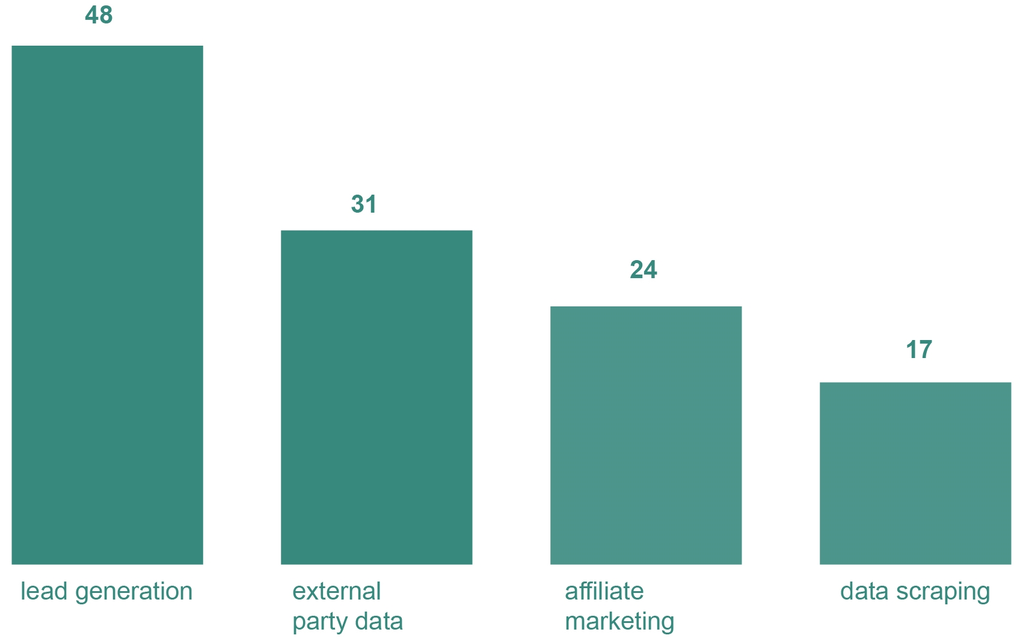

Source: ADMA industry survey 2016 (n=62).

1. Allocation of marketing budget by channels

|  |  |  |
| --- | --- | --- |
| Type | Average % reported by respondents | *n* |
| Email | 25 | *64* |
| Website display advertisement | 21 | *59* |
| Postal mail | 21 | *48* |
| Social media | 17 | *54* |
| Search engine marketing (SEM) | 13 | *43* |
| Telemarketing | 12 | *38* |
| Search engine optimisation (SEO) | 10 | *43* |
| Text/SMS mobile messaging | 6 | *38* |
| Mobile apps | 3 | *20* |
| Fax | 1 | *23* |
| Other | 14 | *17* |

Question: Q29 ‘What percentage of your direct/data-driven marketing budget is spent on? Note the total must add up to 100%.’

Source: ADMA industry survey 2016 (n=67).

Note: Percentage relates to the average percentage reported by respondents.

1. Allocation of marketing budget by channels

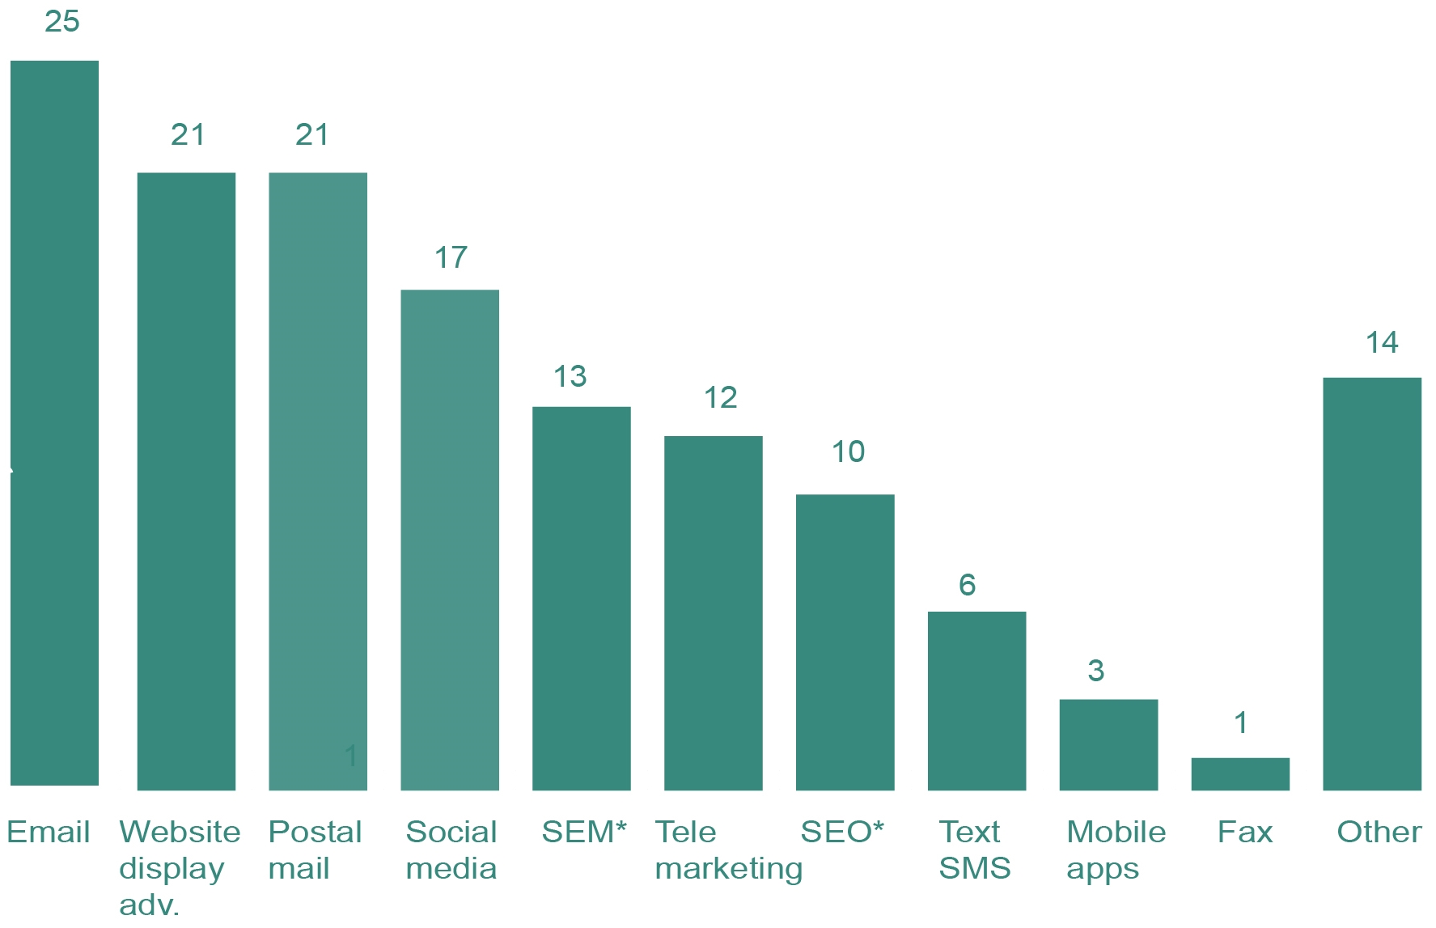

Note: SEM stands for search engine marketing and SEO for search engine optimisation.

Source: ADMA industry survey 2016 (n=67).

## Use of marketing channels

1. Changes in marketing spend by channel over the past year

|  |  |  |  |  |  |  |
| --- | --- | --- | --- | --- | --- | --- |
| Channels | Decreased significantly | Decreased | No change | Increased | Increased significantly | *n* |
|  | (%) | (%) | (%) | (%) | (%) |  |
| Website (your own site) | 0 | 0 | 24 | 60 | 15 | *58* |
| Social media | 0 | 2 | 21 | 52 | 26 | *62* |
| Search engine marketing or optimisation (SEM or SEO) | 0 | 2 | 32 | 49 | 17 | *59* |
| Website display advertisement | 0 | 7 | 36 | 42 | 15 | *59* |
| Email | 2 | 3 | 42 | 47 | 6 | *64* |
| Text/SMS mobile messaging | 2 | 6 | 65 | 25 | 2 | *52* |
| Mobile apps | 0 | 0 | 71 | 23 | 6 | *48* |
| Telemarketing | 8 | 21 | 64 | 6 | 2 | *53* |
| Postal mail | 14 | 28 | 46 | 11 | 2 | *57* |
| Fax | 20 | 2 | 77 | 0 | 0 | *44* |
| Other | 8 | 3 | 74 | 10 | 5 | *39* |

Question: Q30 ‘How has your spending on each of the following marketing channels changed over the past year?’

Source: ADMA industry survey 2016 (n=67).

1. Changes in marketing spend by channel over the past year—by %

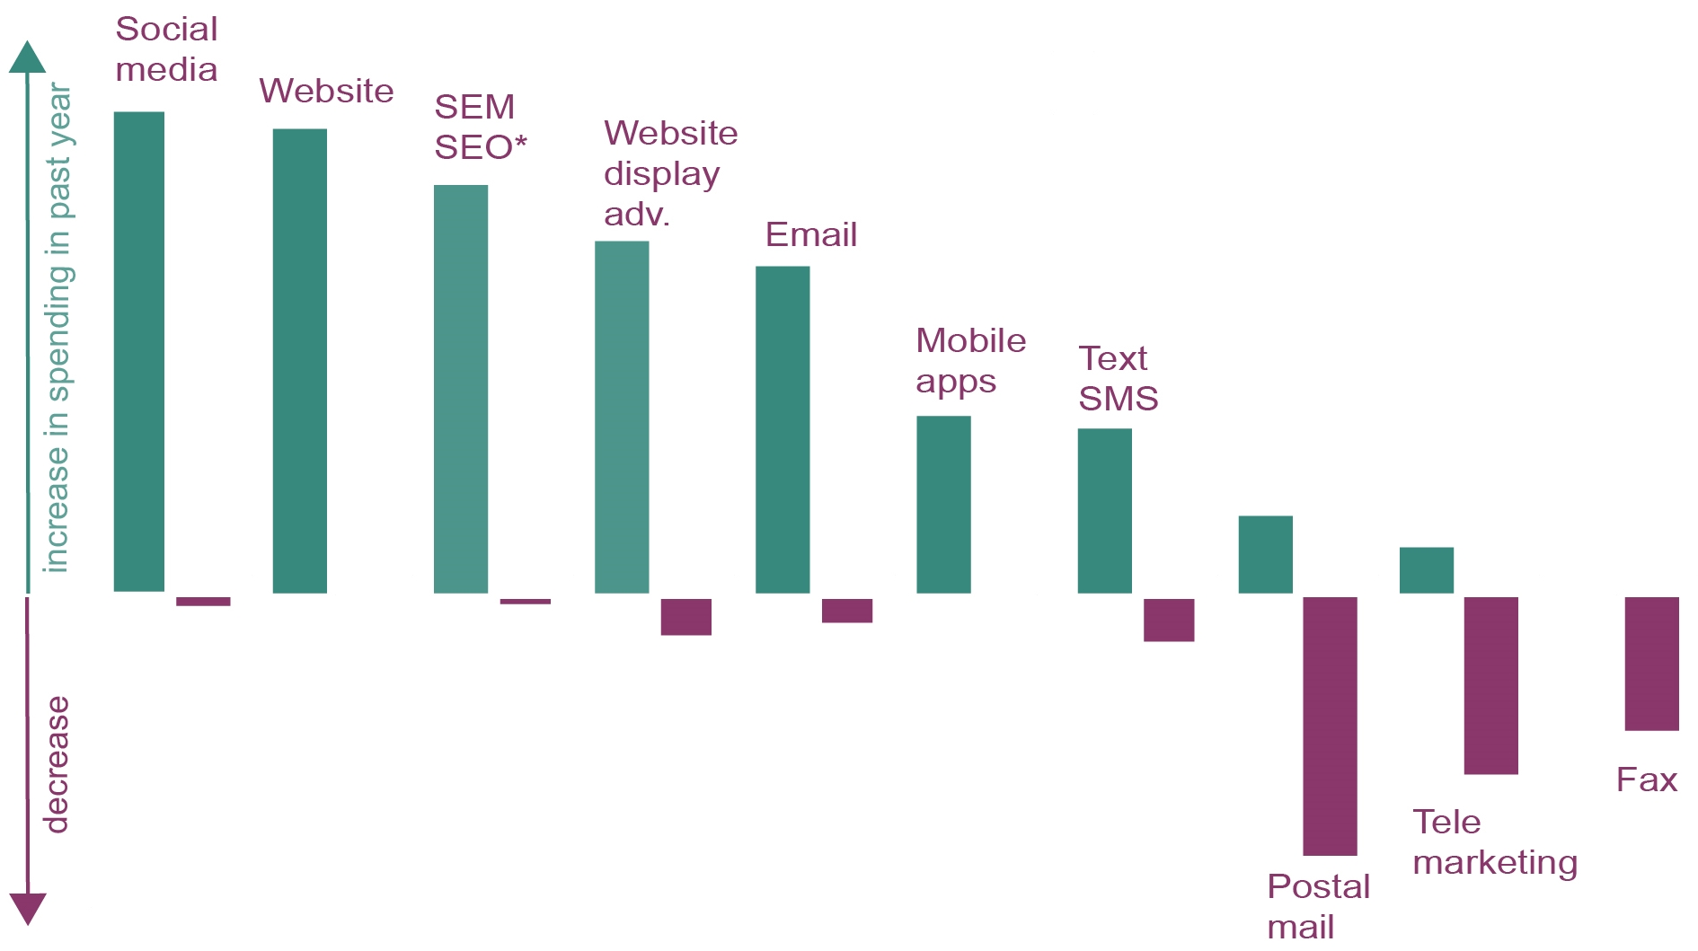

Note: SEM stands for search engine marketing and SEO for search engine optimisation.

Source: ADMA industry survey 2016 (n=67).

1. Expected change in use of channels over the next year

|  |  |  |  |  |  |  |
| --- | --- | --- | --- | --- | --- | --- |
| Channel | Decrease significantly | Decrease | No change | Increase | Increase significantly | *n* |
|  | (%) | (%) | (%) | (%) | (%) |  |
| Website (your own site) | 0 | 5 | 24 | 56 | 15 | *62* |
| Email | 0 | 9 | 34 | 53 | 3 | *64* |
| Social media | 0 | 3 | 25 | 45 | 28 | *65* |
| Search engine marketing or optimisation (SEM or SEO) | 0 | 7 | 27 | 47 | 19 | *59* |
| Website display advertisement | 0 | 3 | 30 | 47 | 20 | *60* |
| Mobile apps | 0 | 4 | 49 | 27 | 20 | *51* |
| Text/SMS mobile messaging | 0 | 8 | 40 | 46 | 6 | *52* |
| Telemarketing | 7 | 22 | 48 | 22 | 0 | *54* |
| Postal mail | 11 | 27 | 57 | 5 | 0 | *56* |
| Fax | 16 | 12 | 72 | 0 | 0 | *43* |
| Other | 5 | 3 | 76 | 11 | 5 | *38* |

Question: Q31 ‘How do you expect your spending to change over the next year for these channels?’

Source: ADMA industry survey 2016 (n=67).

1. Expected change in use of channels over the next year—by %

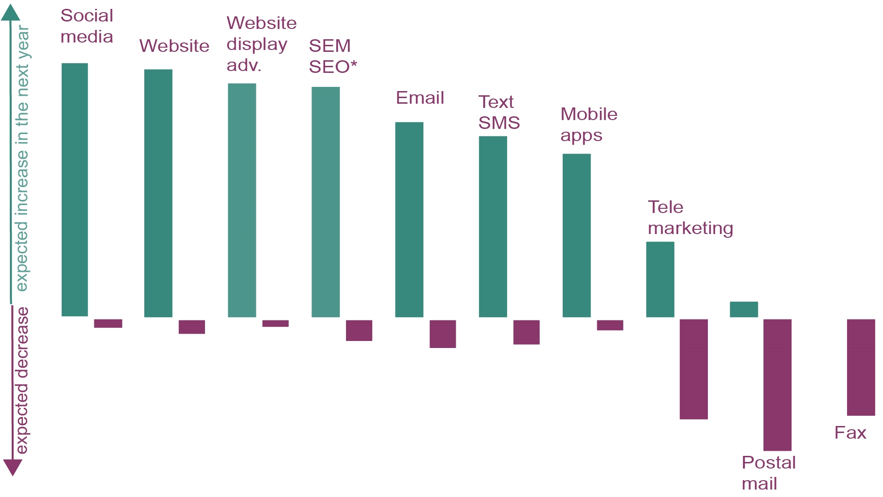

Note: SEM stands for search engine marketing and SEO for search engine optimisation.

Source: ADMA industry survey 2016 (n=67).

## Use of real-time data

The use of real-time data refers to real-time marketing, which involves marketing messages being sent to the consumer a few seconds to a few hours after a triggering action or interaction.

1. Use of real-time data to communicate optimised offers

|  |  |  |
| --- | --- | --- |
|  | % | *n* |
| Yes | 37 | *25* |
| No | 63 | *42* |

Question: Q32: ‘Do you use real-time data to communication optimised offers (e.g. a specific customer behaviour, like checking on a social media triggers a specific action to communication)’

Source: ADMA industry survey 2016 (n=67).

1. Use of real-time data to communicate optimised offers—by %

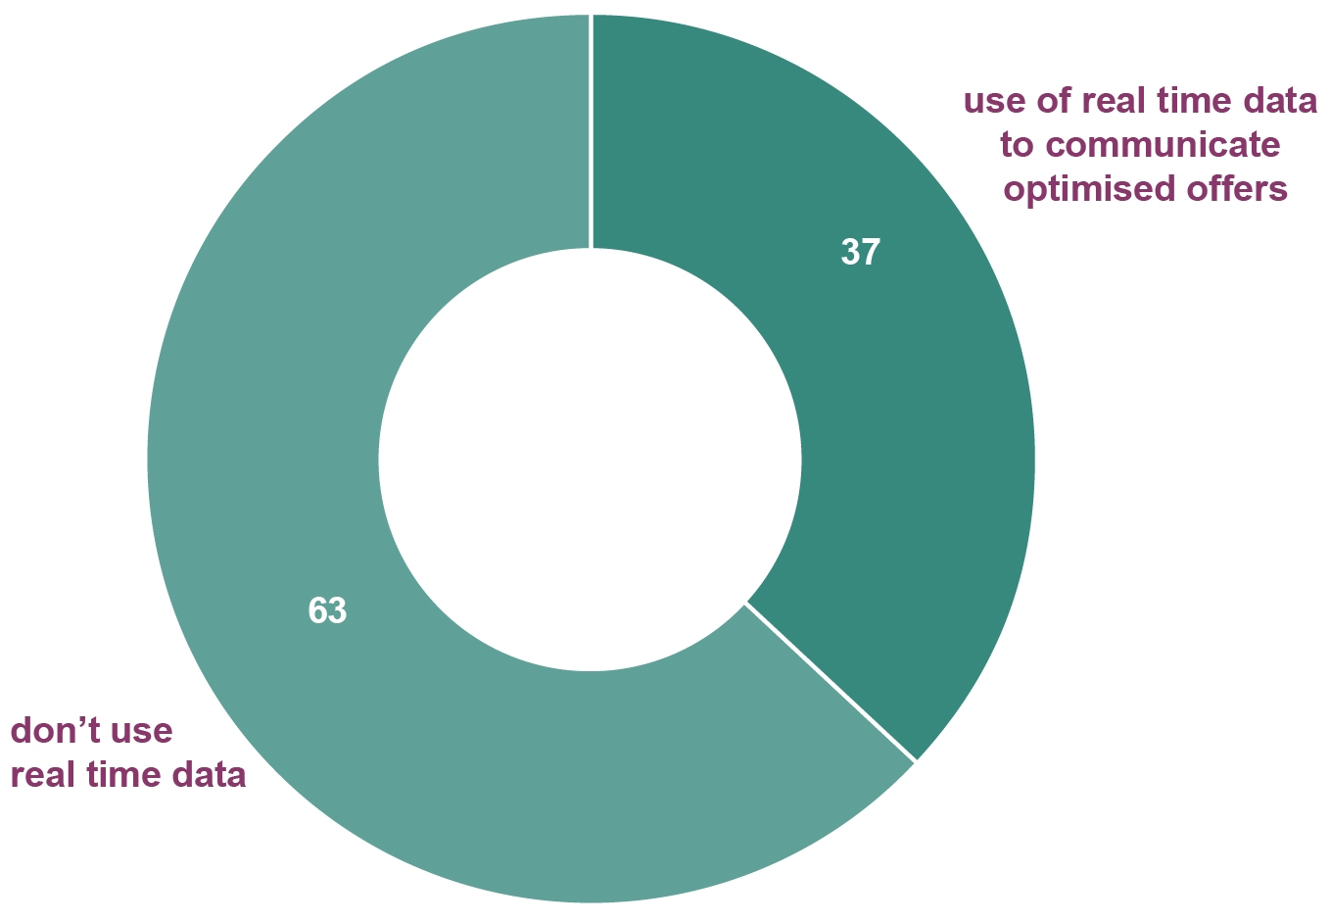

Source: ADMA industry survey 2016 (n=67).

1. Reasons for not using real time data

|  |  |  |
| --- | --- | --- |
| Reasons | % | *n* |
| We can’t monitor customer behaviours in real time | 31 | *22* |
| Our data isn’t good enough | 25 | *18* |
| We do not have the skills to make it work | 21 | *13* |
| We don’t have the budget for the technology | 19 | *14* |
| We don’t trust our data to automatically communicate with customers | 7 | *5* |

Question: Q33: ‘Why do you not use real-time data?’

Source: ADMA industry survey 2016 (n=42).

1. Reasons for not using real time data—by %

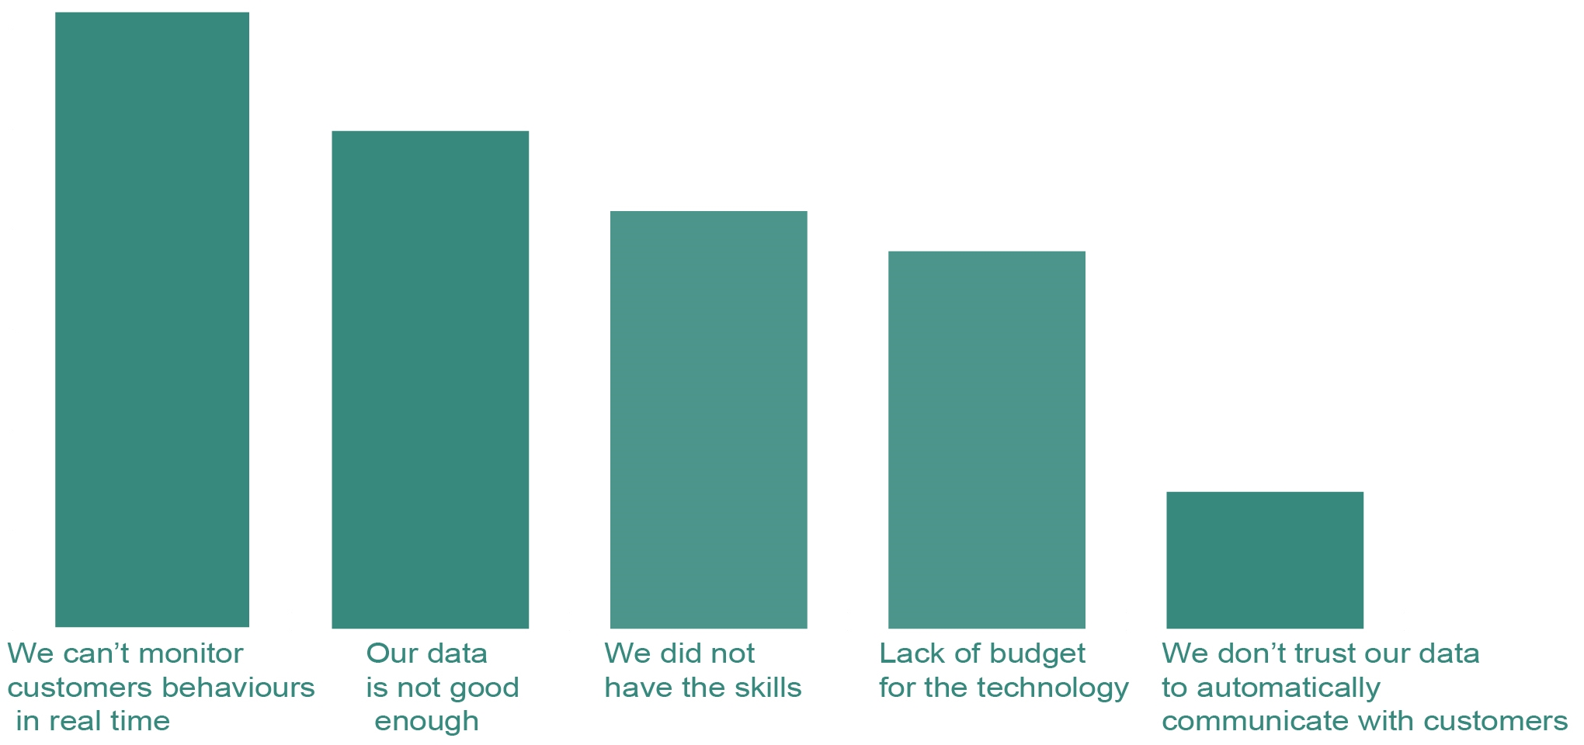

Source: ADMA industry survey 2016 (n=42).

1. Use of real-time data by channel

|  |  |  |  |  |
| --- | --- | --- | --- | --- |
| **Channels** | Currently  (%) | Plan to  (%) | Not considering  (%) | *n* |
| Email | 68 | 26 | 5 | *17* |
| Social media | 65 | 30 | 5 | *20* |
| Website content | 62 | 24 | 14 | *21* |
| Text/SMS messaging | 42 | 32 | 26 | *19* |
| Retargeting display* | 42 | 42 | 16 | *19* |
| Mobile apps | 29 | 41 | 29 | *17* |

Question: Q34 ‘Which of the following channels to you use with real-time data?’

Source: ADMA industry survey 2016 (n=21).

*Retargeting display refers to a form of marketing targeting users who have previously visited your website with banners ads on display networks across the web. It differs from normal display, which tends to target users in the first stages of the buying funnel.

Note: This is a low sample size (n=21)—results provided for information only. For this reason, no chart has been provided for this question Q34 in the survey.

## Changes in technology

1. Impact on marketing of changes in technology

|  |  |  |
| --- | --- | --- |
| Type of impact | % | *n* |
| Opportunity—it creates new openings and opportunities to interact with our markets | 66 | *37* |
| Advantage—it becomes an essential element in a new market offering | 50 | *28* |
| Obstacle—it creates an obstacle we have to navigate to continue our marketing | 5 | *3* |
| Set-back—it hinders our marketing efforts so much we have to make big changes | 4 | *2* |
| Irritant—it means we have to adjust our marketing slightly | 4 | *2* |

Question: Q35 ‘What impact does changes in technology have on marketing today?’

Source: ADMA industry survey 2016 (n=56).

1. Impact on marketing of changes in technology—by %

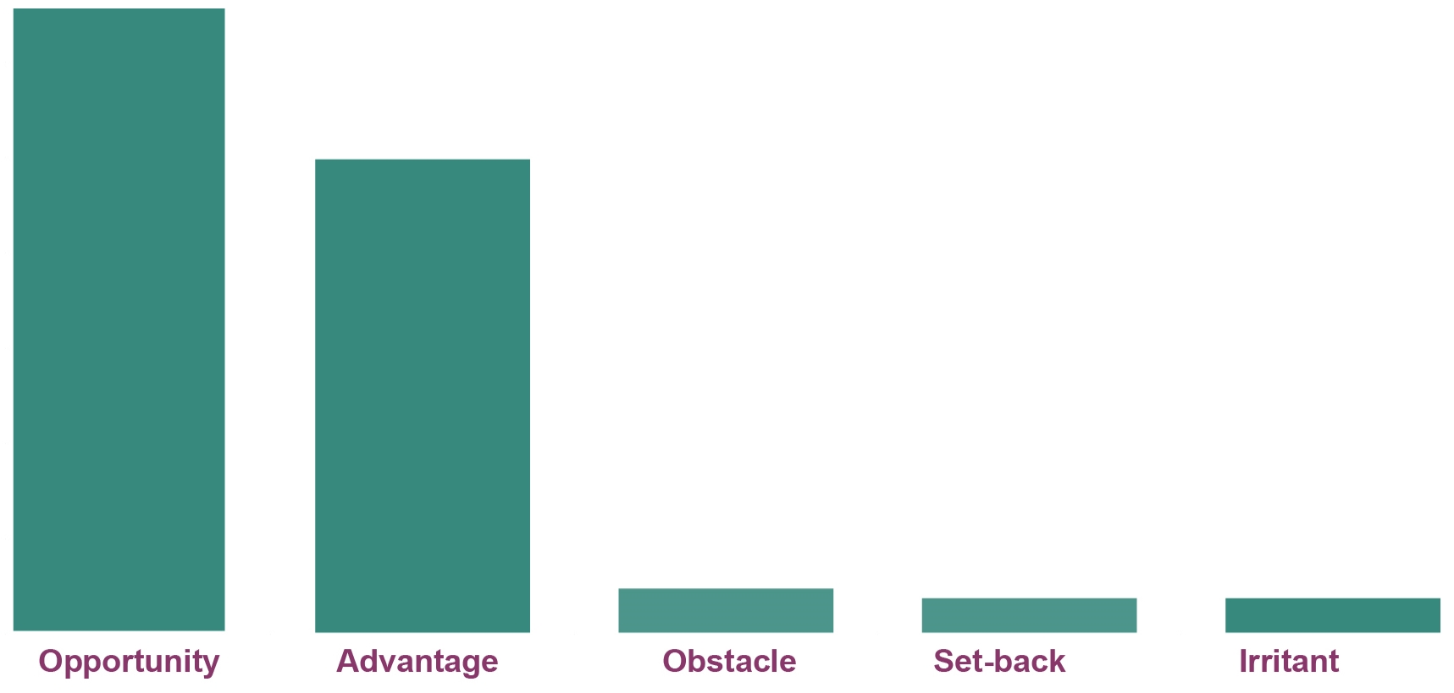

Source: ADMA industry survey 2016 (n=56).

1. Decisions to incorporate new technologies

|  |  |  |
| --- | --- | --- |
| Factors considered | % | *n* |
| If our strategy calls for a new technology we include it | 36 | *20* |
| We are always trialling new technologies | 23 | *13* |
| Once we see a large proportion of our customers using the technology | 18 | *10* |
| When the industry and media start covering it | 13 | *7* |
| Once the technology has a significant user base | 11 | *6* |

Question: Q36 ‘In terms of incorporating new technologies, how do you decide which technologies to include in your marketing?’

Source: ADMA industry survey 2016 (n=56).

1. Decisions to incorporate new technologies

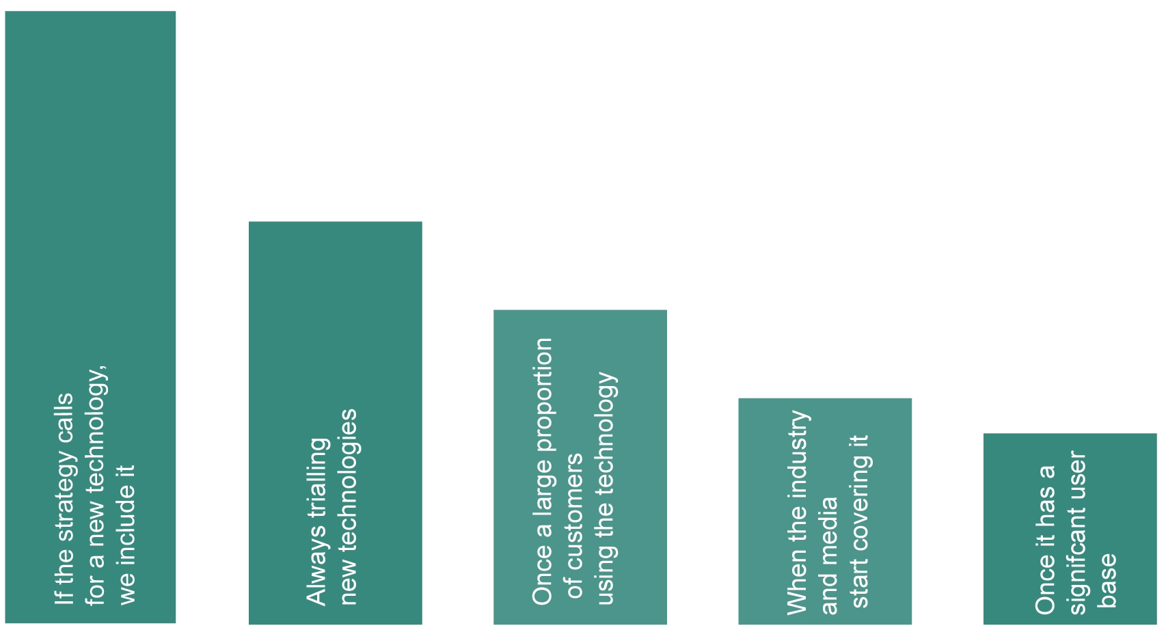

Source: ADMA industry survey 2016 (n=56).

1. [www.cio.com/article/2904405/data-analytics/what-is-data-driven-marketing.html](http://www.cio.com/article/2904405/data-analytics/what-is-data-driven-marketing.html), accessed 11 November 2016.