ACMA modem performance testing

Outcomes report

JULY 2019

Canberra

Red Building   
Benjamin Offices  
Chan Street   
Belconnen ACT

PO Box 78  
Belconnen ACT 2616

T +61 2 6219 5555  
F +61 2 6219 5353

Melbourne

Level 32   
Melbourne Central Tower  
360 Elizabeth Street   
Melbourne VIC

PO Box 13112  
Law Courts   
Melbourne VIC 8010

T +61 3 9963 6800  
F +61 3 9963 6899

Sydney

Level 5   
The Bay Centre  
65 Pirrama Road   
Pyrmont NSW

PO Box Q500  
Queen Victoria Building   
NSW 1230

T +61 2 9334 7700 or 1800 226 667  
F +61 2 9334 7799

Copyright notice

[Creative Commons logo](http://i.creativecommons.org/l/by/3.0/88x31.png)

[https://creativecommons.org/licenses/by/4.0//](https://creativecommons.org/licenses/by/4.0/)

With the exception of coats of arms, logos, emblems, images, other third-party material or devices protected by a trademark, this content is made available under the terms of the Creative Commons Attribution 4.0 International (CC BY 4.0) licence.

We request attribution as © Commonwealth of Australia (Australian Communications and Media Authority) 2019.

All other rights are reserved.

The Australian Communications and Media Authority has undertaken reasonable enquiries to identify material owned by third parties and secure permission for its reproduction. Permission may need to be obtained from third parties to re-use their material.

Written enquiries may be sent to:

Manager, Editorial Services  
PO Box 13112  
Law Courts  
Melbourne VIC 8010  
Email: [info@acma.gov.au](mailto:info@acma.gov.au)

Contents

Background 1

Scope 2

Executive summary 4

Definitions 7

Performance summary table 8

Test results 12

Set up 12

DSL (NBN line) performance 12

Performance on noisy lines 14

Bridge tap performance 14

Stability testing 15

Wired LAN performance 16

Wi-Fi performance 16

Appendix 1—Enex test process 29

Appendix 2—Data tables 35

# Background

The Australian Communications and Media Authority (ACMA) has conducted a study into the performance of modems and modem/routers (devices) used to supply phone and internet services over the National Broadband Network (NBN). The performance of different devices can affect the overall consumer experience when using services delivered over the NBN. For example, a poorly performing device may lead to lower effective data throughput and result in customer dissatisfaction with the speed of their NBN connection. The study was aimed at identifying:

* the extent that device performance can affect a consumer’s experience when using internet services delivered over the NBN
* the extent that device performance can affect a consumer’s experience when transferring information between locally connected accessories (such as network-attached storage)

the characteristics of devices that may lead to reduced performance.

To inform the study, the ACMA undertook a detailed market scan in late 2018 to identify the devices being provided by NBN retail service providers (RSPs) and sold in major electronic retailers. The specifications for performance testing were also informed by consultations with manufacturers, RSPs, NBN Co and consumer groups. Following an open tender process, the ACMA engaged [Enex Pty Ltd](http://testlab.com.au/about/) (Enex) to undertake performance testing of these devices.

The study is based upon the technical features and firmware as it existed in the devices tested during December 2018 to January 2019. It is important to understand that suppliers continually update their devices, both through hardware upgrades and firmware updates, which may have significant impacts on device performance. The ACMA does not represent that devices currently supplied retain all of the features as tested and reported on in this report.

# Scope

This report covers performance testing of 43 devices used in the supply of fibre-to-the-node/building (FTTN/B) NBN services. The 43 devices were identified by the ACMA through its market scan. Two samples of each device were provided directly by RSPs or purchased from electronic retailers for testing. The table below provides a summary of the device manufacturer (left column) and source (top row) of the 43 devices tested by Enex.

1. Summary of 43 devices by manufacturer and source

|  |  |  |  |  |  |  |  |  |  |  |  |  |
| --- | --- | --- | --- | --- | --- | --- | --- | --- | --- | --- | --- | --- |
| Device manufacturer | Electronic retailer | Activenet | Flip TV | Harbour ISP | iiNet | Mate/Barefoot | Optus | Spintel | Telstra | TPG | Vodafone | **Total** |
| Arcadyan |  |  |  |  |  |  |  |  | 1 |  |  | **1** |
| ASUS | 3 |  |  |  |  |  |  |  |  |  |  | **3** |
| Billion | 3 |  |  |  |  |  |  |  |  |  |  | **3** |
| D-Link | 7 |  |  |  |  |  |  |  |  |  |  | **7** |
| DrayTek | 1 |  |  |  |  |  |  |  |  |  |  | **1** |
| Linksys | 1 |  |  |  |  |  |  |  |  |  |  | **1** |
| Netcomm |  | 1 | 1 | 2 |  | 1 |  | 2 |  |  |  | **7** |
| Netgear | 6 |  |  |  |  |  |  |  |  |  |  | **6** |
| Sagecomm |  |  |  |  |  |  | 4 |  |  |  |  | **4** |
| Technicolor |  |  |  |  | 1 |  |  |  | 2 |  | 1 | **4** |
| TP-Link | 5 |  |  |  |  |  |  |  |  | 1 |  | **6** |
| **Total** | **26** | **1** | **1** | **2** | **1** | **1** | **4** | **2** | **3** | **1** | **1** | **43** |

Testing covered five criteria associated with the device’s digital subscriber line (DSL) performance:

1. Comparative performance in the presence of feeder line noise.
2. Comparative performance on varying copper feeder line lengths (ranging from 50 m to 1500 m).
3. Performance with parallel feeder connections (e.g. bridge taps, which are representative of poor/low quality field installations).
4. Communication stability/reliability testing over an extended time period (to detect any unexpected dropouts).

Testing of the maximum attainable sync rate on a 50 m feeder cable connection (typical of best DSL real world data performance).

There were also four criteria used to test the device’s Wi-Fi performance (where applicable):

1. Testing over various transmission distances (ranging from 5 m to 50 m).
2. Testing in the presence of other potentially interfering radio energy sources.
3. Testing with multiple device orientations (to identify non-symmetrical radio range performance issues).

Testing in the presence of obstacles to the wireless signal path (e.g. transmission through walls that might be encountered in a typical consumer home/office environment).

Between December 2018 and January 2019, testing of the 43 different devices was conducted by Enex under a range of conditions designed to emulate, as closely as possible, the operating conditions of a consumer’s typical home environment.[1]

The testing results provide a point in time snapshot of the performance of fixed-line NBN devices available on the market. Some of the devices tested (for example, Arcadyan LH1000 (Telstra Smart Modem 2.0) or Technicolor DMA0120VHA V2 (Vodafone)) enable access to 4G networks via an in-built SIM card. These devices are intended to allow consumers to access the internet when the fixed-line NBN service is not working. Testing of the device’s mobile data connectivity performance was out of scope for the ACMA’s study.

## About Enex

Enex ([www.testlab.com.au](http://www.testlab.com.au)) has been performing independent technical product testing and evaluations since 1989. Enex is ISO 9001 quality certified and has an ISO 17025 accredited test facility.

Enex owns and operates a dedicated facility located in Brunswick, Victoria. The facility houses a live NBN Digital Subscriber Line Access Multiplexer (DSLAM) for testing FTTN/B NBN RSP services (and also houses facilities to test satellite and fibre-to-the-premises (FTTP) products and services).

Executive summary

Commencing in December 2018, Enex, on behalf of the ACMA, tested 43 modem and modem routers (devices) across five DSL performance criteria and four Wi-Fi performance criteria. Twenty-six of the devices were sourced from electronic retailers with the remaining 17 sourced from 10 NBN RSPs. Most devices were relatively easy to set up with several (particularly RSP-supplied devices) offering a simple ‘plug and play’ experience. The devices were tested using the firmware as supplied in the box. This was to simulate the experience of a typical consumer setting up their device.

Overall, the testing found that DSL performance was relatively similar across the devices tested, with one exception[2]. However, Wi-Fi performance varied significantly across all the devices tested.

## DSL performance

The objective of DSL testing was to assess the device’s performance in connecting to the NBN including stability of the device once connected, whether it was able to achieve the manufacturer’s advertised speed and the performance of a device using typical ‘real world’ line conditions.

There was largely no evidence of DSL stability issues with the devices tested (apart from the Linksys X6200 AC750). However, testing did find that a device’s download performance can be seriously affected by noise and there was significant variation in performance between devices on noisy lines.

Testing also simulated the impact of a typical bridge tap[3]. The average effect of the bridge tap was to reduce a device’s download performance to 50 per cent of the NBN line capability.

## Wi-Fi performance

The objective of Wi-Fi testing was to assess the likely impact of the technology on a consumer’s experience in accessing both the internet and home network. The testing investigated the use of particular Wi-Fi bands (i.e. 2.4 GHz compared to 5 GHz), the impact of typical obstructions such as walls, the effect of interfering radio frequency (RF) technologies/systems and the Wi-Fi performance across different distances*.*[4]

Overall, the 2.4 GHz Wi-Fi performance of devices was lower in both capability and range compared to the 5 GHz band.[5] Testing also found that the more expensive Wi-Fi-enabled devices do not necessarily yield greater performance in terms of internet link speeds and Wi-Fi range and performance.

Testing also found that any significant obstacles in the signal path (e.g. intervening walls and other structures in a home) are likely to have a major detrimental effect on the consumer’s Wi-Fi experience. While 5 GHz Wi-Fi is generally considered to be more affected by walls and distance compared to 2.4 GHz Wi-Fi, in reality most 5 GHz Wi-Fi devices tested provided better data streaming performance through walls and at a greater distance compared with their equivalent 2.4 GHz Wi-Fi performance.

Interference from neighbouring Wi-Fi routers and appliances can affect the overall performance of a device’s Wi-Fi performance, sometimes significantly. All devices tested showed some degree of external interference susceptibility in the 2.4 GHz band. However, there were no consistent factors observed indicating why some devices performed better than others.

In terms of Wi-Fi directional testing, considerable variation in ’real world’ transmit signal strength between devices was observed. Several devices were found to have direction dependent Wi-Fi transmission characteristics which may lead to challenges orientating the device for optimal Wi-Fi coverage in a typical consumer’s home or office environment. External antennas, where available, could be adjusted to improve network reception. However, this adjustment would be largely by trial and error and for many devices, optimisation of Wi-Fi reception in one direction is likely to be at the expense of reception in another direction.

## Key findings

From observations and testing results, Enex concluded that:

1. A number of devices tested only offer 100 Mbps wired LAN. Based on the methodology used to conduct the tests, these devices typically provide lower overall LAN to Wi-Fi performance levels compared to those devices offering 1 Gbps wired LAN.[6] However, if a consumer’s NBN service throughput is limited to 100 Mbps, then using a device only offering 100 Mbps wired LAN is unlikely to adversely affect a consumer’s NBN experience.
2. There is a very wide variation in Wi-Fi performance capabilities offered across the range of devices and this is likely to lead to some degree of consumer frustration.
3. A large number of devices have 2.4 GHz Wi-Fi that is incapable of supporting the higher data rates currently offered by FTTN/B NBN services. In fact, some of the devices tested were barely capable of supporting the lower data rates offered by certain FTTN/B NBN services.
4. More expensive devices did not necessarily yield greater performance in terms of internet link speeds and Wi-Fi range and performance. In many cases significantly lower priced devices outperformed (in real world terms) many of the more expensive devices, even those from the same manufacturer.
5. However, higher priced devices typically contained more features and functionality such as flexible parental controls, more LAN ports, greater Wi-Fi capability, access to the latest Wi-Fi specifications and additional security features.
6. Compatibility issues between a consumer’s Wi-Fi devices (particularly older legacy devices such as older laptops, phones or computers) and their modem/modem router is likely to result in them being unable to achieve optimal performance of their FTTN/B NBN service.

Better Wi-Fi performance (and consequently better NBN performance) would be achieved by choosing a device using the 802.11ac standard (or next generation 802.11ax, also known as Wi-Fi 6) operating in the 5 GHz band.

The outcomes of the study have informed the preparation of practical consumer information and guidance to assist consumers in making well-informed decisions in purchasing, setting up and using Wi-Fi modems.

# Definitions

The following definitions are used throughout this report:

**Measured DSL speed (@500 m):** This is the average data transfer speeds (in Mbps) for both down and up link tests achieved for an extended period of 16 hours over a typical copper feeder length of 500 m.

**Performance on noisy DSL line (@1050 m):** This is the average data transfer speed (in Mbps) during the noise performance test divided by the clean line speed (in Mbps) for the same line length. Performance is calculated for both the down link and up link during the noise performance test.

**Wi-Fi:** A type of wireless local area network (WLAN) technology that uses radio waves to provide wireless high-speed internet and network connections using specifications in the Institute of Electrical and Electronic Engineers (IEEE) 802.11 series of WLAN standards.

**Wi-Fi bands:** The radiofrequency ranges used for Wi-Fi communications. The two main bands used for Wi-Fi are the 2.4 GHz band (frequency range between 2400 MHz and 2483.5 MHz) and the 5 GHz band (frequency range of 5725 MHz and 5875 MHz).

**Wi-Fi type:** The categories of Wi-Fi technologies that are based on the IEEE wireless communication standard 802.11. There are several different 802.11 variants in use which use different frequency bands, with 802.11ac being the most recent at the time of testing.

**Manufacturer claimed Wi-Fi speed:** Where applicable, this is based on the manufacturer’s documentation and shows a device’s maximum theoretical speed (in Mbps)—i.e. without any RF interference or noise—per applicable Wi-Fi band.

**Measured Wi-Fi speed (with 2x2 MU-MIMO test device):** Based on Wi-Fi performance testing conducted at a distance of 5 m using a laptop computer with modern specifications (typical of a consumer’s home/small office environment).

**Wi-Fi noise immunity:** Measured data rate (in Mbps) in the presence of RF emissions from a modified domestic microwave oven (2.4 GHz) divided by the measured data rate with no interference.

**Wi-Fi performance at long range – 2.4 GHz:** The highest measured data rate (in Mbps) at a distance of 50 m, using the 2.4 GHz band.

**Wi-Fi performance at long range – 5 GHz:** The highest measured data rate (in Mbps) at a distance of 50 m, using the 5 GHz band.

# Performance summary table

1. Performance summary (all models)

Note: This is not a table of ranked devices. The devices listed in this table are sorted alphabetically for the initial 26 devices sourced from electronic retailers and then by the remaining 17 devices sourced from RSPs. Not tested = Not able to be tested, N/A = Not applicable, N/R = Not reported and N/S = Not specified.

Note: LAN to Wi-Fi speeds were potentially limited by the 100 Mbps LAN ports on some devices in the Wi-Fi test configuration. These devices are indicated in the table. Despite the LAN speed restriction for some devices, all testing achieved data rates that were typically equivalent to the highest rates supported by the current FTTN/B services available.

| **Manufacturer & model** | **Price or supplied by (Nov 2018)[7]** | **Measured DSL speed** | | | | **Wi-Fi band/s** | **Wi-Fi type/s** | **LAN to Wi-Fi speed** | | | | **Wi-Fi noise immunity (% noise free speed)** | **LAN to Wi-Fi  long range performance (@50 m)**  **(Mbps)** | |
| --- | --- | --- | --- | --- | --- | --- | --- | --- | --- | --- | --- | --- | --- | --- |
| **@500 m**  **(Mbps)** | | **On noisy DSL line (@1050 m)**  **(% clean line speed)** | | **Manufacturer claimed**  **(Mbps)** | | **As measured[8]**  **(Mbps)** | |
| **Download** | **Upload** | **Download** | **Upload** | **2.4 GHz** | **5  GHz** | **2.4 GHz** | **5 GHz** | **2.4 GHz** | **5 GHz** |
| **Retailer sourced modems** | | | | | | | | | | | | | | |
| ASUS DSL-AC68U AC1900 | $269 | 75 | 30 | 47% | 76% | 2.4GHz/5GHz | 802.11a/b/g/n/ac | 600 | 1300 | 135 | 577 | 53% | 10 | 135 |
| ASUS DSL-AC88U AC 3100 | $549 | 81 | 30 | 51% | 71% | 2.4GHz/5GHz | 1024QAM (2.4GHz & 5GHz), 802.11a/b/g/n/ac | 1000 | 2167 | 155 | 571 | 71% | 3 | 158 |
| ASUS DSL-AC52U AC750 | $139 | 71 | 31 | 33% | 54% | 2.4GHz/5GHz | 802.11a/b/g/n/ac | 300 | 433 | 157 | 259 | 57% | 0 | 61 |
| Billion 8700NEXL N300[9] | $115 | 61 | 28 | 37% | 58% | 2.4GHz | 802.11b/g/n | 300 | N/A | 67 | N/A | 4% | 1 | N/A |
| Billion BIPAC8700AXL Triple-WAN | $189 | 82 | 35 | 69% | 43% | 2.4GHz/5GHz | 802.11a/b/n/g/ac | 300 | 1300 | 67 | 606 | 19% | 1 | 188 |
| Billion BIPAC8900X Triple-WAN[10] | $255 | 76 | 33 | 73% | 55% | N/A | N/A | N/A | | N/A | N/A | N/A | N/A | N/A |
| D-Link AC1600 - DSL-2888A | $199 | 76 | 33 | 33% | 63% | 2.4GHz/5GHz | 802.11b/g/n/ac | 300 | 1300 | 149 | 292 | 26% | 6 | 49 |
| D-Link DSL-G225[11] | $79 | 74 | 30 | 40% | 62% | 2.4GHz | 802.11n | 300 | N/A | 90 | N/A | 33% | 0 | N/A |
| D-Link DSL-4320L - Taipan - AC3200 | $478 | 70 | 30 | 47% | 79% | 2.4GHz/5GHz | 802.11b/g/n/ac | 600 | 1300 | 70 | 571 | 18% | 0 | 97 |
| D-Link Wireless AC1200 DSL-3785 | $199 | 59 | 30 | 62% | 33% | 2.4GHz/5GHz | 802.11b/g/n/ac | 300 | 866 | 89 | 562 | 20% | 2 | 108 |
| D-Link AC750 DSL-2877AL[12] | $156 | 67 | 31 | 35% | 13% | 2.4GHz/5GHz | 802.11a/b/g/n/ac | 300 | 433 | 58 | 75 | 27% | 0 | 26 |
| D-Link DVA-2800 AC1600 | $329 | 76 | 30 | 32% | 58% | 2.4GHz/5GHz | 802.11b/g/n/ac | 300 | 1300 | 141 | 253 | 43% | 0 | 45 |
| D-Link Cobra AC5300 DSL-5300 | $629 | 71 | 30 | 40% | 66% | 2.4GHz/5GHz | 802.11b/g/n/ac | 1000 | 2167 | 71 | 590 | 22% | 6 | 110 |
| DrayTek Vigor DV130[13] | $140 | 65 | 31 | 60% | 83% | N/A | `N/A | N/A | | N/A | N/A | N/A | N/A | N/A |
| Linksys X6200 AC750[14] | $129 | Not tested | Not tested | Not tested | Not tested | 2.4GHz/5GHz | 802.11b/a/g/n/ac | 300 | 433 | 110 | 364 | 27% | 5 | 20 |
| Netgear AC1200 D6220 | $178 | 70 | 30 | 49% | 75% | 2.4GHz/5GHz | 802.11b/g/n/ac | 300 | 900 | 94 | 374 | 24% | 1 | 121 |
| Netgear AC1600 D6400 | $225 | 72 | 30 | 31% | 50% | 2.4GHz/5GHz | 802.11a/b/g/n/ac | 300 | 1300 | 49 | 379 | 23% | 0 | 0 |
| Netgear DM200[15] | $75 | 72 | 27 | 38% | 42% | N/A | N/A | N/A | | N/A | N/A | N/A | N/A | N/A |
| Netgear AC2600 Nighthawk D7800 X4S | $399 | 69 | 28 | 46% | 61% | 2.4GHz/5GHz | 802.11a/b/g/n/ac | 800 | 1733 | 85 | 571 | 29% | 0 | 169 |
| Netgear D8500 X8 AC5300 | $799 | 75 | 31 | 49% | 79% | 2.4GHz/5GHz | 802.11a/b/g/n/ac | 1000 | 2166 | 63 | 498 | 21% | 4 | 72 |
| Netgear Nighthawk AC1900 R7000 | $268 | 80 | 30 | 49% | 82% | 2.4GHz/5GHz | 802.11a/b/g/n/ac | 450 | 1300 | 127 | 624 | 40% | 0 | 120 |
| TP-Link Archer AC1200 (TD-ARCHERVR400 | $149 | 72 | 30 | 45% | 77% | 2.4GHz/5GHz | 802.11a/b/g/n/ac | 300 | 867 | 139 | 317 | 37% | 5 | 122 |
| TP-Link Archer AC2800 (TDARCHERVR2800) | $349 | 69 | 31 | 27% | 50% | 2.4GHz/5GHz | 802.11a/b/g/n/ac | 600 | 2167 | 141 | 628 | 11% | 2 | 157 |
| TP-Link TD-W9970 | $88 | 65 | 34 | 31% | 66% | 2.4GHz | 802.11b/g/n | 300 | N/A | 89 | N/A | 48% | 0 | N/A |
| TP-Link Archer 1900 VR900 | $199 | 66 | 34 | 40% | 71% | 2.4GHz/5GHz | 802.11a/b/g/n/ac | 600 | 1300 | 155 | 596 | 46% | 2 | 94 |
| TP-Link Archer AC1600 VR600 | $198 | 67 | 32 | 41% | 53% | 2.4GHz/5GHz | 802.11a/b/g/n/ac | 300 | 1300 | 138 | 518 | 50% | 2 | 136 |
| **Service Provider supplied modems** | | | | | | | | | | | | | | |
| Technicolor DJA0231TLS (Smart Modem 2.0) | Telstra | 84 | 34 | 36% | 58% | 2.4GHz/5GHz | 802.11a/b/g/n/ac | 260 | 2166 | 68 | 613 | 15% | 6 | 145 |
| Technicolor DJA0230 (Smart Modem 1.1) | Telstra | 72 | 34 | 36% | 60% | 2.4GHz/5GHz | 802.11a/b/g/n/ac | 260 | 2166 | 76 | 603 | 26% | 5 | 88 |
| Arcadyan LH1000 (Smart Modem 2.0) | Telstra | 68 | 30 | 37% | 53% | 2.4GHz/5GHz | 802.11a/b/g/n/ac | N/S | | 145 | 628 | 26% | 7 | 130 |
| Netcomm AC1600 NF18ACV | Mate/ Barefoot | 73 | 34 | 57% | 65% | 2.4GHz/5GHz | 802.11n/ac | 1600 combined | | 103 | 577 | 22% | 1 | 101 |
| TP-Link AC1200 Archer VR500V | Flip TV | 72 | 32 | 0% | 0% | 2.4GHz/5GHz | 802.11a/b/g/n/ac | 300 | 867 | 149 | 348 | 44% | 4 | 25 |
| Netcomm AC1600 NF18ACV | Activenet | 71 | 27 | 37% | 45% | 2.4GHz/5GHz | 802.11n/ac | 1600 combined | | 100 | 586 | 30% | 2 | 163 |
| Netcomm AC1600 NF18ACV | Harbour ISP | 81 | 30 | 25% | 43% | 2.4GHz/5GHz | 802.11n/ac | 1600 combined | | 120 | 587 | 45% | 1 | 173 |
| Netcomm N300 NF10WV[16] | Harbour ISP | 54 | 32 | 53% | 47% | 2.4GHz | 802.11n | 300 | N/A | 86 | N/A | 18% | 0 | N/A |
| Technicolor DMA0120VHA V2[17] | Vodafone | 69 | 34 | 34% | 53% | 2.4GHz/5GHz | 802.11a/b/g/n/ac | 400 | 1300 | 75 | 89 | 18% | 3 | 76 |
| Netcomm AC1600 NF18ACV | Spintel | 75 | 28 | 72% | 59% | 2.4GHz/5GHz | 802.11n/ac | 1600 combined | | 110 | 571 | 13% | 1 | 108 |
| Netcomm N300 NF10WV[18] | Spintel | 34 | 17 | 48% | 52% | 2.4GHz | 802.11n | 300 | N/A | 88 | N/A | 53% | 0 | N/A |
| TP-Link VR1600V | TPG | 78 | 30 | 35% | 43% | 2.4GHz/5GHz | 802.11a/b/g/n/ac | N/S | | 121 | 577 | 34% | 2 | 206 |
| Sagemcom F@ST 3864V3 AC | Optus | 77 | 32 | 51% | 77% | 2.4GHz/5GHz | 802.11b/g/n/ac | N/S | | 87 | 530 | 13% | 2 | 125 |
| Sagemcom F@ST 3864V3 OP | Optus | 81 | 31 | N/R[19] | 76% | 2.4GHz | 802.11b/g/n | N/S | N/A | 122 | N/A | 22% | 0 | N/A |
| Sagemcom F@ST 3864AC | Optus | 75 | 29 | 32% | 42% | 2.4GHz/5GHz | 802.11b/g/n/ac | N/S | | 158 | 319 | 11% | 1 | 85 |
| Sagemcom F@ST 3864OP | Optus | 76 | 29 | 32% | 43% | 2.4GHz | 802.11b/g/n | N/S | N/A | 151 | N/A | 52% | 0 | N/A |
| Technicolor TG789vac v2[20] | iiNet | 76 | 32 | 35% | 48% | 2.4GHz/5GHz | 802.11a/b/g/n/ac | 270 | 1300 | 73 | 400 | 29% | 0 | 81 |

# Test results

## Setup

To replicate the consumer experience, the Enex test team spent time with each device to learn its features, reading the supplied documentation and going through the process of getting the device up and running (to a level that a typical consumer might expect).

Most devices were relatively easy to set up with several (particularly RSP-supplied devices) offering a simple ‘plug and play’ experience for consumers.

Where possible, all of the devices were tested using the firmware as supplied out of the box.[21]

## DSL (NBN line) performance

DSL speed testing was performed at Enex’s dedicated NBN test facilities using copper lines connected through the in-house DSLAM (with connected NBN FTTN/B services). Testing was conducted on a range of 100/40 Mbps lines (six in total) which were dedicated to device testing. The lines included a mix of NBN services purchased from iiNet, Telstra and Optus.

The test facility included a dedicated feeder farm that can support 10 individual, simultaneous copper pair circuits with line length configurations of up to 1500 m.

With one device (the Linksys X6200 AC750), Enex was unable to achieve a successful connection to any of the NBN FTTN/B test services (Telstra, Optus or iiNet). Despite carefully reviewing the available documentation (which was not supplied with the device) and direct communication with Linksys’ help desk team, Enex was unable to connect the device in order to test its DSL performance. This problem was evident with both samples of the device. Despite being advertised as NBN-compliant and sold for use with FTTN/B connections, Enex concluded that the Linksys X6200 AC750 device is unsuitable for use with FTTN/B NBN services.

### Maximum data rate

The maximum data rate capability was assessed for both upload (data sent to the network) and download (data sent to the consumer) performance.

Using Enex’s performance test tool, the data transfer speed was measured and the end-to-end performance from the devices’ wired LAN ports through the WAN connection (DSL) to a high-speed cloud server was recorded.

A range of data transfer tests were performed using a consistent file size of 6.55 GB. The average of all transfers was used for the assessment.

Testing was conducted with 500 m copper feeder lengths configured to represent a typical consumer’s home FTTN/B NBN installation.

All device data transfer test results were then compared against line performance test results just prior to, or after, completion of the data transfer test.

### Effects of line length

The VDSL2 technology used by the NBN for its FTTN/B services is affected by a number of factors, one being the length of the copper line connection between the consumer’s equipment and the NBN node.

For copper line lengths of up to 450 m, the testing revealed that for most devices, performance at 80 per cent of the device manufacturer’s advertised line performance is achievable. Most devices tested exhibited similar performance characteristics, with a continual decline in performance as line lengths were increased. One exception to this was the Netcomm N300 NF10WV (a device supplied by Harbour ISP) that showed an unexpected drop in performance at a line length of only 450 m.

Testing was conducted at line lengths of 50 m to 1500 m. Copper line lengths exceeding 1000 m are generally not utilised on the NBN. Testing was conducted at the greater distances to assess the devices under more challenging conditions, where relative performance between the different devices becomes more apparent.

Overall, the effects of line length on performance was generally similar across all of the devices (with the exception of the Netcomm N300 NF10WV device mentioned above). However, certain devices typically performed poorly when testing for the effects of line length.

1. Download performance by cable length (all models)

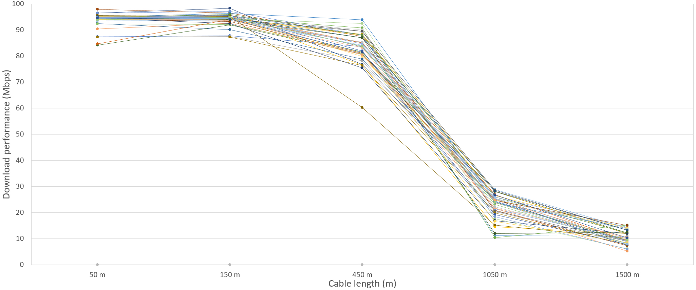

1. Upload performance by cable length (all models)

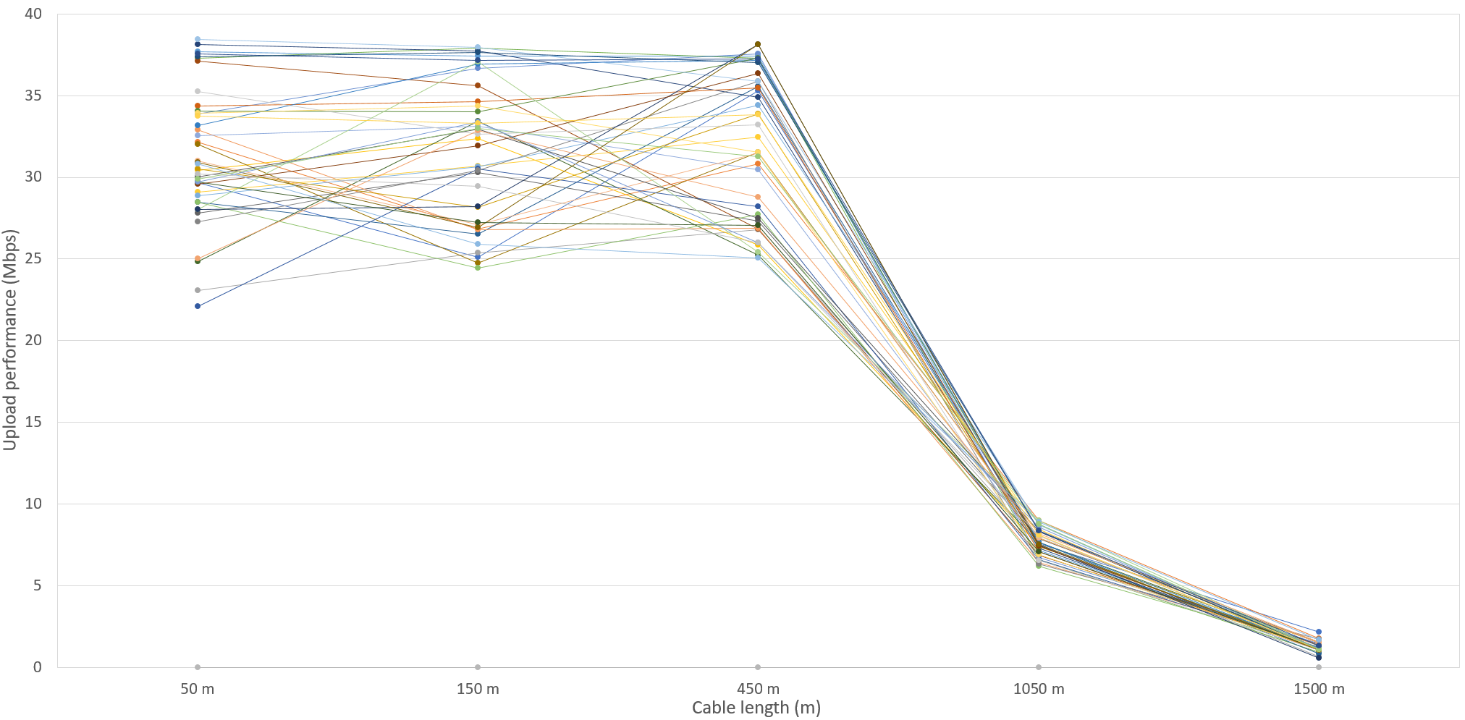

Refer also to Appendix 1 (3.2) for information about feeder loop length testing and Appendix 2 for the supporting upload and download performance (Mbps) by cable length (all models) data tables.

## Performance on noisy lines

Line noise was simulated by indirect injection of ‘white noise’ into the feeder cable system that was connected between the test device and the NBN DSLAM. A ‘noisy’ feeder length of 1050 m was used to test the ability of a device to deal with a significant amount of line noise. While most FTTN/B NBN services are unlikely to experience this amount of noise, this increased amount was chosen to assess the devices under more challenging conditions, where relative performance between different models becomes more apparent.

White noise varies randomly in frequency and amplitude. In real-life deployments, cable noise may be caused by electrical interference, poor quality cabling and/or installation and cross coupling of signals from other cable pairs.

Performance was assessed by measuring the impact on a device’s data transfer performance in the presence of noise.

These results also include an assessment of all devices relative to their same clean (i.e. non-noisy) line performance.

1. Noise test performance (all models)[22]

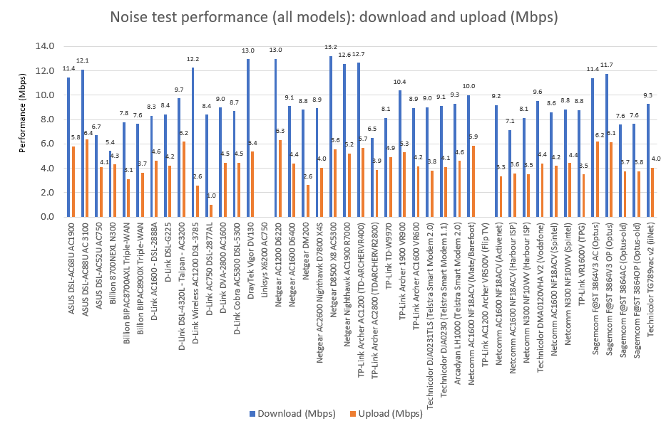

Refer also to Appendix 1 (3.3) for information about line interference testing.

## Bridge tap performance

Bridge tap testing involved testing the performance of each device on a 1000 m length of copper cable with the addition of an unterminated 50 m cable stub connected in parallel at the device/consumer end. This is typical of poor building installations where additional phone sockets have not been correctly isolated or where multiple properties share the same copper pairs. Bridge taps are a known source of FTTN/B NBN performance related issues.

Device performance was assessed by measuring the data transfer performance with the simulated bridge tap installed on the test line. The average effect of the bridge tap was to reduce a device’s download performance to 50 per cent of the NBN line capability.

1. Bridge tap performance (all models)[23]

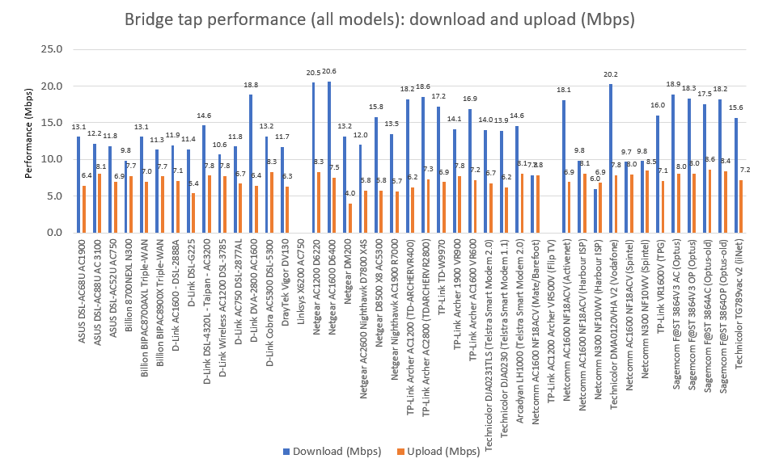

Refer also to Appendix 1 (3.4) for information about simulated bridge tap testing.

## Stability testing

Each device was tested over a continuous period of 16 hours to assess the stability of its performance over time.

Data transfer testing was conducted automatically at periodic intervals to provide an overview of device/line performance during the 16-hour period. Each device was connected using 1000 m of copper pair cable back to the local DSLAM (i.e. NBN network connection).

Enex connected one of its dedicated test services to the consumer interface of each device under test. The devices were then configured to periodically run a number of scheduled tests during the 16-hour test period. Further, each device was set up to run the same suite of tests during the test period (the standardised test suite).

The standardised test suite included network latency tests, a number of speed tests and heart beat (modem/network alive) tests.

At the conclusion of the test cycle, the results were collected and compared with other device test results.

During the test period, all devices tested (apart from the Linksys X6200 AC750) recorded 100 per cent availability.

There was some noticeable variation in download and upload data rates, but it was difficult to determine whether these issues were device or network related. Upload data rates, as a general rule, appeared to exhibit a greater level of variation than download rates.

Refer also to Appendix 1 (3.1) for information about DSL connection stability testing.

## Wired LAN performance

Testing of the wired LAN capability of each device was performed by measuring data transfer rates between a cable connected to a test PC and network-attached storage.

There was very little difference in the wired performance of the devices tested, except for those that only support 100 Mbps between LAN ports (Billion 8700NEXL N300, D-Link DSL-G225, D-Link AC750 DSL-2877AL, TP-Link Archer AC1200 (TD-ARCHERVR400), TP-Link TD-W9970, Netcomm N300 NF10WV (Harbour ISP and Spintel) and Technicolor DMA0120VHA V2 (Vodafone)).

It should be noted that two of the tested devices only supported a single wired LAN connection (the DrayTek Vigor DV130 and the Netgear DM200). If a consumer required more than one wired LAN connection, these devices would most likely require an additional switch/router to be installed at the consumer’s premises.

1. LAN to LAN performance (all models)

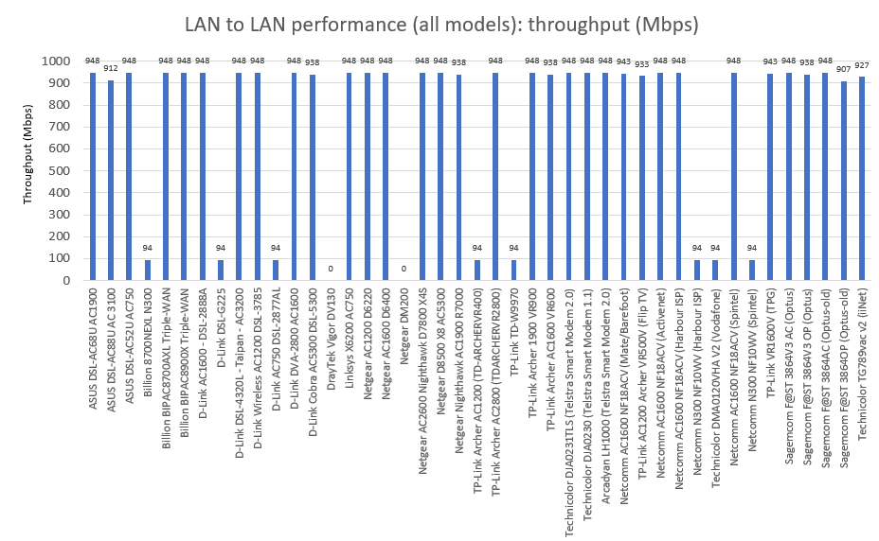

Refer also to Appendix 1 (4.1) for information about the LAN to LAN data transfer test.

## LAN to Wi-Fi performance

The objective of Wi-Fi testing was to explore the performance of devices under different scenarios, representative of a real-world consumer environment.

We note that as this testing was not conducted in a completely controlled environment, it is possible that test results may have been affected by environmental factors. Testing was designed to minimise the effect of external factors. However, we do consider that the test setup is representative of real scenarios that a consumer would be faced with when setting up a device.

Some devices tested had Fast Ethernet LAN ports limited in speed to 100 Mbps. Testing of Wi-Fi connection performance relied on a transfer of data between a device connected to a LAN port and a device connected via Wi-Fi (see 4.2 in Appendix 1). This had the effect of capping all measured Wi-Fi speeds for those devices to 100 Mbps. Therefore, Wi-Fi test results are grouped separately for devices that have 1 Gbps LAN ports, from devices that have 100 Mbps LAN ports.[24]

A LAN to Wi-Fi test configuration (as opposed to a WAN to Wi-Fi configuration) also allowed for assessment of available speeds when accessing LAN-connected devices wirelessly. Consumers are likely to gain the most benefit from higher Wi-Fi speeds (i.e. greater than 100 Mbps) when accessing LAN-connected devices (such as network attached storage). The presence of 100 Mbps LAN ports is therefore likely to result in slower speeds for users accessing LAN-connected devices.

Despite the speed restriction for LAN ports on some devices, all testing achieved data rates that were typically equivalent to the highest rates supported by the current FTTN/B services available. A 100 Mbps LAN port would typically deliver performance similar to that achievable on the highest rate NBN FTTN/B service available in the market at the time of testing.

### Achievable data rate and range testing

There was considerable variation in the performance of all devices when operating in the 2.4 GHz band. Certain devices could barely break the 50 Mbps performance level, whereas the best performing devices achieved closer to 160 Mbps.

It is likely that this large performance gap was due to a mixture of older technology and a limited number of antennas (spatial streams) being present in certain devices. For example, some devices used 802.11n or very early 802.11a/b/g technology, with limited, if any support for multiple antennas.

Performance in the 5 GHz bands was often limited by the capabilities of Enex’s test PCs (typical of current specification laptops) which would only support 802.11ac, 80 MHz bandwidth and two antennas (which equates to about a 600 Mbps limit).

Unexpectedly, the best long-range performance data rates were achieved in the 5 GHz band.

The 2.4 GHz band is often promoted as a better choice for longer range communications. However, Enex’s findings did not support this. Operating in the 5 GHz band appears to be the best choice for consumers under all circumstances.

The 5 GHz band also has the benefit of more recent technology developments which includes features such as directional beamforming and MU/MIMO (with up to eight antennas and multiuser sub-channels).

### Clear line of site

Wireless range testing was conducted in a ‘real-world’ consumer home/small office environment in the presence of other neighbouring Wi-Fi networks and as close as possible to a direct line of sight between the device being tested and a standard laptop.

Generally, considerably greater levels of data throughput can be achieved using the 5 GHz bands as opposed to the 2.4 GHz bands.

When testing at the closest distance of 5 m, around 30 per cent of the devices were unable to achieve 100 Mbps throughput levels using the 2.4 GHz band.[25] This would most likely result in a consumer being unable to reach the performance capability of a typical NBN 100/40 FTTN/B service using a Wi-Fi connection.

For the 5 GHz band[26], most devices achieved performance levels above 100 Mbps at 5 m distances and should be able to outperform a typical NBN 100/40 FTTN/B service.

When testing at distances of 50 m (which is typically beyond the expected working range of the 2.4 GHz band), the majority of devices yielded very poor performance (i.e. only a few Mbps), with a number of devices ceasing to operate entirely.

Operation in the 5 GHz bands yielded much better results at 50 m. Forty-four per cent of those devices which support the 5 GHz bands were able to provide data throughput rates above those required for full utilisation of a 100/40 FTTN/B NBN service.[27]

Some of the devices where the LAN connection was capped at 100 Mbps exhibited good, consistent performance over long distances. This would have a greater impact upon a customer’s experience than a device that may offer a greater Wi-Fi connection speed at close range.

1. 2.4 GHz LAN to Wi-Fi range performance (all models)

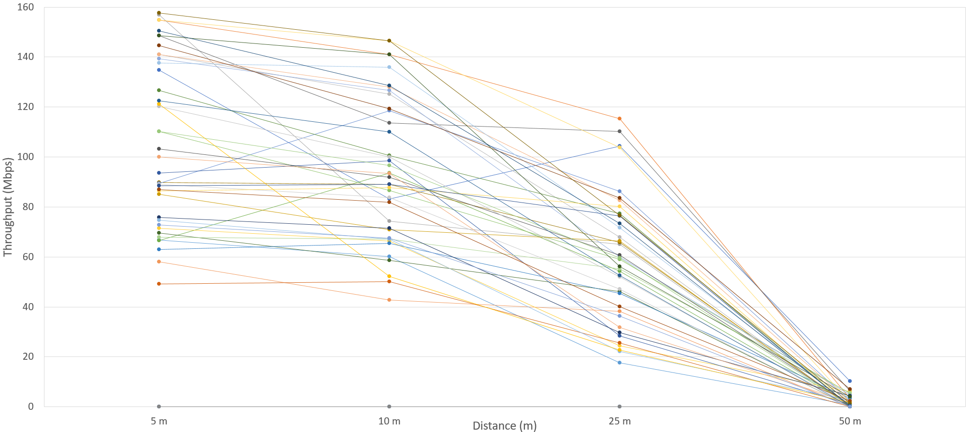

1. 5 GHz LAN to Wi-Fi range performance (all models)

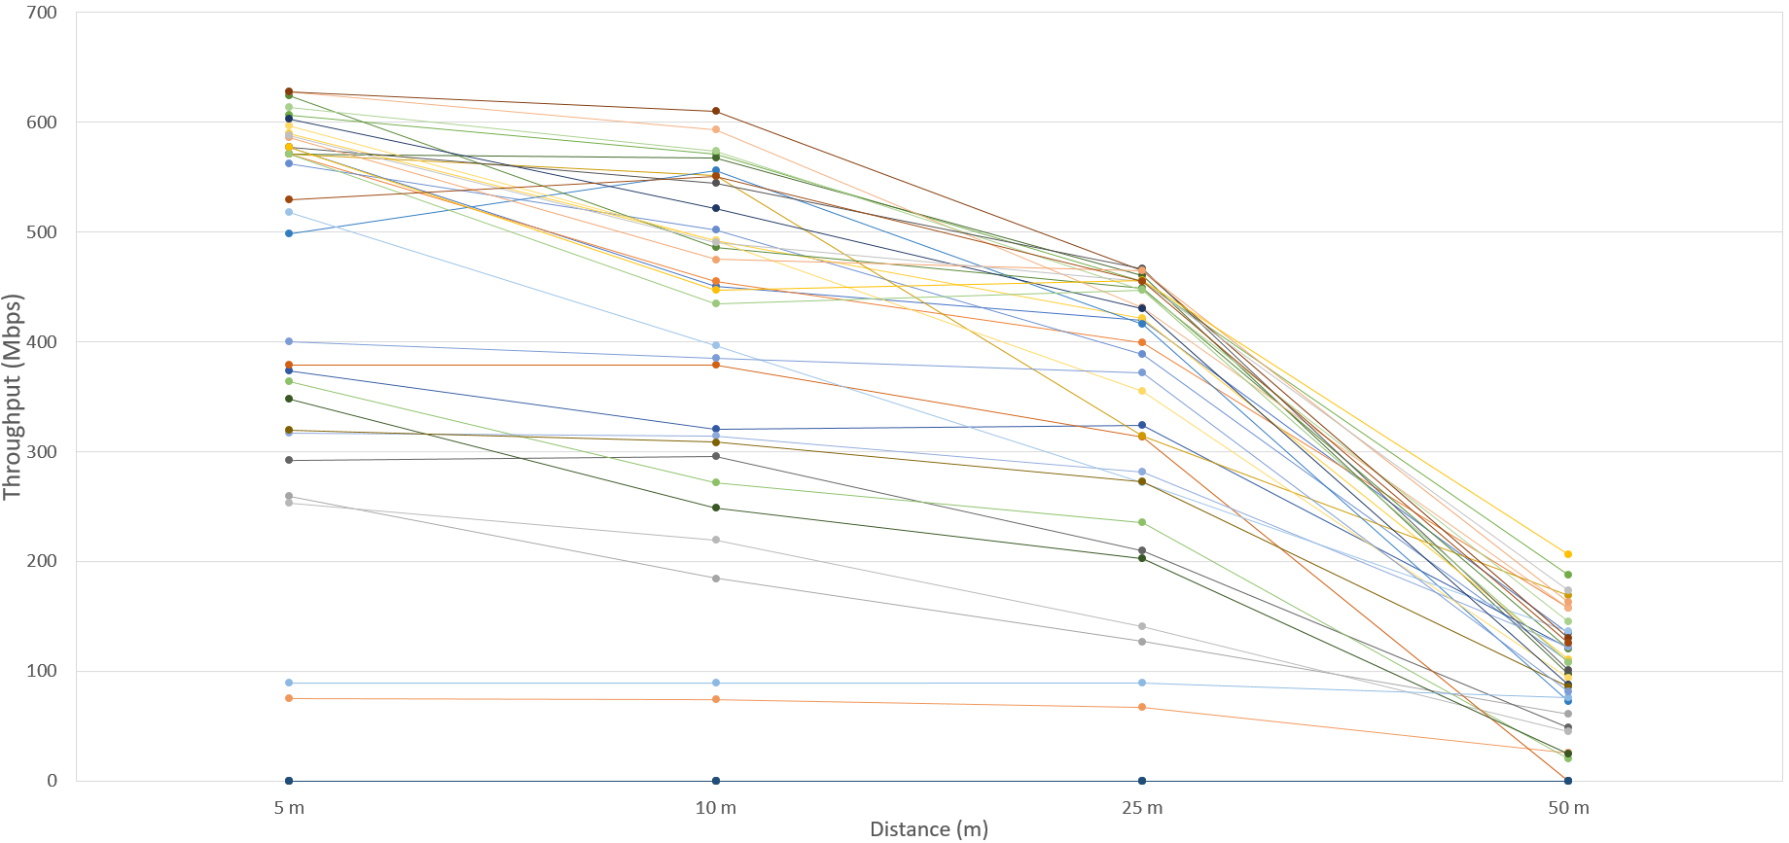

Refer also to Appendix 1 (4.2) for information about the Wi-Fi to LAN data transfer and range test and Appendix 2 for the supporting 2.4 GHz and 5 GHz range performance (all models) data tables.

### Obstacle testing (through walls)

Within the confines of Enex’s test facility, a wireless range test was set up, over a distance of approximately 25 m, that required the wireless signals to pass through a number of brick and studded plaster walls, as would typically be the case in many consumer’s home/office environments.

Using the 2.4 GHz bands, only 26 per cent of the devices tested were able to support data rates of more than 10 Mbps.

Using the 5 GHz bands, about 40 per cent of the devices tested were able to support data rates of 80 per cent or more of the capability of a 100/40 FTTN/B NBN service (i.e. data rates of 80 Mbps or more).

**Figure 8a: 2.4 GHz LAN to Wi-Fi performance through walls versus clear line of sight—at 25 m and 50 m (1 Gbps LAN models)[28]**

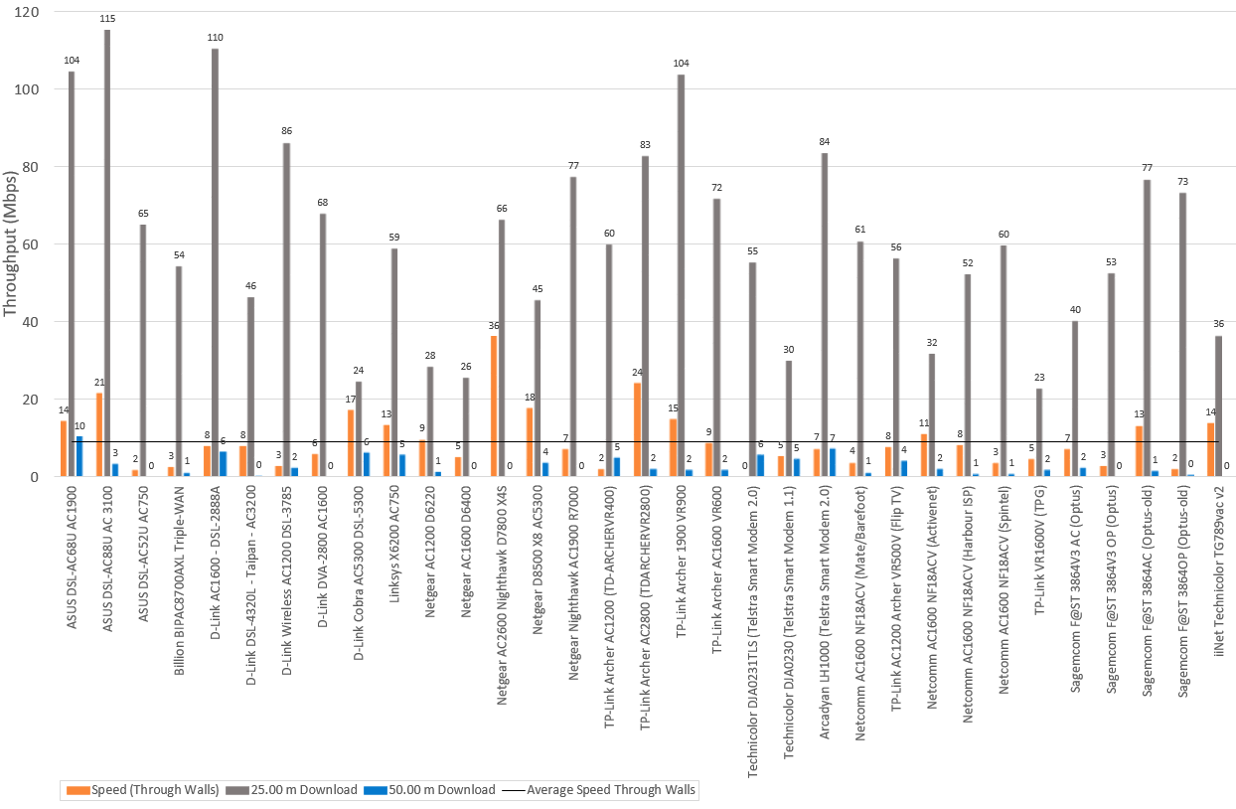

**Figure 8b: 2.4 GHz LAN to Wi-Fi performance through walls versus clear line of sight—at 25 m and 50 m (100 Mbps LAN models)[29]**

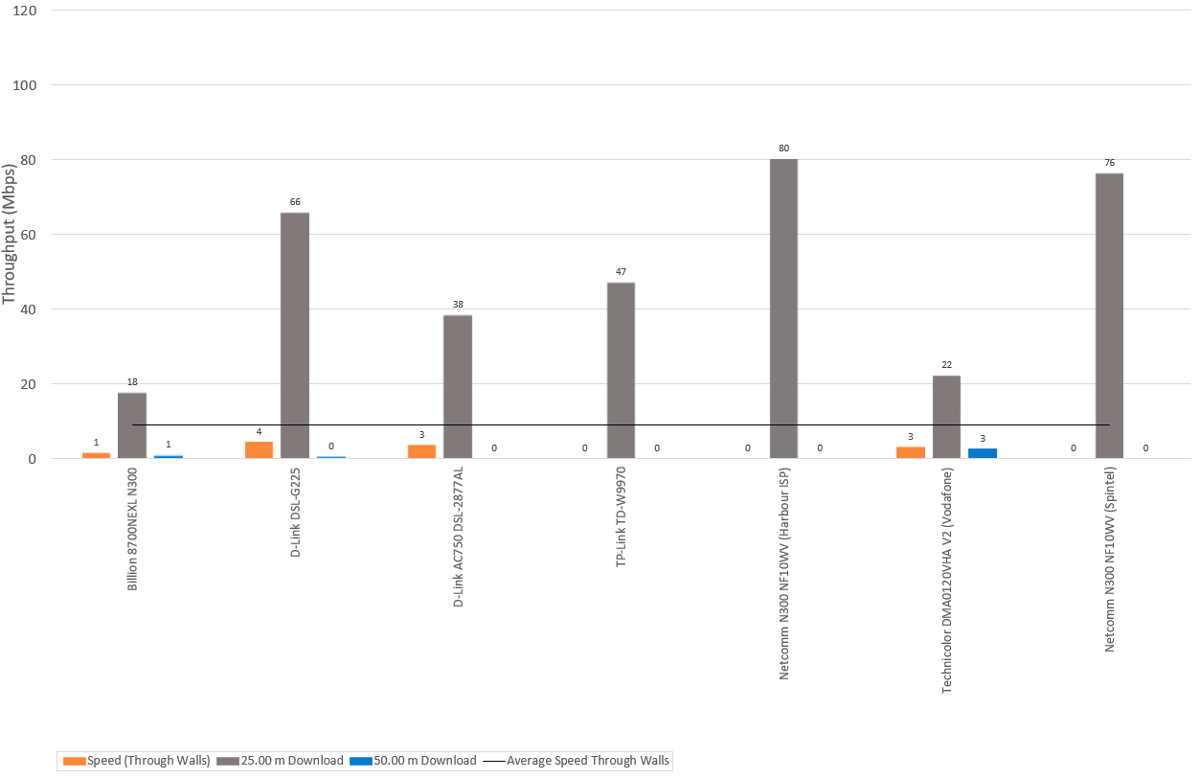

Refer also to Appendix 1 (4.2) for information about the Wi-Fi to LAN data transfer and range test.

**Figure 9a: 5 GHz LAN to Wi-Fi range performance through walls versus clear line of sight—at 25 m and 50 m (1 Gbps LAN models)****[30]**

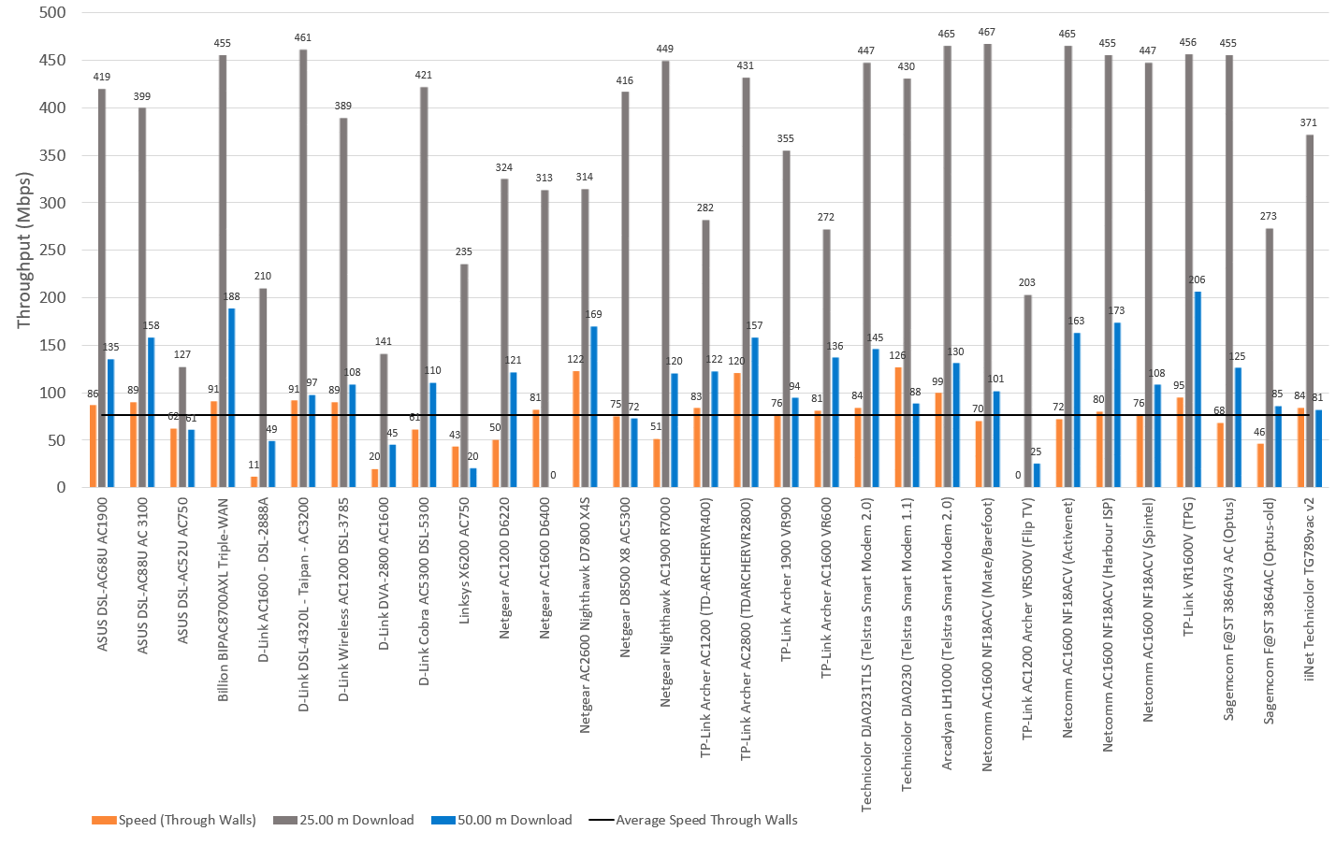

**Figure 9b: 5 GHz LAN to Wi-Fi range performance through walls versus clear line of sight—at 25 m and 50 m (100 Mbps LAN models)[31]**

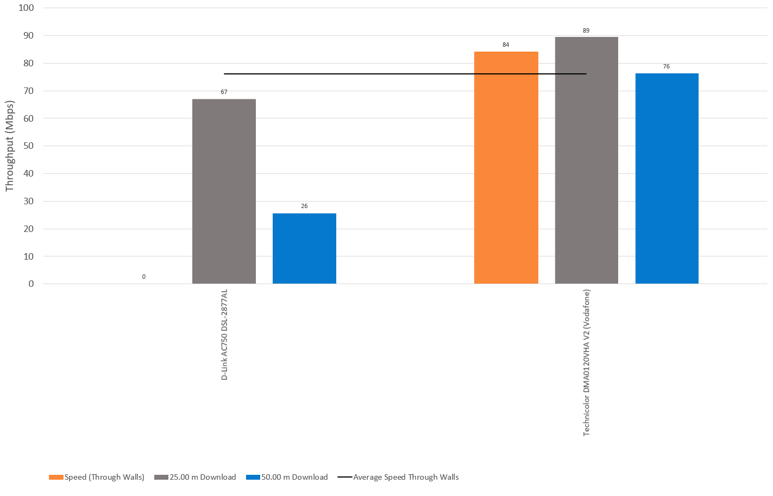

Refer also to Appendix 1 (4.2) for information about the Wi-Fi to LAN data transfer and range test.

### Microwave interference testing

Since Wi-Fi operates in class-licensed bands, it is susceptible to interference from a number of other sources of radio emissions. The 2.4 GHz band, being older technology, is more prone to interference.

Enex conducted interference testing with one of the most common sources of 2.4 GHz Wi-Fi interferers—the domestic microwave oven. Microwave ovens can potentially be a source of very high levels of radio interference. A faulty or poor-quality oven can emit radio signals that are most likely to interfere with the upper Wi-Fi channels in the 2.4 GHz band (i.e. channel nine and above).

For the purpose of testing, a domestic oven was modified so that it simulated a faulty, slightly ‘leaky’ microwave oven (typical of what might occur with damage to the oven cabinet, protective shielding or door seals).

All devices tested were affected to some degree by the external RF interference. Within scope of the test scenario, the worst affected device (the Billion 8700NEXL N300) had its throughput performance reduced to less than 5 per cent of its clear environment performance. On the other hand, the better performing devices were still able to deliver more than 50 per cent of their clear environment performance (e.g. the ASUS DSL-AC88U AC 3100 at 71 per cent). However, the degree of interference varied considerably between devices.

Some of the devices with 100 Mbps LAN ports exhibited strong performance even when subjected to external radio interference.

**Figure 10a 2.4 GHz LAN to Wi-Fi performance with and without microwave interference (1 Gbps LAN models)[32]**

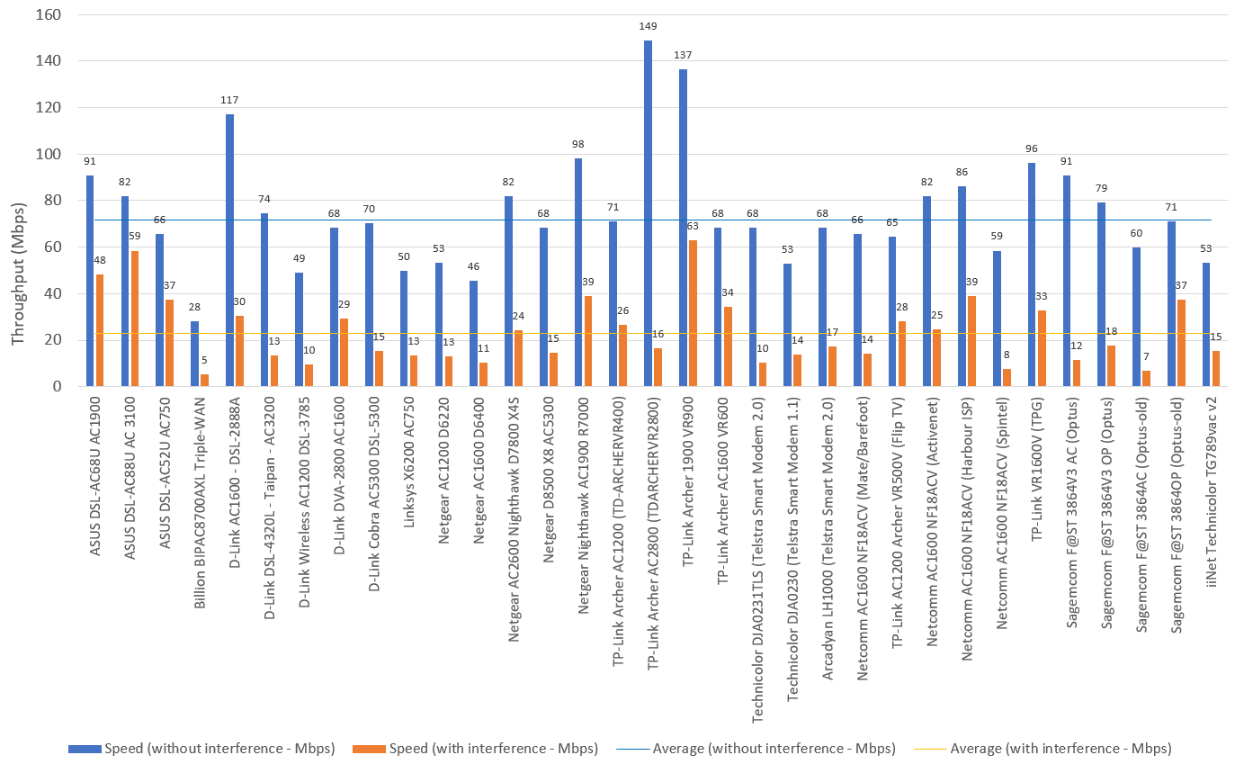

**Figure 10b: 2.4 GHz LAN to Wi-Fi performance with and without microwave interference (100 Mbps LAN models)**

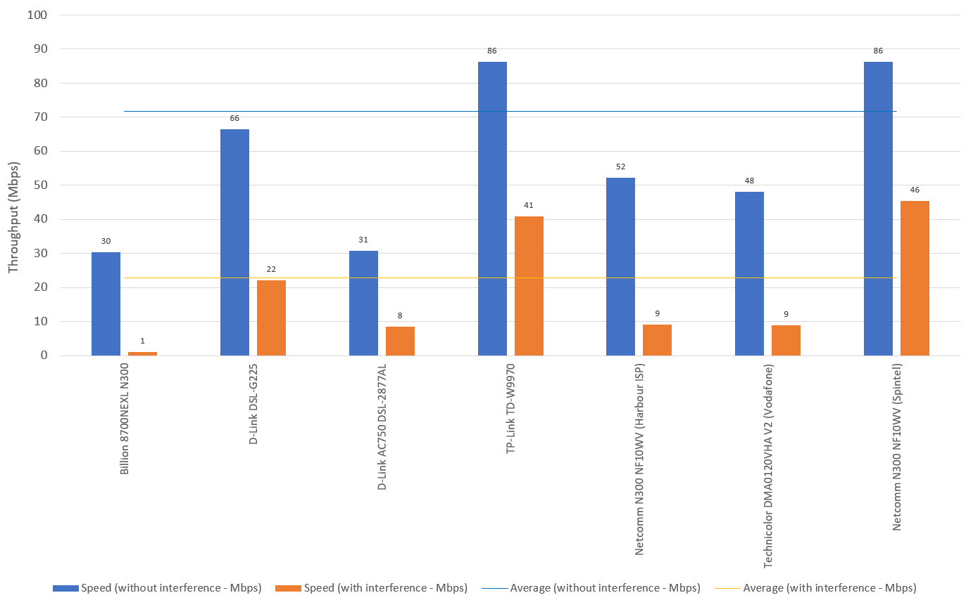

Refer also to Appendix 1 (4.3) for information about Wi-Fi interference susceptibility testing.

### Directional performance assessment

Wi-Fi characterisation testing was conducted to determine the transmission characteristics of the devices, including whether a device’s transmit power varied between front, back, left, right, top and bottom orientations.

A few devices have an almost (ideal) omnidirectional radiation pattern (i.e. not favouring any particular direction). Several devices (e.g. the TP-Link Archer VR400 device) exhibited very limited signal output in a direction vertically above the device. Variations as large as 30–40 dB were observed which could be an issue if those devices were used in multi-storey premises. This was mainly observed on devices with external antennas (with all antennas pointing straight up during testing). This can be adjusted by the consumer moving the antennas to favour this orientation, where this is possible, however, this may be at the expense of other orientations.

It was noted that higher specification devices claimed to incorporate ‘beam shaping technology’. This may assist with directional performance but was unable to be verified by Enex’s testing.

### Signal output/strength assessment

Between the lowest signal output devices and highest signal output devices, variations as high as 30 dB were observed (in the 2.4 GHz band). This equates to a 1000-fold difference in power output level and can result in a potential 30-fold difference in transmission range. A device with a limited range of only 10 m might be outperformed by a device with a range of 300 m (under perfect conditions). However, in practice, such large ranges are unlikely to be achieved.

A large number of devices displayed signal strength variations in excess of 20 dB between their 2.4 GHz and 5 GHz Wi-Fi bands, with the 5 GHz bands yielding better signal levels (which is a potential contributor to superior 5 GHz performance observed in other tests).

In general, the higher end devices within a manufacturer’s range are more likely to yield a better communications range. Further, devices with external antennas are also more likely to be able to be set up to meet the widest range of a consumer’s equipment layout configurations.

Refer also to Appendix 1 (5) for information about RF anechoic chamber Wi-Fi characterisation.

### Signal level at 10 m (dBuV/m) versus orientation – radar plots

On the following pages, ‘radar plots’ are used to provide a perspective on the directional variation of signal strength for each of the devices tested.

For an ideal omnidirectional radiation pattern, the radar plot will look like a symmetrical pentagon with equal signal transmission capabilities in all directions.

Larger distances from the centre of the plot correspond to higher transmit signal levels, which theoretically are more likely to correspond to increased communication range.

A misshapen graph highlights directional sensitivity issues and may require antenna adjustment or repositioning of the device to achieve the best results.

Each device has its own radar plot with all supported Wi-Fi bands (where applicable) also shown. The units of measurement are dBuV/m.

1. Example radar plot

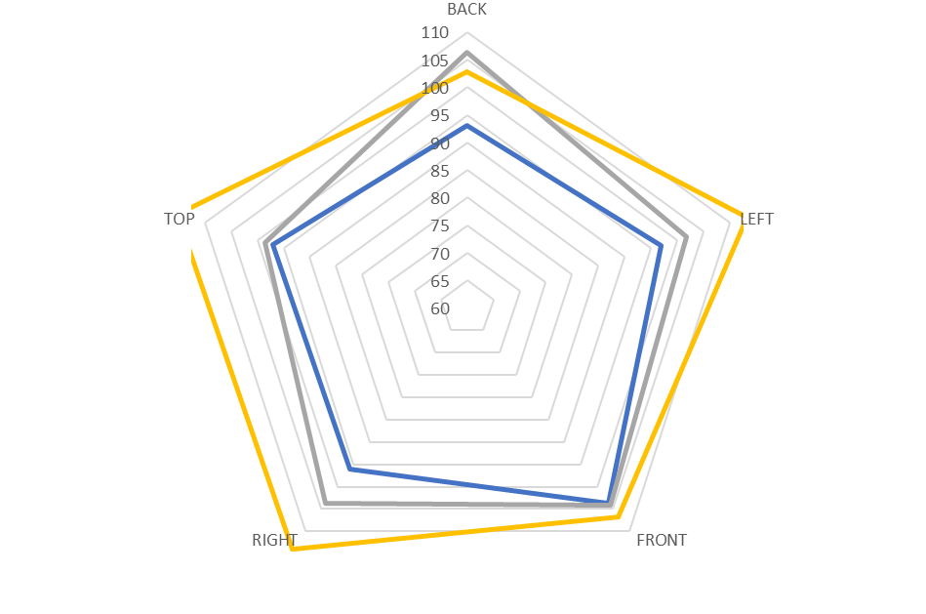

**——** 2.4 GHz band (1) **——** 5 GHz band (2) **——** 5 GHz band (3)

**Figures 12 to 43: Signal level at 10 m (dBuV/m) versus orientation (all models)[33],[34]**

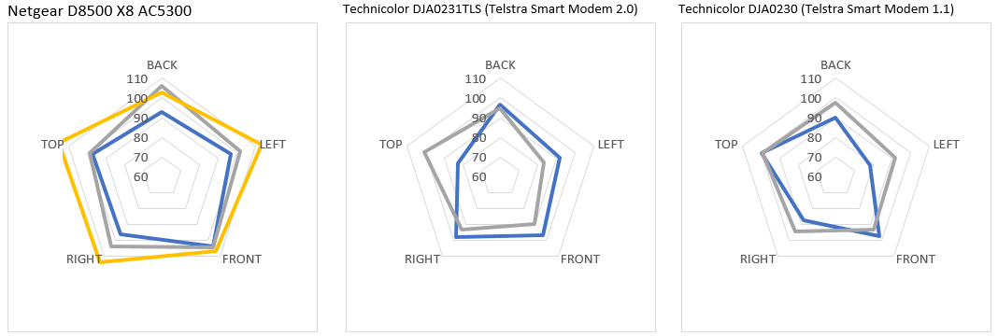

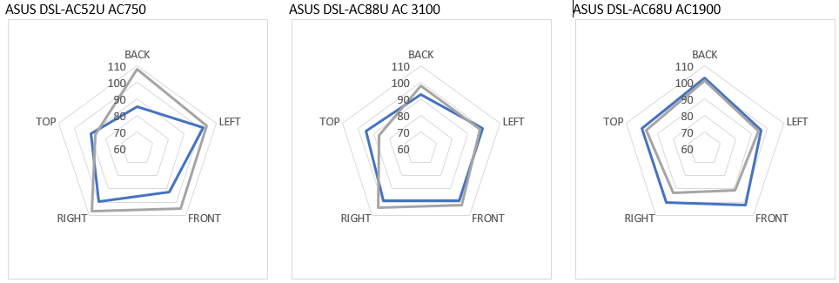

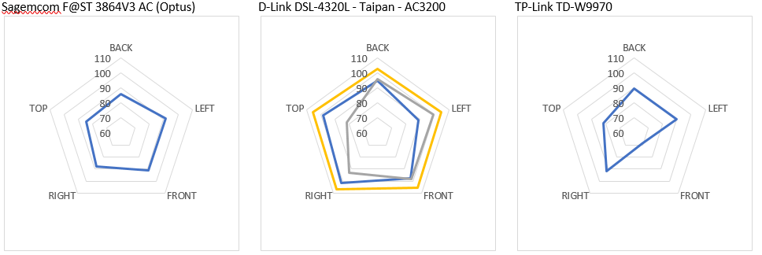

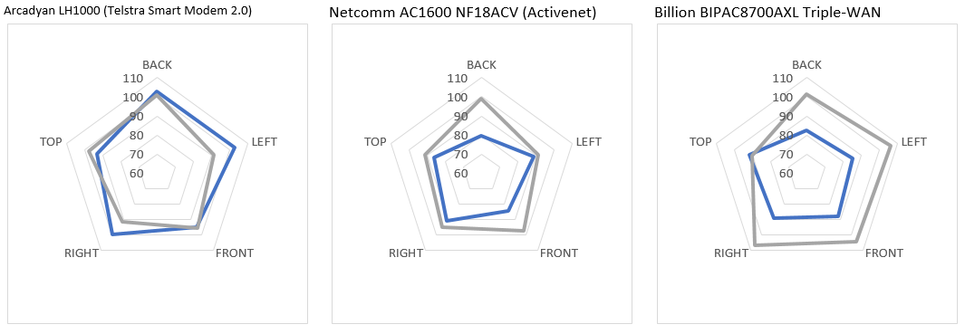

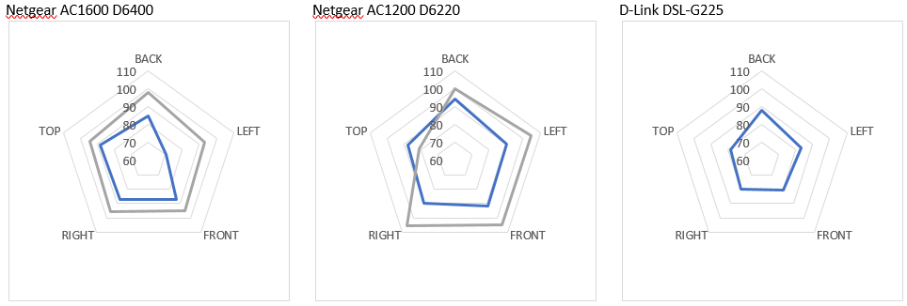

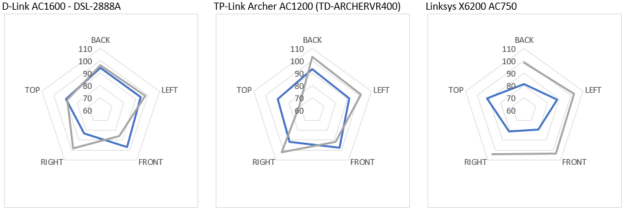

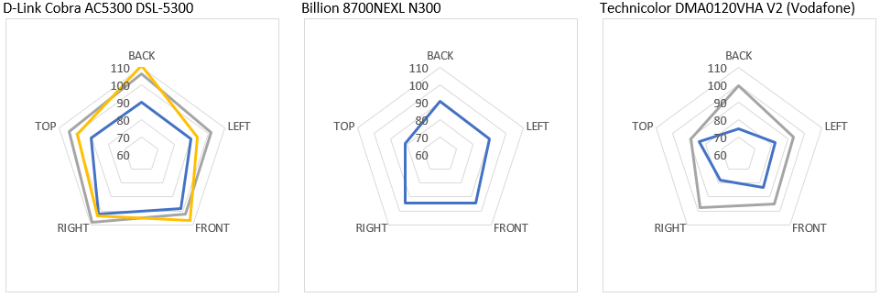

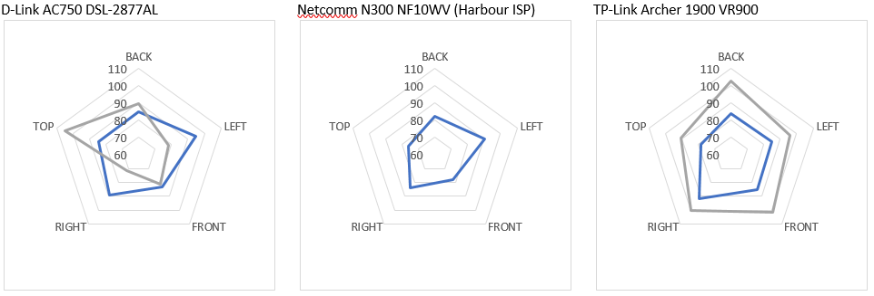

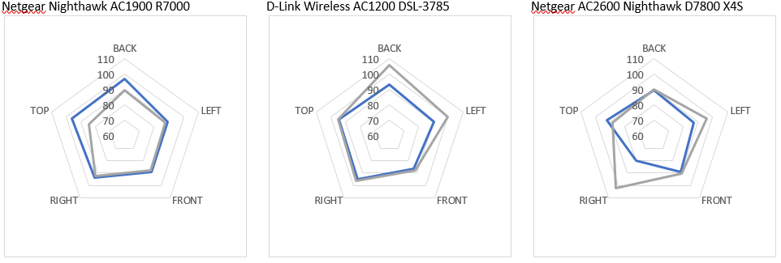

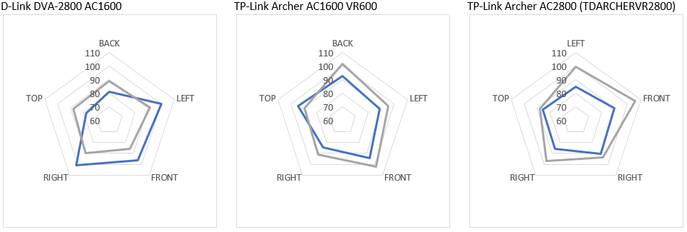

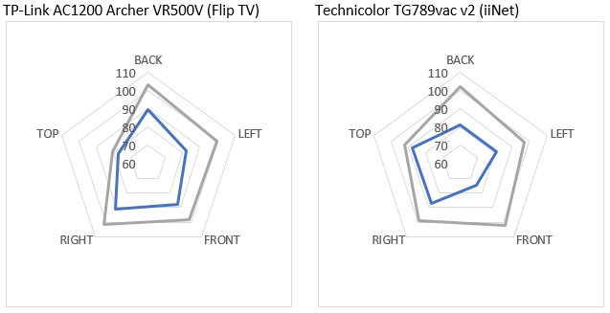

See Appendix 2 for the supporting signal level at 10 m (dBuV/m) versus orientation (all models) data tables.

# Appendix 1—Enex test process

Testing was conducted by the ACMA’s independent testing provider, Enex Pty Ltd. This section describes Enex’s setup and test procedure for each of the tests conducted.

## 1. Test equipment/materials

* Enex TestLab NBN test laboratory environment.
* Enex test devices (client equipment/software simulation).
* Test computers for data transfer testing.
* Device Under Test (DUT) (RSP-supplied or retailer-purchased customer equipment).
* Operations manuals/instructions etc. associated with the DUT.
* Feeder test set and associated patch panel (configurable as 50 m, 150 m, 450 m, 1050 m and 1500 m lengths).
* Two channel noise source injection system (arbitrary waveform generator).
* Digital Subscriber Line Access Multiplexer (DSLAM) and associated patch panel (NBN fibre-to-the-node/building FTTN/B network interface).

Network-attached storage (NAS) (local FTP/data server for LAN/Wi-Fi testing).

Note: The user computer test device used in the context of the DSL testing has performance at a level substantially greater than that provided by the internet service being tested. This is to ensure that the test equipment is not the limiting factor during testing.

For local area network (LAN) and Wi-Fi testing, a PC–NAS combination test setup is used to ensure a sustained data transfer capability consistent with that of the LAN port theoretical speed (typically 1 Gbps).

## 2. Procedure

Technical performance assessment was conducted using the methodologies summarised below:

* Internet connection between Enex’s high speed performance evaluation server (cloud based) and the Enex test device, connected via the DUT, feeder loop patch panel, laboratory and NBN RSP service.
* Local data serving via a NAS connected directly to the DUT and a test laptop computer connected to the DUT LAN ports.

DUT Wi-Fi transmission signal strength and receive sensitivity measurements, conducted in an RF anechoic chamber.[35]

## 3. DSL (NBN) connection performance assessment

Testing within this section was conducted at the Enex Laboratory in Brunswick, Victoria.

The broadband technical tests included a range of simulated data upload and download tests (that can be reliably replicated) as well as specific data transmission tests that enabled both system latency and jitter to be determined (the test suite). Data transfer testing included 50 MB download and 20 MB upload tests.

Note: The combination of the total, elapsed test time for a particular DUT was 24 hours (this includes manually conducted and automatically run tests). This was considered as the optimal time for testing of the proposed population of devices in a reasonable elapsed time frame.

### 3.1 DSL connection stability testing

Each device was tested over a continuous period of 16 hours to assess the stability of its performance over time.

An automated Enex test device was connected to a LAN port on the DUT. The fastest speed port available was chosen for the test. Enex software was used in conjunction with the Enex test device to measure and record a series of results for a typical user experience.

A loop length of 500 m (being representative of a typical node to customer cable length) was configured on the feeder test set patch panel.

The configured Enex test suite (with file sizes of up to 50 MB) was scripted to initiate the periodic testing.

The test series (suite) includes:

* HTTP standard test (using the Enex standard test server).
* Ping test (record latency, connect time values) [a 30 second ping repetition rate was used to assist with the detection of stability issues].
* Speed test (record latency and up/download speeds).

User datagram protocol (UDP) jitter test.

The broadband test suite was repeatedly run at frequent intervals over a period of 16 hours. The consolidated results of the tests were recorded for later analysis.

Repetition of the tests over the 16-hour period assisted with the identification of any time dependant stability issues.

At the completion of testing, the following details were captured for analysis (where available):

* The test results from the test suite.
* The attainable sync rate details from the DUT and DSL line test set.
* The signal level and signal to noise ratio (SNR) details from the DUT and DSL line test set.

The dropout rate details from the test suite.

The recorded results include average upload and download data rates.

### 3.2 Feeder loop length testing

The VDSL2 technology used by the NBN for its FTTN/B services is affected by a number of factors, one being the length of the copper line connection between the customer equipment and the node.

Download and upload tests were run on the DUT over three successive iterations.

The feeder loop test set was connected between the DUT and DSLAM.

The download and upload tests were run multiple times for the following feeder length configurations:

* 150 m
* 450 m
* 1050 m

1500 m

The following information was recorded as obtainable from the DSL/copper line analyser/test set and DUT for each test run:

* Download and upload test suite results (effective transfer rates and latency).
* Attainable sync rate details.
* Maximum and achievable bandwidth.

Line signal level and SNR details.

### 3.3 Line interference testing

Line noise was simulated by indirect injection of white noise into the feeder cable system, connected between the test device and the NBN DSLAM. A ‘noisy’ feeder length of 1050 m was used to test the ability of the devices to deal with typical line noise.

The noise injection source (set for gaussian white noise output at the pre-established bandwidth and amplitude levels) was connected in parallel to the feeder test set patch panel/DUT DSL connections (to simulate electrical noise and crosstalk). One channel of the noise source was connected at the DUT end and the other at the DSLAM end.

The noise source was connected at each end via an unused pair in the feeder cable (feeder cable farm supports up to 10 pairs in each cable run).

The noise generator was configured to produce a pseudo gaussian random noise signal at an injected level of 10 Vpp at each end of the feeder cable.

The feeder test set was configured for a 1050 m loop and the test results were averaged over three consecutive runs of download and upload performance testing.

The level of the noise injected signal was maintained at a constant level for all tests.

The following information was recorded, as obtainable, from the DSL/hand-held services tester, noise sources and DUT for each test run:

* Download and upload test suite results (effective transfer rates and latency).
* Attainable sync rate details.
* Maximum and achievable bandwidth.

Line signal level and SNR details.

### 3.4 Simulated bridge tap testing

Bridge taps are often present in poor building installations where additional phone sockets have not been correctly isolated or where multiple properties share the same copper pairs. Bridge taps are a known source of NBN FTTN/B performance related issues.

Device performance was assessed by measuring the data transfer performance with the simulated bridge tap installed on the test line.

With the feeder test set configured for a 1000 m loop and a 50 m bridge tap simulated at the DUT end (open end cable section), the DUT was tested using three consecutive runs of the download and upload test suite.

The following information was recorded, as obtainable, from the DSL/copper line analyser and DUT for each test run:

* Download and upload test suite results (effective transfer rates and latency).
* Attainable sync rate details.
* Maximum and achievable bandwidth.

Line signal level and SNR details.

The 1000 m feeder loop length was selected as being typical of a usable cable length between a customer’s premises and the FTTN/B node.

The 50 m bridge tap length was selected as a typical worst-case cable length likely to be found in a customer’s premises for the connection of secondary telephone sockets (allows for cable lengths under floor, within wall cavities and roof space).

## 4. Customer LAN/Wi-Fi connection performance assessment

Testing performed within this section was conducted at the Enex laboratory in Brunswick, Victoria.

### 4.1 LAN to LAN data transfer test

Testing of the wired LAN capability of each device was performed by way of measuring data transfer rates between a cable connected test PC and NAS.

A suitable portable computer and NAS device were connected directly to two LAN ports on the DUT.

While transferring files between the NAS and computer using FTP protocol and a set file size (6.8 GB), the transfer time was measured.

The test was performed three times using the FTP transfer protocol.

From the elapsed transfer times, the average transfer rate (Mbps/Gbps) was calculated and recorded.

### 4.2 Wi-Fi to LAN data transfer and range test

Wireless range testing was conducted under simulated real-world conditions to determine the Wi-Fi performance of each device at varying distances. Testing was conducted in, as close as possible to, a direct line of sight between the device being tested and a standard laptop device. Testing of the DUT’s Wi-Fi capabilities was performed under simulated real-world conditions.

A number of test points were identified within the laboratory that provide a mixture of physical test conditions (near and far locations, line of sight and wall/obstacle testing). The test locations were adjusted so to as closely as possible replicate specified test distances of 5 m, 10 m, 25 m and 50 m for direct line of sight and 25 m for the “brick wall and obstacles” test.

For convenience and consistency across the range of devices that were tested, the Wi-Fi capability was tested against a controlled NAS connected directly to one of the DUT’s LAN ports. The NAS was connected via the fastest stated LAN interface, and the portable computer via the fastest wireless connection type available on the DUT.This enabled data transfers to be conducted across the WLAN at various test distances and under various conditions against a controlled test computer (2x2 Wi-Fi connection).

Initial testing with both NAS and test computer connected via Wi-Fi yielded inconsistent and unexpected results. Reduction of one Wi-Fi link enabled better control of the test environment variables.

The majority of the modem/router devices tested supported a 1 Gbps LAN connection to our test NAS. This enabled us to ensure that the link to the NAS did not unduly influence the Wi-Fi test results.

However, there were a number of devices tested that only supported a 100 Mbps LAN connection to the NAS. This did result in a ‘cap’ to the measured Wi-Fi data rates being observed for some of these devices. Due to the limited availability of product data available from some suppliers prior to testing, it was not always possible to determine in advance whether the Wi-Fi data rate for a particular device might effectively be limited by the maximum speed of the LAN port.

Despite the LAN speed restriction for some devices, all testing was performed at data rates that were typically equivalent to the highest rates supported by the current FTTN/B services available. A 100 Mbps LAN connection would typically deliver performance similar to that achievable on the highest rate NBN FTTN/B service available in the market at the time of testing.

However, we note that consumers are likely to gain the most benefit from higher Wi-Fi speeds (in excess of 100 Mbps) when accessing LAN-connected devices (such as network attached storage). The LAN to Wi-Fi data transfer test enabled this mode of operation to be assessed, whereas a WAN to Wi-Fi data transfer test would not.

A simple wireless survey tool was used, prior to actual testing, to identify the quietest channels within the 2.4 GHz and 5 GHz bands. Within the test facilities, it was found that the best channel choices were 4 and 100. All unnecessary Wi-Fi routers within the test lab were disabled prior to commencing testing. The identified ‘quietest’ channels were used for all subsequent tests.

A note was made when a DUT’s automatically selected channels appeared to be different from the ones that would be manually selected to obtain the optimal performance within the test facilities (typically channels 4 and 100 as detailed above).

The DUT router’s wireless channels were set to 4 and 100 (or other close channels when a particular device would not enable these to be selected) and the bandwidths set to 40 Mhz (2.4 GHz Wi-Fi) and 80 Mhz (5 GHz Wi-Fi) to ensure the highest possible data rates (for widely available 802.11n and 802.11ac devices).[36]

The data transfer time was measured while transferring files from the NAS to the computer using FTP protocol, for a range of file sizes (680 MB for 2.4 GHz Wi-Fi and 6.55 GB for 5 GHz Wi-Fi).

The tests were performed three times. From the elapsed transfer times, the average transfer rate (in Mbps) was calculated and recorded.

### 4.3 Wi-Fi Interference susceptibility testing

Wireless communications, by design, are more susceptible to interference from other sources than wired communications connections.

Both 2.4 GHz and 5 GHz Wi-Fi communications technologies operate in public, class licensed radiofrequency spectrum.

These class licensed Industrial, Scientific and Medical (ISM) frequency bands are shared with other commonly available devices typical of home and small office use.

Some devices that operate in these ISM bands include:

* Microwave ovens
* Baby monitors
* Cordless telephones
* Zigbee Internet of Things (IoT) devices
* Bluetooth devices
* Video extender/re-broadcast transmitters

Wireless video cameras.

Many of the above listed devices are more likely to operate in the 2.4 GHz ISM band whereas fewer common devices operate in the 5 GHz ISM band. As a result, it is more likely that Wi-Fi interference will be observed on 2.4 GHz Wi-Fi networks.

It is impractical to test for all types of interference within the context of this modem performance assessment.

Interference testing was conducted using a modified domestic microwave oven. A small external antenna was run through the door seal to conduct radiated energy from within the cooking cavity to the outside environment to simulate a faulty/‘leaky’ microwave oven.

The microwave oven was placed equidistant (7 m) from the DUT and a wirelessly connected test PC.

The three devices (DUT, microwave oven and test PC) were configured in a triangular arrangement.

Data transfer testing was performed (as per other Wi-Fi tests) and the results recorded both with and without the RF interfering device activated. Other test parameters were configured as per the other Wi-Fi tests. The results were recorded to show the relative interference effects.

## 5. RF anechoic chamber Wi-Fi characterisation

Wi-Fi characterisation testing was conducted to determine the transmission characteristics of the devices, including whether a device’s transmit power varied between front, back, left, right, top and bottom orientations.

Testing within this section was conducted in one of Enex affiliate’s RF anechoic facilities (10 m chamber). Within the RF anechoic chamber, uncontrolled RF interference emissions can be reduced to minimal levels. This enables the basic RF performance of the DUT to be tested in a much more controlled fashion.

Since space within the available facilities is limited, all testing was performed at a DUT to reference antenna distance of 10 m. Calibrated test instruments enabled field strength values to be obtained and comparisons to be made between devices.

Simple signal strength measurements were made within the anechoic test facilities (both during transmission and reception) with the device mounted in a range of orientations (five for each test [front, back, left, right and top sides]) relative to the reference antenna.

DUT transmission tests were performed by monitoring the beacon transmissions that are periodically emitted from the DUT and measuring their levels with the reference antenna and chamber instrumentation.

# Appendix 2—Data tables

1. Download performance (Mbps) by cable length (all models)

|  | 50 m | 150 m | 450 m | 1050 m | 1500 m |
| --- | --- | --- | --- | --- | --- |
| ASUS DSL-AC68U AC1900 | 87.33 | 87.78 | 83.58 | 24.43 | 9.21 |
| ASUS DSL-AC88U AC 3100 | 94.76 | 95.19 | 85.22 | 23.76 | 9.54 |
| ASUS DSL-AC52U AC750 | 87.28 | 87.56 | 78.13 | 20.39 | 8.39 |
| Billion 8700NEXL N300 | 94.81 | 95.15 | 76.46 | 14.58 | 12 |
| Billion BIPAC8700AXL Triple-WAN | 94.34 | 95.42 | 88.05 | 11.22 | 10.99 |
| Billion BIPAC8900X Triple-WAN | 94.75 | 94.67 | 90.81 | 10.43 | 15.15 |
| D-Link AC1600 - DSL-2888A | 96.44 | 98.31 | 76.74 | 25.23 | 7.45 |
| D-Link DSL-G225 | 97.86 | 96.52 | 87.5 | 20.94 | 7.31 |
| D-Link DSL-4320L - Taipan - AC3200 | 95.01 | 95.47 | 89.52 | 20.6 | 9.04 |
| D-Link Wireless AC1200 DSL-3785 | 87.25 | 87.29 | 76.38 | 19.86 | 7.73 |
| D-Link AC750 DSL-2877AL | 92.45 | 90.11 | 78.86 | 24.16 | 8.8 |
| D-Link DVA-2800 AC1600 | 84.2 | 91.95 | 80.78 | 28.12 | 12.19 |
| D-Link Cobra AC5300 DSL-5300 | 96.47 | 97.1 | 88.02 | 21.49 | 9.69 |
| DrayTek Vigor DV130 | 90.36 | 92.6 | 80.57 | 21.71 | 5.22 |
| Linksys X6200 AC750[37] | N/A | N/A | N/A | N/A | N/A |
| Netgear AC1200 D6220 | 95.04 | 94.35 | 87.97 | 26.53 | 14.11 |
| Netgear AC1600 D6400 | 94.68 | 94.9 | 85 | 28.89 | 14.08 |
| Netgear DM200 | 92.3 | 92.01 | 81.68 | 23.12 | 8.18 |
| Netgear AC2600 Nighthawk D7800 X4S | 94.95 | 95.61 | 81.97 | 19.2 | 7.85 |
| Netgear D8500 X8 AC5300 | 84.69 | 94.05 | 85.03 | 26.89 | 9.27 |
| Netgear Nighthawk AC1900 R7000 | 95.07 | 95.74 | 83.44 | 25.5 | 8.99 |
| TP-Link Archer AC1200 (TD-ARCHERVR400) | 94.09 | 94.59 | 88.34 | 28.23 | 11.83 |
| TP-Link Archer AC2800 (TDARCHERVR2800) | 94.9 | 96.3 | 93.94 | 23.77 | 13.88 |
| TP-Link TD-W9970 | 94.83 | 96 | 87.98 | 25.98 | 12.17 |
| TP-Link Archer 1900 VR900 | 95.45 | 95 | 84.6 | 26.04 | 14.38 |
| TP-Link Archer AC1600 VR600 | 94.21 | 93.63 | 83.17 | 21.75 | 10.61 |
| Technicolor DJA0231TLS (Telstra Smart Modem 2.0) | 94.7 | 94.83 | 89.92 | 24.81 | 13.82 |
| Technicolor DJA0230 (Telstra Smart Modem 1.1) | 95.19 | 94.95 | 79.88 | 25 | 14.17 |
| Arcadyan LH1000 (Telstra Smart Modem 2.0) | 93.5 | 93.75 | 84.13 | 25.41 | 13.36 |
| Netcomm AC1600 NF18ACV (Mate/Barefoot) | 94.44 | 94.23 | 92.45 | 17.64 | 6.17 |
| TP-Link AC1200 Archer VR500V (Flip TV) | 94.47 | 92.5 | 75.42 | 16.88 | 11.97 |
| Netcomm AC1600 NF18ACV (Activenet) | 94.12 | 93.28 | 81.04 | 24.63 | 15.06 |
| Netcomm AC1600 NF18ACV (Harbour ISP) | 94.06 | 94.11 | 89.45 | 28.64 | 13.22 |
| Netcomm N300 NF10WV (Harbour ISP) | 95.62 | 95.17 | 60.24 | 15.2 | 10.09 |
| Technicolor DMA0120VHA V2 (Vodafone) | 95.02 | 94.69 | 86.94 | 28.16 | 13.21 |
| Netcomm AC1600 NF18ACV (Spintel) | 94.24 | 93.99 | 87.05 | 11.95 | 12.47 |
| Netcomm N300 NF10WV (Spintel) | 94.74 | 94.8 | 81.11 | 18.47 | 6.04 |
| TP-Link VR1600V (TPG) | 93.91 | 94.18 | 80.45 | 24.88 | 10 |
| Sagemcom F@ST 3864V3 AC (Optus) | 94.02 | 94.12 | 85.34 | 22.27 | 9.02 |
| Sagemcom F@ST 3864V3 OP (Optus) | 93.99 | 94.28 | 81.19 | N/R[38] | 8.44 |
| Sagemcom F@ST 3864AC (Optus-old) | 94.35 | 94.46 | 83.94 | 23.96 | 7.95 |
| Sagemcom F@ST 3864OP (Optus-old) | 93.91 | 94.86 | 83.77 | 23.89 | 9.5 |
| iiNet Technicolor TG789vac v2 | 94.58 | 94.16 | 81.39 | 26.81 | 10.34 |

1. Upload performance (Mbps) by cable length (all models)

|  | 50 m | 150 m | 450 m | 1050 m | 1500 m |
| --- | --- | --- | --- | --- | --- |
| ASUS DSL-AC68U AC1900 | 29.68 | 25.12 | 35.29 | 7.56 | 2.13 |
| ASUS DSL-AC88U AC 3100 | 32.14 | 26.82 | 30.81 | 8.96 | 1.731 |
| ASUS DSL-AC52U AC750 | 23.05 | 25.35 | 26.77 | 7.53 | 0.66 |
| Billion 8700NEXL N300 | 30.41 | 32.39 | 25.84 | 7.43 | 1.1 |
| Billion BIPAC8700AXL Triple-WAN | 37.67 | 37.43 | 37.43 | 7.15 | 1.16 |
| Billion BIPAC8900X Triple-WAN | 37.31 | 37.9 | 37.31 | 6.58 | 0.93 |
| D-Link AC1600 - DSL-2888A | 38.12 | 37.73 | 34.89 | 7.3 | 1.04 |
| D-Link DSL-G225 | 37.12 | 35.59 | 26.85 | 6.83 | 1.39 |
| D-Link DSL-4320L - Taipan - AC3200 | 27.79 | 30.31 | 27.31 | 7.85 | 1.53 |
| D-Link Wireless AC1200 DSL-3785 | 32 | 24.76 | 31.55 | 7.91 | 1.49 |
| D-Link AC750 DSL-2877AL | 28.47 | 26.5 | 35.55 | 7.66 | 0.8 |
| D-Link DVA-2800 AC1600 | 24.86 | 33.44 | 25.25 | 7.64 | 1.29 |
| D-Link Cobra AC5300 DSL-5300 | 33.87 | 36.66 | 37.56 | 6.71 | 1.46 |
| DrayTek Vigor DV130 | 32.92 | 26.8 | 26.88 | 6.42 | 1.34 |
| Linksys X6200 AC750[39] | N/A | N/A | N/A | N/A | N/A |
| Netgear AC1200 D6220 | 29.08 | 30.69 | 32.45 | 8.45 | 1.06 |
| Netgear AC1600 D6400 | 28.88 | 30.64 | 34.42 | 8.76 | 1.06 |
| Netgear DM200 | 28.47 | 24.42 | 27.71 | 6.17 | 1.21 |
| Netgear AC2600 Nighthawk D7800 X4S | 22.07 | 30.49 | 28.22 | 6.6 | 1.22 |
| Netgear D8500 X8 AC5300 | 34.35 | 34.61 | 35.46 | 7.06 | 1.04 |
| Netgear Nighthawk AC1900 R7000 | 27.29 | 30.41 | 35.87 | 6.31 | 1.7 |
| TP-Link Archer AC1200 (TD-ARCHERVR400) | 30.51 | 28.14 | 33.88 | 7.38 | 1.52 |
| TP-Link Archer AC2800 (TDARCHERVR2800) | 33.17 | 36.93 | 37.17 | 7.65 | 1.12 |
| TP-Link TD-W9970 | 34.07 | 33.99 | 37.31 | 7.46 | 1.12 |
| TP-Link Archer 1900 VR900 | 32.56 | 33.14 | 30.47 | 7.49 | 1.08 |
| TP-Link Archer AC1600 VR600 | 30.98 | 27.12 | 31.49 | 7.89 | 1.48 |
| Technicolor DJA0231TLS (Telstra Smart Modem 2.0) | 35.23 | 32.62 | 33.2 | 6.54 | 1.06 |
| Technicolor DJA0230 (Telstra Smart Modem 1.1) | 33.94 | 34.36 | 31.51 | 6.87 | 1.07 |
| Arcadyan LH1000 (Telstra Smart Modem 2.0) | 38.43 | 37.95 | 35.87 | 8.72 | 1.1 |
| Netcomm AC1600 NF18ACV (Mate/Barefoot) | 28.03 | 37.09 | 25.43 | 8.97 | 1.13 |
| TP-Link AC1200 Archer VR500V (Flip TV) | 28.05 | 28.2 | 38.14 | 7.48 | 0.57 |
| Netcomm AC1600 NF18ACV (Activenet) | 29.6 | 31.92 | 36.37 | 7.41 | 1.1 |
| Netcomm AC1600 NF18ACV (Harbour ISP) | 30.03 | 32.96 | 27.5 | 8.29 | 1.14 |
| Netcomm N300 NF10WV (Harbour ISP) | 30.93 | 26.94 | 38.12 | 7.51 | 1.06 |
| Technicolor DMA0120VHA V2 (Vodafone) | 37.4 | 37.63 | 37.02 | 8.31 | 1.15 |
| Netcomm AC1600 NF18ACV (Spintel) | 29.71 | 27.25 | 27.06 | 7.07 | 1.12 |
| Netcomm N300 NF10WV (Spintel) | 29.72 | 33.38 | 25.97 | 8.59 | 1.13 |
| TP-Link VR1600V (TPG) | 25.01 | 32.88 | 28.77 | 8.16 | 1.51 |
| Sagemcom F@ST 3864V3 AC (Optus) | 30.18 | 29.45 | 25.97 | 8.05 | 1.1 |
| Sagemcom F@ST 3864V3 OP (Optus) | 33.74 | 33.28 | 33.84 | 8.09 | 1.09 |
| Sagemcom F@ST 3864AC (Optus-old) | 30.84 | 25.9 | 25.04 | 8.87 | 1.67 |
| Sagemcom F@ST 3864OP (Optus-old) | 29.88 | 33 | 31.26 | 8.74 | 1.09 |
| iiNet Technicolor TG789vac v2 | 37.55 | 37.17 | 37.26 | 8.37 | 1.32 |

**Table 5a: 2.4 GHz LAN to Wi-Fi range performance (1 Gbps LAN models)**

|  | 5 m | 10 m | 25 m | 50 m |
| --- | --- | --- | --- | --- |
| ASUS DSL-AC68U AC1900 | 134.77 | 83.14 | 104.45 | 10.20 |
| ASUS DSL-AC88U AC 3100 | 154.74 | 141.03 | 115.25 | 3.24 |
| ASUS DSL-AC52U AC750 | 156.92 | 74.27 | 65.03 | 0.00 |
| Billion BIPAC8700AXL Triple-WAN | 66.58 | 93.62 | 54.35 | 1.04 |
| Billion BIPAC8900X Triple-WAN[40] | N/A | N/A | N/A | N/A |
| D-Link AC1600 - DSL-2888A | 148.55 | 113.68 | 110.31 | 6.31 |
| D-Link DSL-4320L - Taipan - AC3200 | 69.63 | 58.64 | 46.23 | 0.25 |
| D-Link Wireless AC1200 DSL-3785 | 89.37 | 118.52 | 86.14 | 2.30 |
| D-Link DVA-2800 AC1600 | 141.03 | 125.18 | 67.93 | 0.00 |
| D-Link Cobra AC5300 DSL-5300 | 71.42 | 66.32 | 24.43 | 6.13 |
| DrayTek Vigor DV130[41] | N/A | N/A | N/A | N/A |
| Linksys X6200 AC750 | 110.31 | 86.59 | 58.95 | 5.42 |
| Netgear AC1200 D6220 | 93.62 | 98.59 | 28.32 | 1.06 |
| Netgear AC1600 D6400 | 49.15 | 50.19 | 25.63 | 0.00 |
| Netgear DM200[42] | N/A | N/A | N/A | N/A |
| Netgear AC2600 Nighthawk D7800 X4S | 85.05 | 70.96 | 66.32 | 0.00 |
| Netgear D8500 X8 AC5300 | 62.94 | 65.54 | 45.41 | 3.54 |
| Netgear Nighthawk AC1900 R7000 | 126.60 | 100.67 | 77.37 | 0.00 |
| TP-Link Archer AC1200 (TD-ARCHERVR400) | 139.26 | 126.60 | 59.90 | 4.77 |
| TP-Link Archer AC2800 (TDARCHERVR2800) | 141.03 | 128.06 | 82.73 | 1.93 |
| TP-Link Archer 1900 VR900 | 154.74 | 146.59 | 103.80 | 1.74 |
| TP-Link Archer AC1600 VR600 | 137.54 | 135.87 | 71.72 | 1.72 |
| Technicolor DJA0231TLS (Telstra Smart Modem 2.0) | 67.93 | 67.12 | 55.15 | 5.60 |
| Technicolor DJA0230 (Telstra Smart Modem 1.1) | 75.79 | 71.42 | 29.79 | 4.50 |
| Arcadyan LH1000 (Telstra Smart Modem 2.0) | 144.69 | 119.37 | 83.56 | 7.07 |
| Netcomm AC1600 NF18ACV (Mate/Barefoot) | 103.16 | 91.82 | 60.77 | 1.03 |
| TP-Link AC1200 Archer VR500V (Flip TV) | 148.55 | 141.03 | 56.27 | 4.01 |
| Netcomm AC1600 NF18ACV (Activenet) | 100.07 | 93.36 | 31.74 | 1.86 |
| Netcomm AC1600 NF18ACV (Harbour ISP) | 120.23 | 100.07 | 52.06 | 0.62 |
| Netcomm AC1600 NF18ACV (Spintel) | 110.31 | 96.60 | 59.58 | 0.60 |
| TP-Link VR1600V (TPG) | 121.10 | 52.31 | 22.68 | 1.80 |
| Sagemcom F@ST 3864V3 AC (Optus) | 87.04 | 81.92 | 40.08 | 2.28 |
| Sagemcom F@ST 3864V3 OP (Optus) | 122.43 | 109.95 | 52.55 | 0.00 |
| Sagemcom F@ST 3864AC (Optus-old) | 157.66 | 146.59 | 76.66 | 1.40 |
| Sagemcom F@ST 3864OP (Optus-old) | 150.56 | 128.55 | 73.30 | 0.40 |
| iiNet Technicolor TG789vac v2 | 72.82 | 67.52 | 36.41 | 0.00 |

**Table 5b: 2.4 GHz LAN to Wi-Fi range performance (100 Mbps LAN models)[43]**

|  | 5 m | 10 m | 25 m | 50 m |
| --- | --- | --- | --- | --- |
| Billion 8700NEXL N300 | 66.71 | 60.22 | 17.55 | 0.78 |
| D-Link DSL-G225 | 89.85 | 89.13 | 65.79 | 0.40 |
| D-Link AC750 DSL-2877AL | 58.03 | 42.69 | 38.29 | 0.00 |
| TP-Link TD-W9970 | 89.13 | 83.77 | 47.08 | 0.00 |
| Netcomm N300 NF10WV (Harbour ISP) | 86.37 | 87.73 | 80.15 | 0.00 |
| Technicolor DMA0120VHA V2 (Vodafone) | 74.77 | 67.12 | 22.25 | 2.53 |
| Netcomm N300 NF10WV (Spintel) | 88.42 | 89.13 | 76.31 | 0.00 |

**Table 6a: 5 GHz LAN to Wi-Fi range performance (1 Gbps LAN models)**

|  | 5 m | 10 m | 25 m | 50 m |
| --- | --- | --- | --- | --- |
| ASUS DSL-AC68U AC1900 | 576.96 | 450.90 | 419.20 | 134.53 |
| ASUS DSL-AC88U AC 3100 | 570.83 | 454.73 | 398.94 | 157.70 |
| ASUS DSL-AC52U AC750 | 259.22 | 184.39 | 126.85 | 60.59 |
| Billion BIPAC8700AXL Triple-WAN | 606.30 | 570.83 | 454.73 | 187.98 |
| Billion BIPAC8900X Triple-WAN[44] | N/A | N/A | N/A | N/A |
| D-Link AC1600 - DSL-2888A | 292.41 | 295.36 | 209.60 | 48.51 |
| D-Link DSL-4320L - Taipan - AC3200 | 570.83 | 567.81 | 460.58 | 97.24 |
| D-Link Wireless AC1200 DSL-3785 | 561.86 | 501.47 | 388.82 | 108.34 |
| D-Link DVA-2800 AC1600 | 252.70 | 219.01 | 140.59 | 44.79 |
| D-Link Cobra AC5300 DSL-5300 | 589.64 | 492.27 | 421.39 | 110.23 |
| DrayTek Vigor DV130[45] | N/A | N/A | N/A | N/A |
| Linksys X6200 AC750 | 363.78 | 271.91 | 235.34 | 20.19 |
| Netgear AC1200 D6220 | 373.92 | 320.34 | 324.22 | 121.00 |
| Netgear AC1600 D6400 | 379.21 | 379.21 | 313.18 | 0.00 |
| Netgear DM200[46] | N/A | N/A | N/A | N/A |
| Netgear AC2600 Nighthawk D7800 X4S | 570.83 | 551.28 | 313.79 | 169.33 |
| Netgear D8500 X8 AC5300 | 498.37 | 556.04 | 415.95 | 72.10 |
| Netgear Nighthawk AC1900 R7000 | 623.93 | 485.59 | 449.02 | 119.96 |
| TP-Link Archer AC1200 (TD-ARCHERVR400) | 316.56 | 314.40 | 281.67 | 121.93 |
| TP-Link Archer AC2800 (TDARCHERVR2800) | 627.57 | 592.90 | 430.98 | 157.12 |
| TP-Link Archer 1900 VR900 | 596.20 | 492.27 | 354.57 | 93.99 |
| TP-Link Archer AC1600 VR600 | 517.60 | 396.48 | 271.91 | 136.12 |
| Technicolor DJA0231TLS (Telstra Smart Modem 2.0) | 613.23 | 573.88 | 447.15 | 145.20 |
| Technicolor DJA0230 (Telstra Smart Modem 1.1) | 602.89 | 520.95 | 430.41 | 87.84 |
| Arcadyan LH1000 (Telstra Smart Modem 2.0) | 627.57 | 609.75 | 464.57 | 130.36 |
| Netcomm AC1600 NF18ACV (Mate/Barefoot) | 576.96 | 544.75 | 466.59 | 101.06 |
| TP-Link AC1200 Archer VR500V (Flip TV) | 347.67 | 248.41 | 202.86 | 24.86 |
| Netcomm AC1600 NF18ACV (Activenet) | 586.42 | 474.85 | 464.57 | 162.57 |
| Netcomm AC1600 NF18ACV (Harbour ISP) | 587.49 | 490.02 | 454.73 | 173.04 |
| Netcomm AC1600 NF18ACV (Spintel) | 570.83 | 434.47 | 447.15 | 107.60 |
| TP-Link VR1600V (TPG) | 576.96 | 447.15 | 456.01 | 205.73 |
| Sagemcom F@ST 3864V3 AC (Optus) | 529.52 | 550.33 | 454.73 | 125.32 |
| Sagemcom F@ST 3864V3 OP (Optus)[47] | N/A | N/A | N/A | N/A |
| Sagemcom F@ST 3864AC (Optus-old) | 319.39 | 308.38 | 272.84 | 85.41 |
| Sagemcom F@ST 3864OP (Optus-old)[48] | N/A | N/A | N/A | N/A |
| iiNet Technicolor TG789vac v2 | 400.43 | 384.64 | 371.33 | 81.44 |

**Table 6b: 5 GHz LAN to Wi-Fi range performance (100 Mbps LAN models)[49]**

|  | 5 m | 10 m | 25 m | 50 m |
| --- | --- | --- | --- | --- |
| Billion 8700NEXL N300[50] | N/A | N/A | N/A | N/A |
| D-Link DSL-G225[51] | N/A | N/A | N/A | N/A |
| D-Link AC750 DSL-2877AL | 75.10 | 73.91 | 66.86 | 25.58 |
| TP-Link TD-W9970[52] | N/A | N/A | N/A | N/A |
| Netcomm N300 NF10WV (Harbour ISP)[53] | N/A | N/A | N/A | N/A |
| Technicolor DMA0120VHA V2 (Vodafone) | 89.13 | 89.13 | 89.28 | 76.14 |
| Netcomm N300 NF10WV (Spintel)[54] | N/A | N/A | N/A | N/A |

1. Transmit signal levels (dBuV/m) @ 10 m – Band 1 (all models)

*Transmit signal levels (dBuV/m) @ 10 m – Band 1*

Note: Higher values for back, left, front, right, top and average are better.

| Transmitting | | Band 1 | | | | | | |  |
| --- | --- | --- | --- | --- | --- | --- | --- | --- | --- |
| 2.4 GHz | | | | | | |  |
| Back | Left | Front | Right |  |  | Top |  |
| Device description | Ants[55] | 0 | 90 | 180 | 270 | Variation | Avg | Top | Top var |
| ASUS DSL-AC68U AC1900 | 3 | 102.58 | 95.62 | 102.29 | 100.11 | 6.96 | 100.15 | 100.10 | -0.05 |
| ASUS DSL-AC88U AC 3100 | 4 | 92.56 | 98.99 | 98.97 | 98.86 | 6.43 | 97.35 | 95.00 | -2.35 |
| ASUS DSL-AC52U AC750 | 4 | 85.46 | 101.90 | 92.66 | 99.30 | 16.44 | 94.83 | 89.50 | -5.33 |
| Billion 8700NEXL N300 | 2 | 90.91 | 90.00 | 94.42 | 94.56 | 4.56 | 92.47 | 81.36 | -11.11 |
| Billion BIPAC8700AXL Triple-WAN | 3 | 82.60 | 85.24 | 87.67 | 89.28 | 6.68 | 86.20 | 91.64 | 5.44 |
| D-Link AC1600 - DSL-2888A | 3 | 94.42 | 94.39 | 96.68 | 82.99 | 13.69 | 92.12 | 89.62 | -2.50 |
| D-Link DSL-G225 | N/S | 88.34 | 83.23 | 80.40 | 79.92 | 8.42 | 82.97 | 78.72 | -4.25 |
| D-Link DSL-4320L - Taipan - AC3200 | 6 | 94.77 | 88.37 | 97.28 | 101.78 | 13.41 | 95.55 | 98.18 | 2.63 |
| D-Link Wireless AC1200 DSL-3785 | N/S | 93.42 | 90.08 | 86.60 | 95.15 | 8.55 | 91.31 | 94.36 | 3.05 |
| D-Link AC750 DSL-2877AL | N/S | 85.08 | 94.64 | 82.93 | 89.37 | 11.71 | 88.01 | 84.59 | -3.41 |
| D-Link DVA-2800 AC1600 | 3 | 81.39 | 100.51 | 95.99 | 101.10 | 19.71 | 94.75 | 78.15 | -16.60 |
| D-Link Cobra AC5300 DSL-5300 | 8 | 90.18 | 89.87 | 98.19 | 102.30 | 12.43 | 95.14 | 90.36 | -4.78 |
| Linksys X6200 AC750 | N/A | 81.13 | 88.10 | 79.31 | 81.19 | 8.79 | 82.43 | 91.50 | 9.07 |
| Netgear AC1200 D6220 | 3 | 94.37 | 90.28 | 91.54 | 89.71 | 4.66 | 91.48 | 87.59 | -3.88 |
| Netgear AC1600 D6400 | N/A | 85.00 | 70.30 | 87.04 | 86.86 | 16.74 | 82.30 | 88.30 | 6.00 |
| Netgear AC2600 Nighthawk D7800 X4S | 4 | 89.58 | 87.03 | 89.15 | 79.98 | 9.60 | 86.44 | 92.34 | 5.91 |
| Netgear D8500 X8 AC5300 | 8 | 93.03 | 96.87 | 103.70 | 96.13 | 10.67 | 97.43 | 96.98 | -0.45 |
| Netgear Nighthawk AC1900 R7000 | 3 | 96.90 | 89.39 | 88.91 | 93.69 | 7.99 | 92.22 | 96.29 | 4.07 |
| TP-Link Archer AC1200 (TD-ARCHERVR400) | 3 | 93.34 | 91.24 | 97.63 | 91.40 | 6.39 | 93.40 | 89.59 | -3.81 |
| TP-Link Archer AC2800 (TDARCHERVR2800) | 4 | 84.81 | 89.73 | 90.71 | 86.12 | 5.90 | 87.84 | 85.57 | -2.27 |
| TP-Link TD-W9970 | 2 | 89.91 | 89.96 | 68.68 | 91.72 | 23.04 | 85.07 | 81.72 | -3.35 |
| TP-Link Archer 1900 VR900 | 3 | 83.67 | 84.65 | 85.32 | 92.00 | 8.33 | 86.41 | 78.68 | -7.73 |
| TP-Link Archer AC1600 VR600 | 3 | 92.98 | 88.38 | 94.09 | 84.43 | 9.66 | 89.97 | 94.45 | 4.48 |
| Technicolor DJA0231TLS (Telstra Smart Modem 2.0) | N/S | 96.45 | 91.54 | 97.00 | 97.88 | 6.34 | 95.72 | 82.50 | -13.22 |
| Technicolor DJA0230 (Telstra Smart Modem 1.1) | N/S | 89.80 | 78.37 | 97.44 | 87.36 | 19.07 | 88.24 | 99.53 | 11.29 |
| Arcadyan LH1000 (Telstra Smart Modem 2.0) | N/S | 102.90 | 102.80 | 95.01 | 99.60 | 7.89 | 100.08 | 93.18 | -6.90 |
| TP-Link AC1200 Archer VR500V (Flip TV) | 2 | 89.82 | 81.88 | 87.57 | 91.05 | 9.17 | 87.58 | 77.43 | -10.15 |
| Netcomm AC1600 NF18ACV (Activenet) | N/S | 79.40 | 88.54 | 84.29 | 90.71 | 11.31 | 85.74 | 86.19 | 0.45 |
| Netcomm N300 NF10WV (Harbour ISP) | N/S | 82.15 | 90.26 | 77.90 | 84.11 | 12.36 | 83.61 | 76.24 | -7.37 |
| Technicolor DMA0120VHA V2 (Vodafone) | 0 | 74.82 | 82.16 | 83.57 | 78.23 | 8.75 | 79.70 | 84.13 | 4.44 |
| Sagemcom F@ST 3864V3 AC (Optus) | 0 | 85.80 | 91.60 | 90.90 | 87.97 | 5.80 | 89.07 | 84.32 | -4.75 |
| iiNet Technicolor TG789vac v2 | 0 | 81.04 | 80.86 | 75.02 | 86.93 | 11.91 | 80.96 | 87.93 | 6.97 |

1. Transmit signal levels (dBuV/m) @ 10 m – Band 2 (all models)

*Transmit signal levels (dBuV/m) @ 10 m – Band 2*

Note: Higher values for back, left, front, right, top and average are better.

| Transmitting | | Band 2 | | | | | | |  |
| --- | --- | --- | --- | --- | --- | --- | --- | --- | --- |
| 5 GHz | | | | | | |  |
| Back | Left | Front | Right |  |  | Top |  |
| Device description | Ants | 0 | 90 | 180 | 270 | Variation | Avg | Top | Top var |
| ASUS DSL-AC68U AC1900 | 3 | 101.02 | 94.17 | 91.33 | 92.78 | 9.69 | 94.83 | 97.02 | 2.20 |
| ASUS DSL-AC88U AC 3100 | 4 | 97.95 | 97.66 | 101.87 | 104.12 | 6.46 | 100.40 | 86.88 | -13.52 |
| ASUS DSL-AC52U AC750 | 4 | 108.20 | 104.31 | 104.65 | 106.80 | 3.89 | 105.99 | 87.00 | N/T |
| Billion BIPAC8700AXL Triple-WAN | 3 | 101.33 | 106.35 | 104.05 | 106.61 | 5.28 | 104.59 | 90.06 | -14.53 |
| D-Link AC1600 - DSL-2888A | 3 | 96.48 | 98.30 | 86.07 | 98.29 | 12.23 | 94.79 | 88.48 | -6.31 |
| D-Link DSL-4320L - Taipan - AC3200 | 6 | 96.21 | 98.89 | 98.09 | 92.90 | 5.99 | 96.52 | 81.82 | -14.70 |
| D-Link Wireless AC1200 DSL-3785 | N/S | 105.98 | 99.85 | 88.05 | 96.55 | 17.93 | 97.61 | 95.00 | -2.61 |
| D-Link AC750 DSL-2877AL | N/S | 89.54 | 78.17 | 81.02 | 71.78 | 17.76 | 80.13 | 104.79 | 24.66 |
| D-Link DVA-2800 AC1600 | 3 | 89.32 | 91.61 | 85.96 | 89.51 | 5.65 | 89.10 | 88.01 | -1.09 |
| D-Link Cobra AC5300 DSL-5300 | 8 | 106.64 | 102.04 | 102.44 | 108.26 | 6.22 | 104.85 | 103.90 | -0.94 |
| Linksys X6200 AC750 | N/A | 98.77 | 102.73 | 103.37 | 104.23 | 5.46 | 102.28 | 0.00 | -102.28 |
| Netgear AC1200 D6220 | 3 | 100.35 | 104.75 | 104.50 | 105.57 | 5.22 | 103.79 | 81.12 | -22.67 |
| Netgear AC1600 D6400 | N/A | 98.25 | 92.96 | 95.10 | 95.72 | 5.29 | 95.51 | 94.47 | -1.04 |
| Netgear AC2600 Nighthawk D7800 X4S | 4 | 90.15 | 95.82 | 90.66 | 102.25 | 12.10 | 94.72 | 88.18 | -6.54 |
| Netgear D8500 X8 AC5300 | 8 | 106.30 | 101.83 | 104.21 | 103.74 | 4.47 | 104.02 | 98.62 | -5.40 |
| Netgear Nighthawk AC1900 R7000 | 3 | 89.43 | 87.51 | 88.09 | 92.46 | 4.95 | 89.37 | 84.51 | -4.86 |
| TP-Link Archer AC1200 (TD-ARCHERVR400) | 3 | 103.32 | 101.50 | 91.90 | 102.42 | 11.42 | 99.79 | 71.08 | -28.71 |
| TP-Link Archer AC2800 (TDARCHERVR2800) | 4 | 99.66 | 106.04 | 93.57 | 96.71 | 12.47 | 99.00 | 88.05 | -10.95 |
| TP-Link Archer 1900 VR900 | 3 | 102.80 | 95.95 | 101.25 | 100.05 | 6.85 | 100.01 | 90.45 | -9.56 |
| TP-Link Archer AC1600 VR600 | 3 | 101.84 | 95.10 | 102.23 | 91.02 | 11.21 | 97.55 | 89.58 | -7.97 |
| Technicolor DJA0231TLS (Telstra Smart Modem 2.0) | N/S | 94.85 | 83.30 | 89.60 | 93.10 | 11.55 | 90.21 | 100.56 | 10.35 |
| Technicolor DJA0230 (Telstra Smart Modem 1.1) | N/S | 97.80 | 91.60 | 93.10 | 94.64 | 6.20 | 94.29 | 99.28 | 5.00 |
| Arcadyan LH1000 (Telstra Smart Modem 2.0) | N/S | 100.88 | 91.04 | 95.67 | 91.20 | 9.84 | 94.70 | 97.33 | 2.63 |
| TP-Link AC1200 Archer VR500V (Flip TV) | 2 | 103.24 | 99.73 | 98.09 | 101.33 | 5.15 | 100.60 | 80.43 | -20.17 |
| Netcomm AC1600 NF18ACV (Activenet) | N/S | 98.80 | 91.39 | 97.38 | 95.03 | 7.41 | 95.65 | 90.83 | -4.82 |
| Technicolor DMA0120VHA V2 (Vodafone) | 0 | 99.68 | 93.25 | 95.16 | 97.72 | 6.43 | 96.45 | 88.91 | -7.54 |
| iiNet Technicolor TG789vac v2 | 0 | 102.48 | 97.18 | 102.15 | 98.95 | 5.30 | 100.19 | 92.40 | -7.79 |

1. Transmit signal levels (dBuV/m) @ 10 m – Band 3 (all models)[56]

*Transmit signal levels (dBuV/m) @ 10 m – Band 3*

Note: Higher values for back, left, front, right, top and average are better.

| Transmitting | | Band 3 | | | | | | |  |
| --- | --- | --- | --- | --- | --- | --- | --- | --- | --- |
| 5 GHz | | | | | | |  |
| Back | Left | Front | Right |  |  | Top |  |
| Device description | Ants | 0 | 90 | 180 | 270 | Variation | Avg | Top | Top var |
| D-Link DSL-4320L - Taipan - AC3200 | 6 | 102.65 | 104.70 | 105.22 | 106.50 | 3.85 | 104.77 | 105.33 | 0.56 |
| D-Link Cobra AC5300 DSL-5300 | 8 | 111.48 | 93.67 | 106.88 | 103.23 | 17.81 | 103.82 | 98.79 | -5.02 |
| Netgear D8500 X8 AC5300 | 8 | 102.90 | 113.29 | 106.71 | 113.90 | 11.00 | 109.20 | 115.21 | 6.01 |

1. Some tests were conducted under controlled conditions, while others were semi-controlled and designed to represent real-world conditions. See Appendix 1 for information about Enex’s test process.
2. With the Linksys X6200 AC750, Enex was unable to achieve a successful connection to any of the NBN FTTN/B test services.
3. The existence of any unused parallel connected cable connections on the line (e.g. additional old phone sockets) is generally referred to as bridge taps.
4. Not all devices offered wireless capabilities.
5. Not all devices offered 5 GHz capability.
6. For consistency across the range of devices that were tested, the Wi-Fi capability was tested against a controlled network-attached storage (NAS) device connected directly to one of the device’s LAN ports. This LAN to Wi-Fi test configuration (as opposed to a WAN to Wi-Fi configuration) also allowed for assessment of available speeds when accessing LAN-connected devices wirelessly.
7. Prices listed only for those not supplied by service providers.
8. Wi-Fi speed measured with 2x2 MU-MIMO test device (@5m).
9. LAN to Wi-Fi speeds were potentially limited by the 100 Mbps LAN ports on this device in the Wi-Fi test configuration.
10. The Billion BIPAC8900X Triple-WAN has no wireless capabilities.
11. LAN to Wi-Fi speeds were potentially limited by the 100 Mbps LAN ports on this device in the Wi-Fi test configuration.
12. LAN to Wi-Fi speeds were potentially limited by the 100 Mbps LAN ports on this device in the Wi-Fi test configuration.
13. The DrayTek Vigor DV130 has no wireless capabilities.
14. The DSL connection was not able to be established for the Linksys X6200 AC750.
15. The Netgear DM200 has no wireless capabilities.
16. LAN to Wi-Fi speeds were potentially limited by the 100 Mbps LAN ports on this device in the Wi-Fi test configuration.
17. LAN to Wi-Fi speeds were potentially limited by the 100 Mbps LAN ports on this device in the Wi-Fi test configuration.
18. LAN to Wi-Fi speeds were potentially limited by the 100 Mbps LAN ports on this device in the Wi-Fi test configuration.
19. The clean line performance at 1050 m was unable to be measured accurately. Therefore the noisy line performance of this devices is not able to be reported as a percentage. Please refer to Figure 3 for results in Mbps.
20. iiNet’s Technicolour TG789vac v2 model was supplied by Enex.
21. The two exceptions were the ASUS DSL-AC52U AC750 and the Linksys X6200 AC750, which both required firmware updates.
22. The DSL connection was not able to be established for the Linksys X6200 AC750, and the TP-Link AC1200 Archer VR500V (FlipTV) failed to sync.
23. The DSL connection was unable to be established for the Linksys X6200 AC750, and the TP-Link AC1200 Archer VR500V (FlipTV) failed to sync over the bridge tapped line.
24. Devices that have only 100 Mbps LAN ports are the Billion 8700NEXL N300, D-Link DSL-G225, D-Link AC750 DSL-2877AL, TP-Link TD-W9970, Netcomm N300 NF10WV (Harbour ISP and Spintel) and Technicolor DMA0120VHA V2 (Vodafone).
25. This percentage does not include devices where the Wi-Fi test results were constrained by the presence of 100 Mbps LAN ports on the device.
26. Note: The data rates obtained for the 5 GHz tests were limited by the capability of Enex’s standard test laptop which had 2x2 MU/MIMO capability.
27. This percentage does not include devices where the Wi-Fi test results were potentially constrained by the presence of 100 Mbps LAN ports on the device.
28. Note: the Billion BIPAC8900X Triple – WAN, Netgear DM200 and DrayTek Vigor DV130 devices have no wireless capabilities. Further, the ASUS DSL-AC52U AC750, D-Link DVA-2800 AC1600, Netgear AC1600 D6400, Netgear AC2600 Nighthawk D7800 X4S, Netgear Nighthawk AC1900 R7000, Sagemcom F@ST 3864V3 OP (Optus) and Technicolor TG789vac v2 (iiNet) failed to connect at 50 m.
29. The D-Link AC750 DSL-2877AL, TP-Link TD-W9970, Netcomm N300 NF10WV (Harbour ISP and Spintel), failed to connect at 50 m.
30. Note: the Sagemcom F@ST 3864V3 OP (Optus) and Sagemcom F@ST 3864OP (Optus-old) devices do not support 5 GHz. Further, the Billion BIPAC8900X Triple – WAN, Netgear DM200 and DrayTek Vigor DV130 have no wireless capabilities and the Netgear AC1600 D6400 failed to connect at 50 m.
31. Note: the Billion 8700 NEXL N300, D-Link DSL-G225, TP-Link TD-W9970, Netcomm N300 NF10WV (Harbour ISP) and Netcomm N300 NF10WV (Spintel) devices do not support 5 GHz.
32. Note: the Billion BIPAC8900X Triple – WAN, Netgear DM200 and DrayTek Vigor DV 130 devices have no wireless capabilities.
33. A total of 32 devices were tested in the RF anechoic testing chamber. Of these, five did not support 5 GHz (the Billion 8700NEXL N300, D-Link DSL-G225, TP-Link TD-W9970, Netcomm N300 NF10WV (Harbour ISP) and Sagemcom F@ST 3864V3 AC (Optus)).
34. Of the remaining 11 devices that were not tested in the RF anechoic testing chamber, eight devices arrived after the testing was completed (the Netcomm AC1600 NF18ACV (Mate/Barefoot), Netcomm AC1600 NF18ACV (Harbour ISP), Netcomm AC1600 NF18ACV (Spintel), Netcomm N300 NF10WV (Spintel), TP-Link VR1600V (TPG), Sagemcom F@ST 3864V3 OP (Optus), Sagemcom F@ST 3864AC (Optus-old) and Sagemcom F@ST 3864OP (Optus-old)). The remaining three devices were not tested due to having no wireless capabilities (the Billion BIPAC8900X Triple-WAN, DrayTek Vigor DV130 and Netgear DM200).
35. An RF anechoic chamber is a shielded room lined with material designed to absorb electromagnetic waves.
36. On some devices it is not possible to manually set the highest channel bandwidth of 40 MHz (for 2.4 GHz) or 80MHz (for 5 GHz); rather an ‘auto’ setting will automatically determine the channel bandwidth. If the ‘auto’ setting causes the device to choose a reduced channel bandwidth, this may lead to reduced Wi-Fi performance.
37. The DSL connection was not able to be established for the Linksys X6200 AC750. Therefore, download performance was not able to be measured.
38. The accuracy of this data point could not be verified.
39. The DSL connection was unable to be established for the Linksys X6200 AC750. Therefore, upload performance was unable to be measured.
40. The Billion BIPAC8900X Triple-WAN has no wireless capabilities.
41. The DrayTek Vigor DV130 has no wireless capabilities.
42. The Netgear DM200 has no wireless capabilities.
43. LAN to Wi-Fi speeds were potentially limited by the 100 Mbps LAN ports on these devices in the Wi-Fi test configuration.
44. The Billion BIPAC8900X Triple-WAN has no wireless capabilities.
45. The DrayTek Vigor DV130 has no wireless capabilities.
46. The Netgear DM200 has no wireless capabilities.
47. The Sagemcom F@ST 3864V3 OP (Optus) does not support 5 GHz.
48. The Sagemcom F@ST 3864OP (Optus-old) does not support 5 GHz.
49. LAN to Wi-Fi speeds were potentially limited by the 100 Mbps LAN ports on these devices in the Wi-Fi test configuration.
50. The Billion 8700NEXL N300 does not support 5 GHz.
51. The D-Link DSL-G225 does not support 5 GHz.
52. The TP-Link TD-W9970 does not support 5 GHz.
53. The Netcomm N300 NF10WV (Harbour ISP) does not support 5 GHz.
54. The Netcomm N300 NF10WV (Spintel) does not support 5 GHz.
55. Ants = Number of antennas.
56. Some devices offer tri-band Wi-Fi functionality, which is like having three wireless routers in one. For example, the D-Link DSL-4320L - Taipan - AC3200 uses the 2.4 GHz wireless band (offering a theoretical speed of up to 600 Mbps) and two separate 5 GHz wireless bands (offering a theoretical speed of up to 1300 Mbps) that all operate at the same time.